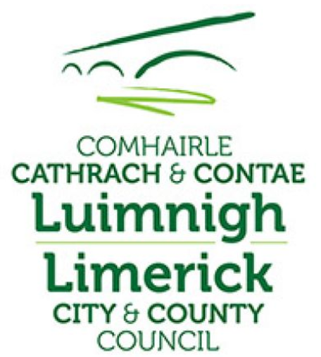

Comhairle Cathrach & Contae Luimnigh.

The Refurbishment of Ardagh Station House and Goods Shed & change of use to Community, Tourism & Commercial use and the Refurbishment of Barnagh Station House & change of use to Community & Tourism use on the Great Southern Greenway Limerick at Kilreash, Ardagh, Co. Limerick and at Ballymurragh East, Co. Limerick.

Part VIII Planning Process
Public Display Drawings

Comhairle Cathrach & Contae Luimnigh.

The Refurbishment of Ardagh Station House and Goods Shed & change of use to Community, Tourism & Commercial use and the Refurbishment of Barnagh Station House & change of use to Community, Tourism & Commercial use on the Great Southern Greenway Limerick at Kilreash, Ardagh, Co. Limerick and at Ballymurragh East, Co. Limerick.

Schedule of Part VIII Drawings

GSG-ARD-1020/01 Site Layout Ardagh Station and Goods Shed
GSG-ARD-1020/02 Elevations of Ardagh Station and Goods Shed
GS G-BNA-1020/01 Elevations Barnagh Station House
GSG-BNA-1020/02 Site Layout Barnagh Station House

