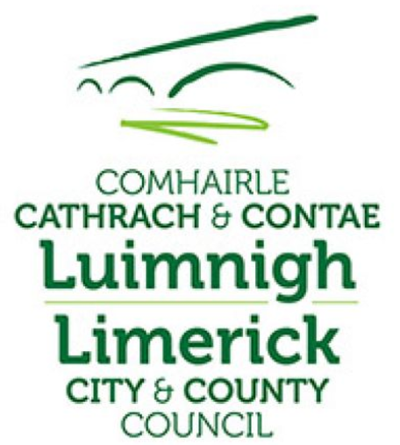

13th October 2020

Re. PLANNING AND DEVELOPMENT ACTS 2000 (as amended)

PLANNING AND DEVELOPMENT REGULATIONS 2001 (as amended)

To Whom it May Concern.

Description of Works

ARDAGH STATION HOUSE (which is a protected structure)
Refurbishment of Ardagh Station House and Goods Shed & change of use to Community, Tourism & Commercial use on the Great Southern Greenway Limerick at Kilreash, Ardagh, Co. Limerick. The provision of a parking areas. Upgrade of the railway platform and ancillary works. Construct a foul sewer pump station and network and connect to existing sewer. Connect to watermain and provide firemain on site. Discharge stormwater to storm outfall.
The installation of a playground area and provision of cycling furniture and information signage for users of the Greenway.

BARNAGH STATION HOUSE (which is a protected structure)
Refurbishment of Barnagh Station House and change of use to a Community & Tourism use on the Great Southern Greenway Limerick at Ballymurragh East, Co. Limerick. Upgrade of the railway platform and all ancillary site works.

In accordance with Part XI of the Planning & Development Acts 2000 (as amended) and Part 8, Article 81 of the Planning and Development Regulations 2001 (as amended), notice is hereby given that Limerick City and County Council proposes to carry out the following development:-

The proposed works comprises:-

ARDAGH STATION HOUSE (which is a protected structure)
- Refurbishment of Ardagh Station House and Goods Shed & change of use to Community, Tourism & Commercial use.
  - The refurbishment and renovation of the station house and goods shed and associated site works.
- The Provision of car parking spaces and camper van parking bays.
- Setback of the entrance.
- Provision of a playground facility.
- Enhancement and landscaping works to the site, circa 2.2 acres and entrance area.
- The provision of LED public lighting throughout the facility.
- New connections to existing public sewer and water services and all associated site works including installation of a holding tank and mechanical pumping system to nearby Irish Water pump station.
- Connecting to Irish Water watermain on public road and lay firemain on site.
- Constructing stormwater network on site with interceptors and discharge to outfall
- Install timber post and rail fencing along boundary of greenway and parking area.
- Installation of greenway furniture including seating, benches and cycle stands on the site.
- The removal of a section of stone wall to facilitate the widening of the existing entrance to accommodate 2-way traffic.
- Installation of signage including:
  - Information sign boards and related structures,
  - Additional directional signage on the greenway and related roads.

BARNAGH STATION HOUSE (which is a protected structure)
- Refurbishment of Barnagh Station House and change of use to a Community & Tourism use on the Great Southern Greenway Limerick. The refurbishment and renovation of the station house and associated site works
- Upgrade of the railway platform
- Installation of signage including:
  - Information sign boards and related structures,
- The provision of LED lighting.
- Enhancement and landscaping works to the site.
- Install fencing along the boundary.

Documentation Provided:
- Site and Newspaper Notice
- Site Layouts of Proposed Works
- Elevations of Proposed Works
- Appropriate Assessment and Screening Document
- Environmental Assessment Screening Document
- Planning Cover Note

Limerick City and County Council invites submissions or observations
- online via http://mypoint.limerick.ie
- in writing to Planning and Environmental Services Department, Limerick City and County Council, County Hall, Dooradoyle, Limerick V94 WV78

Any submissions or observations received will be addressed in the Part 8 Report and presented at a future meeting of the Members of the Municipal District of Newcastlewest

Yours faithfully,

GORDON DALY
For DIRECTOR,
Community Development Directorate.

