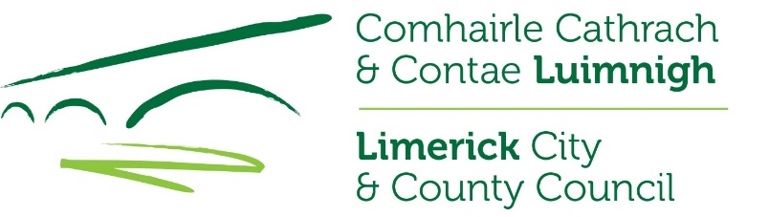
Data Protection Privacy Statement for the Review of the Rathkeale Local Area Plan 2012 – 2018 (as extended)
Who we are and why do we require your information?
Limerick City and County Council seeks to promote the economic, social and cultural development of Limerick City and County and in doing so contribute significantly to improving the quality of life of its people. The delivery of high quality services, tailored to meet the needs of all our customers, remains one of Limerick City and County Council’s core objectives and is included in our Corporate Plan. This quality service includes not only the level and quality of service given to our customers, but also the quality of our decision-making processes, the efficiency and effectiveness of our corporate operations, standard of our facilities and our ability to adapt in an ever-changing environment. In order to provide the most effective and targeted range of services to meet the needs of the citizens, communities and businesses of Limerick City and County we will be required to collect, process and use certain types of information about people and organisations. Depending on the service being sought or provided, the information sought may include ‘personal data’ as defined by the Data Protection Acts and by the General Data Protection Regulation (GDPR) and may relate to current, past and future service users; past, current and prospective employees; suppliers; and members of the public who may engage in communications with our staff. In addition, staff may be required, from time to time, to collect process and use certain types of personal data to comply with regulatory or legislative requirements.
Why do we have a privacy statement?
Limerick City and County Council has created this privacy statement in order to demonstrate our firm commitment to privacy and to assure you that in all your dealings with Limerick City and County Council that we will ensure the security of the data you provide to us. Limerick City and County Council creates, collects and processes a significant amount of personal data in various multiple formats on a daily basis. Limerick City and County Council’s commitment is that the personal data you may be required to supply to us is;
- Obtained lawfully, fairly and in a transparent manner
- Obtained for only specified, explicit and legitimate purposes
- Adequate, relevant and limited to what is necessary for purpose for which it was obtained
- Recorded, stored accurately and securely and where necessary kept up to date
- Kept only for as long as is necessary for the purposes for which it was obtained.
- Kept in a form which permits identification of the data subject
- Processed only in a manner that ensures the appropriate security of the personal data including protection against unauthorised or unlawful processing.
Data Protection Policy
Limerick City and County Council has a detailed Data Protection Policy, which outlines how we as a public body are committed to ensuring the security of any personal data you provide to us.
What is the activity referred to in this Privacy Statement?
Public display of the review of the Rathkeale Local Area Plan.

What is the basis for making the processing of personal data in this activity lawful?
Section 20 of the Planning and Development Act 2000 (As Amended) requires this level of detail.

We require your contact details
Please note that to help protect your privacy; we take steps to verify your identity before granting access to personal data. These contact details may also be used to verify your identify.
See above

What other items of personal data do we need to undertake this activity?
Name and address/email address are required to be submitted with the submission.

Is the personal data submitted as part of this activity shared with other organisations?
Limerick City and County Council may, to fulfil statutory or regulatory obligations or in the public interest, from time to time, have to share personal data with other organisations or entities (in Ireland or abroad). Where this is required Limerick City and County Council shall have regard to the security and integrity of the data and will minimise the data shared.
In this process, the data will be shared with the following recipients:

Submissions/Objections will be summarised in the Chief Executives Report and will be made publically available online, only the name of the individual making the submission/objection will be included.
In this activity, if the personal data is to be transferred to a different country, it will be transferred to the following countries (if there are no countries listed, it is not intended to transfer the personal data abroad).

It is not intended to transfer the personal data abroad.

How long is this personal data held by Limerick City and County Council?
Limerick City and County Council has a detailed record retention policy, which goes in to more detail of the time period for which your personal data will be retained by Limerick City and County Council and what will happen to it after the required retention period has expired.

The data processed as part of this activity will be retained for the following period(s):
In accordance with the National Retention Policy.

What will happen if the requested personal data is not provided?
Details are required in accordance with the Planning and Development Act 2000 (As Amended), otherwise a submission cannot be accepted.

Your Rights
You have the right to request access to personal data held about you, obtain confirmation as to whether data concerning you exists, be informed of the content and source of data and check its accuracy. In addition, if the data held by us is found to be inaccurate you have the right to change, remove, block, or object to the use of, personal data held by Limerick City and County Council. You also have the right to data portability. In certain circumstances blocking access to data may delay or remove access to a service where the data is required by law or for essential purposes related to delivery of a service to you. To exercise these rights, you should contact Limerick City and County Council (Data Controller) at the following address:
email: dataprotectionofficer@limerick.ie
Data Protection Officer,
Limerick City and County Council,
Merchants Quay,
Limerick
Right of Compliant to the Office of the Data Protection Commissioner
If you are not satisfied with the outcome of the response you received from Limerick City and County Council in relation to your request, then you are entitled to make a complaint to the Data Protection Commissioner who may investigate the matter for you.
The Data Protection Commissioner’s website is www.dataprotection.ie or you can contact their office at:
Lo Call Number: 1890 252 231
E-mail: info@dataprotection.ie
Postal Address:
Data Protection Commissioner
Canal House
Station Road
Portarlington, Co. Laois. R32 AP23.

