Document:
Appropriate Assessment Screening

Project:
Improvement works in Abbeyfeale, Co. Limerick.

Prepared for:
Limerick City and County Council.

Prepared by:
Rory Dalton, Independent Ecologist

Table of Contents
Statement of Competence 3
1. Introduction 3
1.1 Appropriate Assessment Process 4
1.2 Methodology 5
2. Description of the Site and Proposed works 6
2.1 Description and Location of the Site 6
2.2 Proposed Works 6
3. Natura 2000 Sites and The Proposal 8
3.1 Natura 2000 Sites within the 15km Zone of Influence 8
3.2 Natura 2000 Sites and their Designations 8
3.3 Natura 2000 Sites excluded from further assessment 9
4. Natura 2000 Sites and Potential Impacts 10
4.1 Sources, Pathways and Receptors 10
4.2 Lower River Shannon SAC 11
4.2.1 Pressures and Threats 12
4.2.2 Assessment of Potential Impacts 13
4.3 Stack’s to Mullaghareirk Mountains, West Limerick Hills and Mount Eagle SPA 15
4.3.1 Assessment of Potential Impacts 16
4.4 Cumulative Impacts 17
5. Conclusion 17
6. Bibliography 18
7. Maps 19

Statement of Competence
Rory is an independent ecological consultant with a decade of experience across a range of disciplines including aquatic ecology, habitats, mammals, and birds. He also carries out a range of species-specific and research-based studies. He graduated from University College Cork with a BSc. Hons in Environmental and Earth Science, after which he spent three years working with a leading ecological consultancy in Limerick. He then set up his own company and has been running it since. Sectors he works in include, conservation, solar farms, wind farms, roads and bridges, grid connections, housing, greenways, instream civil works, drinking water etc. The projects he is involved with range in size from small bridge surveys to the largest wind energy project in the country and the largest water quality project in Europe. He carries out work for a number of State Bodies, Semi-State Bodies, Engineering Consultants, Ecology Consultants, Environmental Consultants and Laboratories.

- Introduction

Rory Dalton was appointed by Limerick City and County Council to prepare a document for the appropriate assessment for Improvement works to be undertaken in Abbeyfeale, Co. Limerick. The proposed project (detailed in section 2 below) consists of the construction of a footpath in Abbeyfeale town, Co. Limerick. It is proposed to install a section of footpath to a total length of approximately 600 meters on the L 7089.

1.1 Appropriate Assessment Process

An Appropriate Assessment is undertaken to establish if any proposed plan or project is likely to have a significant effect or impact on any site that has been designated under: the E.U. Habitats Directive (92/43/EEC) i.e. SAC; or the E.U. Birds Directive (79/409/EEC as amended 2009/147/EC) i.e. SPA. Collectively, SAC’s and SPA’s are known as Natura 2000 sites. The need to undertake one or more stages of this process has arisen from Articles 6(3) and 6(4) of the aforementioned Habitats Directive; where the former Article is primarily concerned with the protection of sites from likely significant effects and the latter allows derogation from such protection in very specific circumstances involving imperative reasons of overriding public interest.
Article 6(3) of the Habitats Directive requires that:
“Any plan or project not directly connected with or necessary to the management of the site but likely to have a significant effect thereon, either individually or in combination with other plans or projects, shall be subject to appropriate assessment of its implications for the site in view of the site's conservation objectives. In the light of the conclusions of the assessment of the implications for the site and subject to the provisions of paragraph 4, the competent national authorities shall agree to the plan or project only after having ascertained that it will not adversely affect the integrity of the site concerned and, if appropriate, after having obtained the opinion of the general public.”
And Article 6(4) of the Habitats Directive requires that:
“If, in spite of a negative assessment of the implications for the site and in the absence of alternative solutions, a plan or project must nevertheless be carried out for imperative reasons of overriding public interest, including those of a social or economic nature, the Member State shall take all compensatory measures necessary to ensure that the overall coherence of Natura 2000 is protected. It shall inform the Commission of the compensatory measures adopted.”
In Stage 1, a screening process is undertaken to identify whether significant impacts on a Natura 2000 site are likely to arise from the project or plan in question. If significant impacts are likely to occur or if it is unclear whether significant impacts are likely to occur, then the process moves on to Stage 2 where an AA considers potential mitigation measures for adverse impacts. If it is considered that mitigation measures will not be able to satisfactorily reduce potential adverse impact on a Natura 2000 site then an assessment of alternative solutions is considered in Stage 3. This is then followed by Stage 4 in the event that adverse impacts remain and the proposed activity or development is deemed to be of Imperative Reasons of Overriding Public Interest (IROPI), allowing an assessment of compensatory measures to be considered. The outcome of a Stage 2 and higher assessment is presented in a report known as a Natura Impact Statement (NIS). While an AA NIS is provided by the advocate of the plan or project in question, the AA NIS itself is undertaken by the competent authority.

1.2 Methodology

Documents associated with the proposed project and relevant ecology databases were consulted as part of this assessment, with a site walkover also undertaken. Furthermore, the following guidelines were used in the completion of this assessment;
- Assessment of Plans and Projects Significantly Affecting Natura 2000 Sites – European Commission Methodical Guidance on the provisions of Article 6(3) and 6(4) of the ‘Habitats’ Directive 92/43/EEC (European Commission 2001)
- Integrated Biodiversity Impact Assessment – Streamlining AA, SEA and EIA Processes: Practitioner’s Manual (EPA 2013)
- Appropriate Assessment of Plans and Projects in Ireland – Guidance for Planning Authorities (DoEHLG 2009)

The Screening Stage of Appropriate Assessment is used to identify whether the Plan, either alone or in combination with other plans or projects, is likely to have a significant effect on a Natura 2000 site. This report follows European Commission (2001) guidance which recommends that screening should follow a four step process as outlined below:
- : Determine whether the plan is directly connected with or necessary to the management of the site.
- : Describe the plan and other plans and projects that, ‘in combination’, have the potential to have significant effects on a European site.
- : Identify the potential effects on the European site.
- : Assess the significance of any effects on the European site.

In stage 2 the potential impacts to conservation interests of the Natura site are looked at in depth and mitigations are put forward to avert these impacts. Each impact is assessed with reference to the conservation interest to which it applies in a case-specific manner. Mitigations are then tailored to each specific situation

- Description of the Site and Proposed works

2.1 Description and Location of the Site

The site of the proposed works exists on the outskirts of the town. It is proposed to install a section of footpath to a total length of approximately 600 meters, on the L 7089 otherwise known as St. Ita’s Road. The road comprises predominantly private residential properties, GZT zone R2 - Existing residential and agricultural land. There is also the entrance to a reservoir in the center of the site of the proposed work GZT zone: N2.1 - Water. There is also a portion of land adjacent to the L7089 zoned GZT Zone: R1 - New/proposed residential.
The northernmost section of the site of the proposed works begins at the junction of the L 7089 and the L 7050 and extends south west along the L7089 for approximately 600 meters. It is proposed to construct the footpath on the eastern side of the road. An existing footpath from here to SuperValu will be improved from its state of disrepair.

.2.2 Construction Methodology
Limerick City and County Council have outlined that the works involve the replacement of existing footpaths within the outskirts of Abbeyfeale
- Existing footpath to be dug up using small excavator, and rubble to be removed from the site to the council compound or to a licensed waste disposal site. For greenfield sections, the s general principal applies
- Some sections of the existing footpath are narrow, and may need to be widened. Where kerb replacement is required, this will be carried out prior to the pouring of footpath concrete in order to attain the heights for the concrete. Kerbing will either be precast kerbs placed as standard, or a shuttered kerb which is filled with a relatively dry mix and let to set over night or over a number of days. Similarly, in greenfield sections, the kerbing will be laid and allowed to set prior to the pouring of concrete. This shutter will be struck out prior to the pouring of the footpaths and will ensure that the cell to be poured is sealed in terms of concrete leaking out onto the road.
- This works area will move along on a rolling basis as the old footpath is being excavated and the new footpath is being laid. The excavation work will be carried out by a small team in short sections (30 to 80m) to avoid excessive disturbance to members of the public using the footpath. The works area will be marked out with cones and an alternative footpath provided adjacent to the footpath being worked on.
- Devices (PVC Screed, expansion joint filler foam etc) to facilitate expansion/contraction will be placed at regular intervals in line with the levels of the footpath.
- Concrete pours will consist of one load of concrete (circa 8m³) being poured at a time and allowed to set before the next load arrives. This will equate to approximately 20-40m of footpath and the small team will work on levelling, screeding, floating and finishing the concrete. Pours will only be carried out during dry weather to ensure the quality of the finished surface and also to eliminate risk to the aquatic environment. In the unlikely event of unexpected rain, any uncured concrete will be covered in plastic sheeting; 50m length of which will be kept onsite at all times.
- On sloped areas, baffles of potato sacking/ hemp fibre will be placed at 90 degrees to the kerb will be placed every 10m to ensure that sediment which may become mobilised in a shower is minimised, similarly any entrances to the stormwater drainage system adjacent to the works will be covered with potato sack/hemp fibre.
- The rolling works area will be finished, brushed and cleaned, along with the road adjacent, as the works moves along to ensure overall tidiness of the village and to ensure the footprint of the works remains small.
- The Council will inspect the site intermittently to ensure that the site is in good condition and that the method outlined above is followed

The methodology above will be applied to the following sections:

- The northernmost section of the site of the proposed works begins at the junction of the L 7089 and the L 7050 and extends south west along the L7089 for approximately 600 meters.
- The southernmost point of the proposed works ends at a property known as Fitzgerald's farmhouse, accommodation and equestrian center.
- It is proposed to construct the footpath on the eastern side of the road.

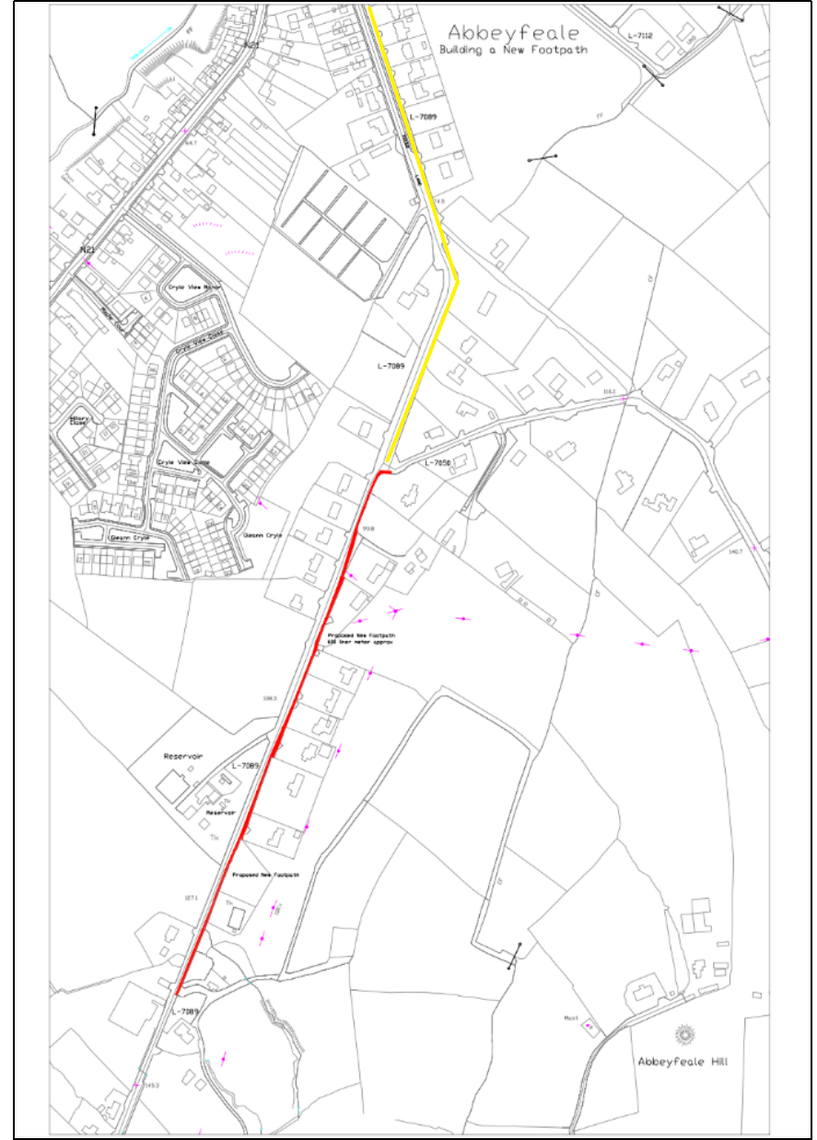
Figure 1 – Footpath works to be carried out in Abbeyfeale, the new footpath is in red, existing footpath to be re-done is in yellow.

- Natura 2000 Sites and Proposal

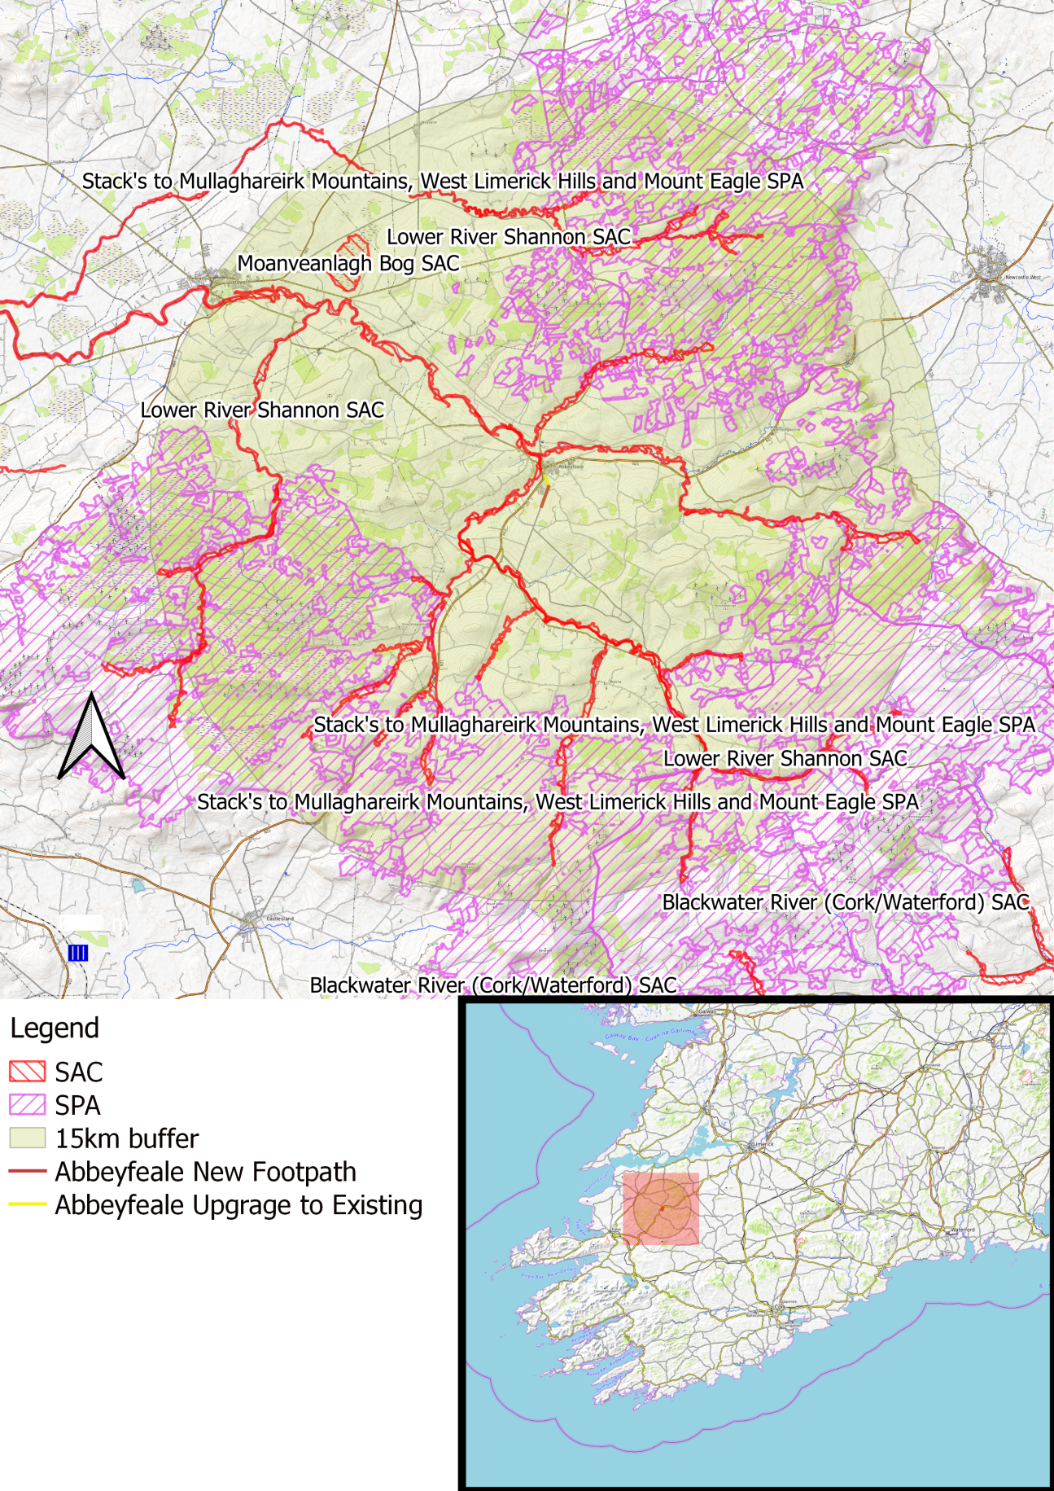
Figure 2 - Natura 2000 sites within the 15km zone of influence

3.1 Natura 2000 Sites within the 15km Zone of Influence
Natura Site | Distance between study site and Natura 2000 site | Hydrological/ecological connection?
Lower River Shannon SAC (002165) | 250mtrs at the closest point, the majority of the footpath is 500-700m away | During rainfall
Stack's to Mullaghareirk Mountains, West Limerick Hills and Mount Eagle SPA (004161) | 4 Km | No
Moanveanlagh Bog SAC (002351) | 10.5 Km | No

3.2 Natura 2000 Sites and their Designations
Natura Site | Designated Features
Lower River Shannon SAC (002165) | [1110] Sandbanks  [1130] Estuaries  [1140] Tidal Mudflats and Sandflats  [1150] Coastal Lagoons*  [1160] Large Shallow Inlets and Bays  [1170] Reefs  [1220] Perennial Vegetation of Stony Banks  [1230] Vegetated Sea Cliffs  [1310] Salicornia Mudflats  [1330] Atlantic Salt Meadows  [1410] Mediterranean Salt Meadows  [6410] Molinia Meadows  [3260] Floating River Vegetation  [91E0] Alluvial Forests*  [1029] Freshwater Pearl Mussel (Margaritifera margaritifera)  [1095] Sea Lamprey (Petromyzon marinus)  [1099] River Lamprey (Lampetra fluviatilis)  [1096] Brook Lamprey (Lampetra planeri)  [1106] Atlantic Salmon (Salmo salar)  [1349] Bottle-nosed Dolphin (Tursiops truncatus)  [1355] Otter (Lutra lutra)
Stack's to Mullaghareirk Mountains, West Limerick Hills and Mount Eagle SPA (004161) | (A082) Hen Harrier (Circus cyaneus)
Moanveanlagh Bog SAC (002351) | 7110 Active raised bogs  7120 Degraded raised bogs still capable of natural regeneration 7150 Depressions on peat substrates of the Rhynchosporion.

3.3 Natura 2000 Sites excluded from further assessment

Natura Site | Rationale for exclusion from further assessment
Moanveanlagh Bog SAC (002351) | The site of the proposed works exists 10.5km from this SAC. The conservation interests of this SAC are active raised bogs, degraded raised bogs and depressions on peat substrates of the Rhynchosporion. These habitats will not be affected by the works due to the scale and nature of the development, the isolation of the site of the proposed works from the SAC and the characteristics of the SAC’s conservation interests. There is no hydrological connection to this habitat and the proposed works have no potential to cause negative impacts to this SAC.

- Natura 2000 Sites and Potential Impacts

4.1 Sources, Pathways and Receptors

Source | Pathway | Receptor
Construction Phase
Earthworks can cause the input of silt / fine sediment to a watercourse and pose the risk of introducing hydrocarbons should an incident arise | There are two main elements to this. Initially, the old footpath must be dug up which will generate sediment onsite. Then the concrete footpaths will be laid which will mean there will be cementitious material onsite. These elements are explored separately below, however there is a lot of similarity and crossover.  Initially, the old footpath must be dug up which will generate sediment onsite. The works area will move along on a rolling basis as the old footpath is being excavated and the new footpath is being laid. The excavation work will be carried out by a small team and the rolling works area will be 30 to 80m in length. This effectively reduces the size of the site from the 1100m of footpath presented in Figure 1 above down to a rolling site of 30-80m in length. This is the single most important aspect of the methodology in terms of protecting the aquatic environment. As well as this, the footpath to be dug up is inside an existing kerb, and much of this kerb will remain in place during the works as long is it is in good condition and there is sufficient footpath width; this kerb will contain the works area and keep out water flowing down the road along the kerb. Excavated rubble is to be removed from the rolling site as it is being dug rather than laying within the works area. Baffles of hemp fibre will be placed at 90 degrees to the kerb out onto the road; these will be placed every 10m to ensure that sediment which may become mobilised in a rain shower is captured and minimised, similarly any entrances to the stormwater drainage system adjacent to the works will be covered with hemp fibre. Finally, the rolling works area will be finished, brushed and cleaned, along with the road adjacent, as the works moves along to ensure overall tidiness of the village and to ensure the footprint of the works remains small. All of these measures in combination will comfortably ensure that minimal sediment is incident on the watercourse.  The concrete footpaths will be laid which will mean there will be cementitious material onsite. The works area will move along on a rolling basis as the old footpath is being excavated and the new footpath is being laid. The excavation work will be carried out by a small team and the rolling works area will be 30 to 80m in length. This effectively reduces the size of the site from the 1100m of footpath presented in Figure 1 above down to a rolling site of 30-80m in length. This is the single most important aspect of the methodology in terms of protecting the aquatic environment. The original kerb will remain intact or will be replaced prior to pouring concrete; this will ensure that the cell to be poured is sealed in terms of concrete leaking out onto the road. Concrete pours will consist of one load of concrete (circa 8m3) being poured at a time and allowed to set before the next load arrives. This will equate to approximately 20-40m of footpath and the small team will work on levelling, screeding, floating and finishing the concrete. Pours will only be carried out during dry weather to ensure the quality of the finished surface and also to eliminate risk to the aquatic environment. In the unlikely event of unexpected rain, any uncured concrete will be covered in plastic sheeting; 50m length of plastic sheeting will be kept onsite at all times. Baffles of hemp fibre will be placed at 90 degrees to the kerb out onto the road; these will be placed every 10m to ensure that sediment which may become mobilised in a rain shower is captured and minimised, similarly any entrances to the stormwater drainage system adjacent to the works will be covered with hemp fibre. Finally, the rolling works area will be finished, brushed and cleaned, along with the road adjacent, as the works moves along to ensure overall tidiness of the village and to ensure the footprint of the works remains small. All of these measures in combination will comfortably ensure that cementitious material is contained within the footprint of the works.  Additionally, the Council will inspect the site intermittently to ensure that the site is in good condition and that the method outlined in the Construction Methodology (as desplayed in Section 2.2 above) is followed. | Aquatic species
Physical disturbance can can arise from noise associated with construction; mainly by machinery and to a lesser degree power tools and hammering | Due to the scale of the works, noise disturbance from machinery and power tools during the development is not likely to be significantly elevated above normal levels of the town of Abbeyfeale and its agricultural surroundings. Also due to the distance from the site of the proposed works to the surrounding SPAs and SACs, no significant pathway for disturbance exists. | Otter, Hen Harrier
Destruction of habitat | The small amount of habitat to be removed in order to install the new sections of footpath will be minimal. Some grassy verges and hedgerow will be affected. Much of the works will be undertaken on surfaces of little ecological value such as amenity grassy land, gravel road verges and hard stand surfaces which exist in front of private residential properties. Therefore there will be no significant destruction of habitat which is considered to be of high ecological value connected to SACs or SPAs. This project does not have the capacity or pathway for habitat destruction in any of the nearby Natura 2000 sites. | Habitats and the species which depend upon them
Operational Phase
Disruption to the hydrology of a catchment can arise from creating new hard-stands | The nature of the works will not present any significant alterations to the hydrology of the catchment. Any sections of new hard stand will be adjacent to a road way and will be relatively small in nature and not of such significance to alter the hydrology of a catchment. | Aquatic and riparian species and habitats
Physical disturbance can can arise from noise associated with habitation | During the operational phase of the development the amount of noise pollution will not be increased. As the proposed works will be undertaken in order to install new footpaths there will be no increase in traffic volume or disturbance. | Otter, Hen Harrier

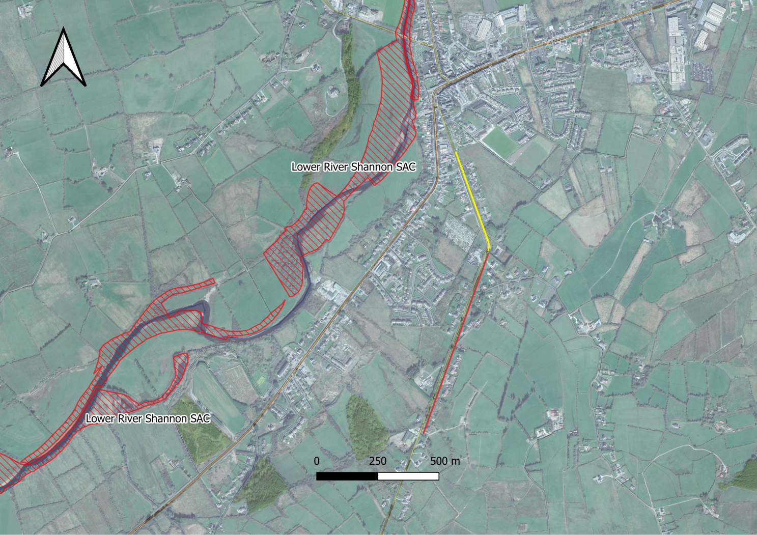
Figure 3 – Footpath layout with respect to nearby protected areas, the new footpath is in red, existing footpath to be re-done is in yellow.

4.2 Lower River Shannon SAC

This very large site stretches along the Shannon valley from Killaloe in Co. Clare to Loop Head/ Kerry Head, a distance of some 120 km. The site thus encompasses the Shannon, Feale, Mulkear and Fergus estuaries, the freshwater lower reaches of the River Shannon (between Killaloe and Limerick), the freshwater stretches of much of the Feale and Mulkear catchments and the marine area between Loop Head and Kerry Head. The vast majority of the surface area is estuarine, however, the site also encompasses extensive river corridors, and so as a whole the site is varied in nature.
This site is of great ecological importance. It is designated for 11 marine/estuarine habitats, two terrestrial habitats, one freshwater habitat, 5 freshwater species, one marine mammal, and one semi-aquatic mammal. It includes the largest estuarine habitat in the country.

4.2.1 Pressures and Threats
Pressures and threats within this SAC are summarised in the following table
Level | Threat and Pressure Code | Inside or outside SAC | Threat and Pressure
Low | C01.01.02 | Inside | Removal of beach materials
Low | F01 | Inside | Marine and Freshwater Aquaculture
Low | F03.01 | Inside | Hunting
Low | E03 Inside | Inside | Discharges
Medium | J02.01.01 | Inside | Polderisation [drainage of wetlands]
Low | J02.12.01 | Inside | Abandonment of management of water bodies
Low | G01.01 | Inside | nautical sports
Low | J02.10 | Inside | management of aquatic and bank vegetation for drainage purposes
Medium | A04 | Inside | grazing
Low | B | Inside | Sylviculture, forestry
Medium | H04 | Outside | Air pollution, air‐borne pollutants
Low | D01.01 | Inside | paths, tracks, cycling tracks
Medium | E03 outside | Outside | Discharges
Medium | J02.01.02 | Outside | reclamation of land from sea, estuary or marsh
Low | I01 | Inside | invasive non‐native species
Medium | E01 | Outside | Urbanised areas, human habitation
Medium | A08 | Outside | Fertilisation
Medium | K02.03 | Outside | eutrophication (natural)
Medium | A08 | Inside | Fertilisation
Low | C01.03.01 | Inside | cutting of peat

4.2.2 Assessment of Potential Impacts

Conservation Interest | Assessment of Potential Impacts
Sandbanks which are slightly covered by sea water all the time [1110]  Estuaries [1130]  Mudflats and sandflats not covered by seawater at low tide [1140]  Coastal lagoons [1150]  Large shallow inlets and bays [1160]  Reefs [1170]  Perennial vegetation of stony banks [1220]  Vegetated sea cliffs of the Atlantic and Baltic coasts [1230]  Salicornia and other annuals colonising mud and sand [1310]  Atlantic salt meadows [1330]  Mediterranean salt meadows [1410] | These are coastal and esturine habitats.Potential impacts include direct habitat destruction usually by machine, severe siltation, pollution via discharges or fertilisation and the introduction of invasive aquatic plants. However, due to the site's hydrological isolation from the SAC and the lack of any significant pathways for such impacts to occur, no negative impacts are envisaged.
Floating River  Vegetation [3260] | Patches of this habitat are present in the Galey River. Potential impacts include direct habitat destruction usually by machine, severe siltation, and the introduction of invasive aquatic plants. This project does not have the capacity to generate these Potential Impacts
Molinia meadows on calcareous, peaty or clayey-silt-laden soils [6410] | This habitat has been recorded on the eastern bank of the Shannon, just north of Castleconnell, Co. Limerick. Full distribution of this habitat in this SAC is currently unknown and it almost certainly occurs elsewhere (NPWS, 2012). Potential impacts include direct habitat destruction or hydrological modification (both usually by machine), and the introduction of invasive plants. This habitat is not present within or near the works site, this project does not have the capacity to generate these Potential Impacts, and so no likely significant effects are envisaged
Alluvial forests with Alnus glutinosa and Fraxinus excelsior [91E0] | Due to the nature of the works involved, and the fact this habitat does not exist within the footprint of the works or immediately adjacent to the works, there is no potential for direct habitat destruction, introduction of invasive species, drainage of the watercourse or water table upon which the habitat depends. This insures this habitat will not be negatively affected by the proposed works.
Freshwater Pearl Mussel [1029] | The freshwater pearl mussel conservation objectives for the Lower River Shannon SAC relates specifically to the Cloon River population in Co. Clare which is located within a different river catchment approximately 20km across the Lower Shannon Estuary transitional waterbody from the proposed gravel removal works.  The Feale River is not represented under the “Margaritifera Habitat Classification”or the “Margaritifera SAC Catchment”, nor are its headwaters represented in the “Margaritifera First Order Rivers”, all of which are layers on the EPA Map Portal. The Feale is however shown in the “Margaritifera Sensitive Areas” mapping as a “Catchments of other extant populations”; this is the middle in importance of 3 categories within the “Margaritifera Sensitive Areas” database. A previous study found a small number of mussels in the Feales Bridge area, ~6km upstream of Abbeyfeale having surveyed a number of other sites also but to no avail. Indeed, it is likely that pockets of the species exist in suitable areas of the main channel and suitable tributaries such as the Oolagh, Allaghaun, Oweg and Clydagh, as well as the Smearlagh further downstream.  As discussed in section 4.1 above, the method employed to carry out the works, particularly limiting the size of the works area to a rolling works area of 30m to 80m in length as well as working inside of kerbing, ensures that little or no sediment or cementitious material will enter the watercourse, and certainly not enough to coat the riverbed or impact any unlikely FPM population downstream of
Sea Lamprey [1095]  Brook Lamprey [1096]  River Lamprey [1099] | Barriers to migration are a significant threat/pressure on river and sea lamprey NPWS 2019b. The bridge apron at Listowel Racecourse and the weir at Finnuge pose a serious obstacle to both of these species. A survey by Ecofact found sea lamprey in Abbeyfeale, however, these obstacles are likely to hold back a considerable percentage of the population within the system. Brook lamprey are present throughout the river.  As discussed in section 4.1 above, the method employed to carry out the works, particularly limiting the size of the works area to a rolling works area of 30m to 80m in length as well as working inside of kerbing, ensures that little or no sediment or cementitious material will enter the watercourse, and so no likely significant impacts are envisaged for these species.
Salmon [1106] | This species is present throughout the Feale, and the Feale was once considered one of the finest salmon rivers in the country.In the 1920’s, a record number of salmon were taken on the Feale – 127,000 to net and rod. This is the highest record of salmon ever taken on any river in Ireland. In 1962, 43,000 salmon were taken. In 1963, 1475 salmon were taken in the nets in one hour on the Cashen, where the Feale runs into the sea. Sadly, the river has declined massively since then and in 2019 the angling on the river closed as the river was not reaching conservation limits.  As discussed in section 4.1 above, the method employed to carry out the works, particularly limiting the size of the works area to a rolling works area of 30m to 80m in length as well as working inside of kerbing, ensures that little or no sediment or cementitious material will enter the watercourse, and so no likely significant impacts are envisaged for these species.
Common Bottlenose Dolphin [1349] | This species exists in the middle and outer Shannon Estuary and no sources or pathways for impacts to this species exist.
Lutra lutra (Otter) [1355] | There is no suitable holt habitat within the footprint of the works. Disturbance will not be elevated much above the usual noises of the village. No likely significant impacts are envisaged.

4.3 Stack's to Mullaghareirk Mountains, West Limerick Hills and Mount Eagle SPA

The Stack’s to Mullaghareirk Mountains, West Limerick Hills and Mount Eagle SPA is a very large site centred on the borders between the counties of Cork, Kerry and Limerick. The site is skirted by the towns of Newcastle West, Ballydesmond, Castleisland, Tralee and Abbeyfeale. The mountain peaks included in the site are not notably high or indeed pronounced, the highest being at Knockfeha (451 m). Other mountains included are Mount Eagle, Knockanefune, Garraunbaun, Taur, Rock Hill, Knockacummer, Mullaghamuish, Knight’s Mt, Ballincollig Hill, Beennageeha Mt, Sugar Hill, Knockanimpuba and Knockathea, amongst others. Many rivers rise within the site, notably the Blackwater, Owentaraglin, Owenkeal, Glenlara, Feale, Clydagh, Allaghaun, Allow, Oolagh, Galey and Smerlagh.
The site consists of a variety of upland habitats, though almost half is afforested. The coniferous forests include first and second rotation plantations, with both pre-thicket and post-thicket stands present. Substantial areas of clear-fell are also present at any one time. The principal tree species present are Sitka Spruce (Picea sitchensis) and Lodgepole Pine (Pinus contorta). A substantial part (28%) of the site is unplanted blanket bog and heath, with both wet and dry heath present. The vegetation of these habitats is characterised by such species as Ling Heather (Calluna vulgaris), Bilberry (Vaccinium myrtillus), Common Cottongrass (Eriophorum angustifolium), Hare’s-tail Cottongrass (Eriophorum vaginatum), Deergrass (Scirpus cespitosus) and Purple Moor-grass (Molinia caerulea). The remainder of the site is mostly rough grassland that is used for hill farming. This varies in composition and includes some wet areas with rushes (Juncus spp.) and some areas subject to scrub encroachment.
The site is a Special Protection Area (SPA) under the E.U. Birds Directive, of special conservation interest for Hen Harrier. This SPA is a stronghold for Hen Harrier and supports the largest concentration of the species in the country. A survey in 2005 recorded 45 pairs, which represents over 20% of the all-Ireland total. A similar number of pairs had been recorded in the 1998-2000 period. The mix of forestry and open areas provides optimum habitat conditions for this rare bird, which is listed on Annex I of the E.U. Birds Directive. The early stages of new and second-rotation conifer plantations are the most frequently used nesting sites, though some pairs may still nest in tall heather of unplanted bogs and heath. Hen Harriers will forage up to c. 5 km from the nest site, utilising open bog and moorland, young conifer plantations and hill farmland that is not too rank. Birds will often forage in openings and gaps within forests. In Ireland, small birds and small mammals appear to be the most frequently taken prey.
Short-eared Owl, a very rare species in Ireland, has been known to breed within the site. Nesting certainly occurred in the late 1970s and birds have been recorded intermittently since. The owls are considered to favour this site due to the presence of Bank Voles, a favoured prey item. Merlin also breed within the site but the size of the population is not known. Red Grouse is found on some of the unplanted areas of bog and heath – this is a species that has declined in Ireland and is now Red-listed.

The Stack’s to Mullaghareirk Mountains, West Limerick Hills and Mount Eagle SPA is of ornithological importance because it provides excellent nesting and foraging habitat for breeding Hen Harrier and is one the top sites in the country for the species. The presence of three species, Hen Harrier, Merlin and Short-eared Owl, which are listed on Annex I of the E.U. Birds Directive is of note.

4.3.1 Assessment of Potential Impacts

Conservation Interest | Assessment of Potential Impacts
(A082) Hen Harrier (Circus cyaneus) | The site of the proposed works exists 4 kilometers from this SPA at the closest point.  An Irish National Hen Harrier Survey undertaken by Ruddock et al (2012) found that the majority of breeding pairs, 43.8%, of hen harriers nested primarily in second rotation plantation forest habitats, while 24.4% nested in heather habitats. Studies undertaken of the foraging activity of hen harriers continued to indicate that hen harriers favor open moorland while hunting, avoiding intensive agricultural areas. Their diets, consisting of birds and mammals, are regularly composed of ground nesting birds such as the meadow pipit and skylark.  The proposed works will occur in a built-up area, amid private dwellings and agricultural land, which does not provide suitable habitat for Hen Harrier. Neither suitable nesting sites or suitable foraging for the hen harriers exists within the footprint of the works.  As the Stack's to Mullaghareirk Mountains, West Limerick Hills and Mount Eagle SPA is 4 kilometers from the site of the proposed works, there is no pathway for noise disturbance from machinery and power tools during the development. This localised disturbance will be minor in nature and of short duration and will be typical of regular road works. During the operational phase of the works no additional disturbance will be generated hence, no significant pathway for disturbance exists.  No negative impacts are envisaged for this species

4.4 Cumulative Impacts
Given the absence of pathways for the sources identified in Section 4.1 above, combined with the nature and scale of the works, it can be said with reasonable confidence that there will be no cumulative impact to any of the conservation interests of the Lower River Shannon SAC and the Stack's to Mullaghareirk Mountains, West Limerick Hills arising from this proposal.

5. Conclusion
In conclusion the construction of footpaths in Abbeyfeale, Co. Limerick will not cause adverse impacts on the conservation objectives of any Natura 2000 Site .

6. Bibliography

Department of Environment, Heritage & Local Government (DoEHLG). 2009. Appropriate Assessment of Plans and Projects in Ireland – Guidance for Planning Authorities. DoEHLG, Dublin
Environment Agency's 'River Habitat Survey in Britain and Ireland Field Survey Guidance Manual 2003'
European Commission. 2001. Assessment of Plans and Projects Significantly Affecting Natura 2000 Sites – European Commission Methodical Guidance on the provisions of Article 6(3) and 6(4) of the ‘Habitats’ Directive 92/43/EEC. European Commission DG Environment, Oxford UK.
European Commission (2018). Managing Natura 2000 sites. The provisions of Article 6 of the Habitats Directive 92/43/EEC. Brussels, 21.11.2018 C(2018) 7621 final.
Environmental Protection Agency (EPA). 2013. Integrated Biodiversity Impact Assessment – Streamlining AA, SEA and EIA Processes: Practitioner’s Manual. EPA STRIVE Programme 2007–2013; Report Series No. 106. EPA, Wexford.
EPA(2020) EPA map viewer. Last accessed on 3.05.2022 at https://gis.epa.ie/EPAMaps
NPWS (2012) Conservation Objectives: Lower River Shannon SAC 002165. Version 1.0. National Parks and Wildlife Service, Department of Arts, Heritage and the Gaeltacht.
NPWS (2015) Conservation objectives for Stack's to Mullaghareirk Mountains, West Limerick Hills and Mount Eagle SPA. Department of Housing, Local Government and Heritage.
NPWS (2019) The Status of EU Protected Habitats and Species in Ireland. Volume 2: Habitat Assessments
NPWS (2015) Conservation objectives for the Moanveanlagh Bog SAC. Version 1.0. National Parks and Wildlife Service, Department of Arts, Heritage and the Gaeltacht.
Ruddock, M. & Dunlop, B.J., O’Toole, L., Mee, A., Nagle, T. (2012) Republic of Ireland National Hen Harrier Survey 2010. Irish Wildlife Manual, No. 59. National Parks and Wildlife Service, Department of Arts, Heritage and the Gaeltacht, Dublin, Ireland.

https://www.npws.ie/sites/default/files/protected-sites/natura2000/NF002165.pdf

