|  |
| --- |
|  |
| |  | | --- | | Limerick City and County Council | | O'Connell Street Revitalisation – Phase I | | Part 8 Planning Report | | REP | | Issue 3 | 25 July 2019 | |

|  |  |  |
| --- | --- | --- |
| This report takes into account the particular  instructions and requirements of our client.  It is not intended for and should not be relied  upon by any third party and no responsibility  is undertaken to any third party.  Job number 250780-00 |  | ArupLogo2010_k_OvaWord1000mm_CompoundTransparent_100kGreyscale.wmf |
| |  | | --- | | **Ove Arup & Partners Ireland Ltd** | |
| **Arup**  One Albert Quay  Cork  T12 X8N6  Ireland  www.arup.com |

|  |  |  |  |  |  |  |  |  |  |  |  |
| --- | --- | --- | --- | --- | --- | --- | --- | --- | --- | --- | --- |
| Document verification | | | | | | ArupLogo2010_k_OvaWord1000mm_CompoundTransparent_100kGreyscale.wmf | | | | | |
|  | | | | | |  | | | | | |
|  | | |  | | | | |  | | | |
| Job title | | | O'Connell Street Revitalisation – Phase I | | | | | Job number | | | |
| 250780-00 | | | |
|  | | |  | | | | |  | | | |
| Document title | | | Part 8 Planning Report | | | | | File reference | | | |
|  | | | |
|  | | |  | | | | | | | | |
| Document ref | | | REP | | | | | | | | |
|  | |  |  |  | | | | | | | |
| Revision | | Date | Filename | 250780-00\_Part 8 Planning Report\_I1.docx | | | | | | | |
|  | |  |  |  | | | | | | | | |
| Issue 1 | | 18 Jun 2019 | Description | Issue | | | | | | | |
|  | Prepared by | | Checked by | | Approved by | | | |
| Name | Niamh O'Regan | | Niall Harte | | David O'Keeffe | | | |
| Signature |  | |  | |  | | | |
|  | |  |  |  | | | | | | | | |
| Issue 2 | | 24 Jul 2019 | Filename | 250780-00\_Part 8 Planning Report\_I2.docx | | | | | | | |
| Description | Second Issue | | | | | | | |
|  | Prepared by | | Checked by | | Approved by | | | |
| Name | Niamh O'Regan | | Niall Harte | | David O'Keeffe | | | |
| Signature |  | |  | |  | | | |
|  | |  |  |  | | | | | | | | |
| Issue 3 | | 25 Jul 2019 | Filename | 250780-00\_Part 8 Planning Report\_I3.docx | | | | | | | |
| Description | Third Issue | | | | | | | |
|  | Prepared by | | Checked by | | Approved by | | | |
| Name | Niamh O'Regan | | Niall Harte | | David O'Keeffe | | | |
| Signature |  | |  | |  | | | |
|  | |  |  |  | | | | | | | | |
|  | |  | Filename |  | | | | | | | |
| Description |  | | | | | | | |
|  | Prepared by | | Checked by | | Approved by | | | |
| Name |  | |  | |  | | | |
| Signature |  | |  | |  | | | |
|  | | | | | | | | | | |
| Press **Control+Shift+D** to insert or remove DV sheet | | | | Issue Document verification with document | | | |  | ✓ |  |
|  | | | | | | | | | | |

Contents

Page

[1 Introduction 1](#_Toc14876360)

[1.1 Accompanying Material 1](#_Toc14876361)

[2 Objectives and Constraints 2](#_Toc14876362)

[2.1 Vision and Objectives 2](#_Toc14876363)

[2.2 Constraints Study 2](#_Toc14876364)

[3 Description of Proposed Works 5](#_Toc14876365)

[3.1 Denmark Street to William Street 6](#_Toc14876366)

[3.2 William Street to Roches Street 8](#_Toc14876367)

[3.3 Roches Street to Cecil Street 11](#_Toc14876368)

[4 Design Statement 13](#_Toc14876369)

[4.1 Introduction 13](#_Toc14876370)

[4.2 Design Context 13](#_Toc14876371)

[4.3 Design Team 13](#_Toc14876372)

[4.4 Meeting Project Objectives 14](#_Toc14876373)

[5 Conclusion 17](#_Toc14876374)

References

Tables

Figures

Drawings

Pictures

Photographs

Attachments

Appendices

1. Introduction

Limerick City is undergoing a transformation. The completion of Gardens International, the progress of the Opera Centre and the proposed Rugby Experience building will see larger numbers of people working in Limerick City Centre. With projected population growth for Limerick City of 50,000 people under the Project 2040 National Planning Framework, the work currently being carried out by Limerick City and County Council’s CityXChange programme will promote the City Centre as a viable place to live. O’Connell Street will be a principal connector between all of these developments and must reflect and underpin anticipated population growth and significantly increased footfall.

In anticipation of this growth, Limerick City and County Council is currently undertaking the O’Connell Street Revitalisation Project (Phase 1). The project will start at the top of Patrick Street, end at The Crescent, and Phase 1 will focus on that area of O’Connell Street that lies between Denmark Street and Cecil Street. The aim of the project is to breathe new life into O’Connell Street for pedestrians and residents, to redefine its role as a destination within Limerick City and the greater Mid-West region, to support more sustainable modes of transport, and to provide a stronger and more visually appealing urban connector within the city centre.

While O’Connell Street is a critical thoroughfare for Limerick City at present, this project seeks to redress this through placemaking along O’Connell Street and its immediate vicinity. The O'Connell Street Revitalisation Project will create a backdrop to more positive engagement with the city through much-reduced traffic volumes, greater cyclist and bus accessibility, wider and improved footpaths, reduction in urban clutter, increased landscaping and trees, and will generally contribute to a more pleasant environment for those who currently live and work in the city centre, and for the anticipated increase in working and residential populations of Limerick.

The project is being part-funded by the European Regional Development Fund (ERDF) via the Southern Regional Assembly.

The purpose of this report is to set out the proposed layout for Phase 1 of the O'Connell Street Revitalisation Project, and detail the process followed in developing this layout for a planning application.

* 1. Accompanying Material

This report should be read in conjunction with the accompanying plan layout drawings and photomontages (OCS-L-002 to OCS-L-011). Environmental Impact Assessment (EIA) and Appropriate Assessment (AA) Screening Reports also form part of this application.

1. Objectives and Constraints
   1. Vision and Objectives

A vision statement was established for the O’Connell Street Revitalisation project which visualises O’Connell Street as “Limerick’s signature street, a desirable place to live, work and shop which embraces Limerick’s rich Georgian heritage”. The project aims to provide a high quality urban environment supporting ease of movement for all, and to reposition the city centre as the premier regional destination for retail, cultural, commercial, work and leisure purposes.

The project objectives were developed under the headings below according to the Department of Finance’s Common Appraisal Framework for Transport Projects and Programmes. This was carried out in cognisance of the Limerick City Development Plan 2010-2016 as extended, Limerick 2030, and the Limerick Movement Framework Strategy.

* Environment
  + Minimise transport-related impacts on the environment.
  + Moderate unnecessary vehicular traffic in the city centre and on O’Connell Street in particular.
* Economy
  + Create an attractive public realm to facilitate increased footfall on O’Connell Street.
  + Provide improved access to the city centre for all, through an efficient and reliable transport network.
* Safety and Physical Activity
  + Promotion of walking and cycling in the city centre.
  + Provide a safer environment for users of the city centre.
* Accessibility and Social Inclusion
  + Improve ease of movement in the city centre, particularly for vulnerable road users.
  + Increase public transport accessibility in the city centre.
* Integration
  + Support Limerick’s strategic economic and sustainable planning aims.
  + Promote low-carbon strategies in accordance with the European Regional Development Fund funding conditions.
  1. Constraints Study

A constraints study was carried out to identify constraints to the project under a number of different headings:

* Engineering;
* Geotechnical; and
* Environmental.
  + 1. Engineering Constraints

Potential constraints to the project from an engineering point of view include traffic movements and current street operation, existing utilities, and structures on and underneath the street.

The operation of the street in terms of access for businesses and residents represents a constraint during both construction and operation. The main retail area of the city centre extends from the junction of O’Connell Street with Denmark Street to the junction with Cecil Street, including varied uses such as large high street chains, independent retailers, banks, cafes and fast food outlets. Commercial occupants are likely to have varying requirements or preferences for the operation of the street, including but not limited to pedestrianisation, loading access, and vehicular access for customers. The larger commercial premises do not carry out their loading from O'Connell Street but use back and side streets, however, access will be required from O’Connell Street for customers and staff throughout construction and post construction, as well as deliveries for smaller businesses.

Existing one-way streets in the city centre, including O'Connell Street itself, were a consideration which needed to be taken into account throughout the project design in terms of potential movements through the city. This network reduces ease of movement for cyclists, public transport services and private traffic. Any proposed alteration to existing movements should be carried out with consideration of the potential interaction between pedestrians, cyclists, public transport vehicles and private traffic. Where possible, the project should aim to improve the environment around these movements for all users, minimise safety risks, and facilitate public transport in particular as the city centre bus network shares the general traffic lanes and is constrained to certain routes due to one-way systems.

Many utilities are present along and crossing the street, primarily underground. It is important to maintain these services in the long term, and to minimise disruption as much as possible during construction. The level of cover over buried services varies but is generally less than 200mm as determined as part of the site investigation works carried out in 2017 as part of this project. Due to the nature of the project as an urban realm scheme, services will not be diverted, as they are required to serve the properties in the area, but they may need to be rationalised, ducted, upgraded and/or re-laid at a revised depth or in a revised line in certain locations, depending on the extent of the works and the condition and location of the services.

As O'Connell Street incorporates part of Georgian Limerick, there are a number of historic buildings on the street, some of which include basements under the buildings, open light-wells to the front, and vaulted coal cellars underneath the street itself. Some of these are in active use while others have been filled in, walled off, or in the case of light-wells, covered over. There is also a walking culvert running along the centre of O'Connell Street between the coal cellars. This culvert acts as a combined storm and foul sewer. Site investigation has revealed that the depth of cover to these structures is very shallow in places, and previous collapses to the vaulted coal cellars have been noted in the vicinity.

The proposed design has taken cognisance of the location and condition of the underground structures, and as far as possible avoids disturbance to these as part of the works.

* + 1. Geotechnical Constraints

Potential geotechnical constraints overlap with engineering constraints in that they consist of below-ground constraints, including the basement structures and the walking culvert running below the street.

The actual ground itself is also a consideration, however. Due to its urban setting, the site is predominantly underlain by made ground which often overlays the Georgian vaulted basements that extend across the full width of the street. The made ground mainly comprises of gravelly clay. Given the nature of the project, it is likely that the made ground will have to be replaced by road and pavement build-up for the planned urban revitalisation of the street.

* + 1. Environmental Constraints

Environmental constraints were compiled and considered under the following topics:

* Population and Human Health;
* Biodiversity;
* Historical, Cultural and Archaeological;
* Landscape and Visual;
* Land and Soils;
* Water Quality, Hydrology and Hydrogeology;
* Air Quality and Climate;
* Noise and Vibration;
* Traffic and Transportation; and
* Land Use and Material Assets.

The potential effects of the proposed development on each set of constraints was assessed as part of the EIA Screening Report, which is included with this planning application.

1. Description of Proposed Works

The proposed works provide for the redistribution of space on O’Connell Street from Denmark Street to Cecil Street, between various modes of transport and the public realm.

There are currently two southbound traffic lanes on O’Connell Street between Denmark Street and Cecil Street. Kerbside activities are provided for along both sides of the street, including parking, disabled parking, taxi ranks, loading bays and bus stops. General parking occupies the majority of this space along the full length of the street.

Phase 1 of the O’Connell Street Revitalisation project will reduce the width of traffic lanes between Denmark Street and Cecil Street to a maximum of 3.0m, and relocate parking and other kerbside vehicular spaces. This space will be adapted to provide wider footpaths, a southbound bus lane between William Street and Cecil Street, and additional public realm areas to facilitate people gathering, on-street trading, “spill out zones” from shops and cafes on the street to allow e.g. tables and chairs or promotional events, all of which will contribute to the sense of place and make O'Connell Street a destination in and of itself as well as a transport link in the city centre.

Street furniture including seating areas, trees, planting, bicycle stands, and lighting will be provided, as well as features such as sculptures, pedestrian plazas and water installations.

The reduction in space dedicated to vehicular traffic will be strengthened by the reconfiguration of the carriageway to provide one vehicular lane and one bus lane along O’Connell Street from William Street to Cecil Street. A shared surface, where the footpath and the carriageway will be at the same level, will be introduced on O’Connell Street just north of Denmark Street and will continue for three blocks to just south of Roches Street. This will introduce a Universal Design concept by improving the ease and comfort of pedestrian movement on the street whilst reducing the perceived priority and dominance of motor vehicles. A shared surface is also proposed outside the proposed International Rugby Experience museum just north of Cecil Street. As a result, all junctions within the proposed development boundary will be converted to raised table junctions, which will act as traffic calming measures, especially for traffic on the side streets off O’Connell Street, which will be required to ramp up and down to cross the street also.

The 6m-wide corridor proposed for use by vehicular traffic has been designed so as to provide for flexible uses in the future. It is anticipated that this will remain a movement corridor; however the form of this may change over time. For example, it will accommodate with minimal amendments a two-way dedicated public transport corridor with segregated cycleways if required under the Limerick Metropolitan Area Transport Strategy.

The proposals for each block are described in more detail in Sections 3.1 to below.

* 1. Denmark Street to William Street

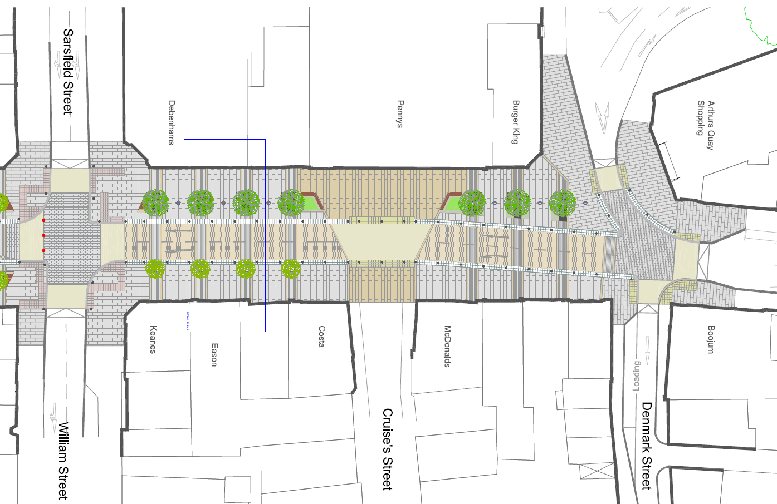

**Figure 1: Proposed Design - Denmark Street to William Street**

O’Connell Street will be converted to a shared surface between Denmark Street and William Street, with a combination of street furniture, tactile paving and bollards rather than kerbs to delineate the pedestrian space. Two lanes of general traffic will remain on this section of O’Connell Street.

A total of 14 trees will be planted on this block, with seven large trees planted directly at street level on the western side of the street, and seven slightly smaller trees in raised planters on the eastern side. Seating, other lower-level planting, and bicycle parking areas will be provided between the trees. These will provide rest areas and meeting points for pedestrians and cyclists, as well as acting as delineators between the carriageway and pedestrian area. The presence of trees and planting will also soften the hard landscaping on the street and introduce a natural element in the built environment. A plaza area on the western side of this block, directly opposite Cruise’s Street, creates a sense of place at the northern end of O'Connell Street and reduces the focus on through movements.

The junctions at Denmark Street and William Street will be raised level with the footpaths, and therefore traffic to and from Patrick Street, Denmark Street, Arthur’s Quay, Sarsfield Street and William Street will ramp up and down at these junctions. An uncontrolled pedestrian crossing will be provided at the western end of Cruise’s Street to cater for the pedestrian desire line across O'Connell Street at this location. This crossing will be ducted to allow for a future installation of signals should they be deemed necessary. Traffic signals will be retained at the William Street junction. A new bus stop will also be provided on Patrick Street, to the north of Denmark Street, in order to provide sufficient services to the city centre with the relocation of the existing stop outside the Augustinian Church further south.

Currently, no parking or other kerbside activities are permitted, and this arrangement is proposed to continue.

* 1. William Street to Roches Street

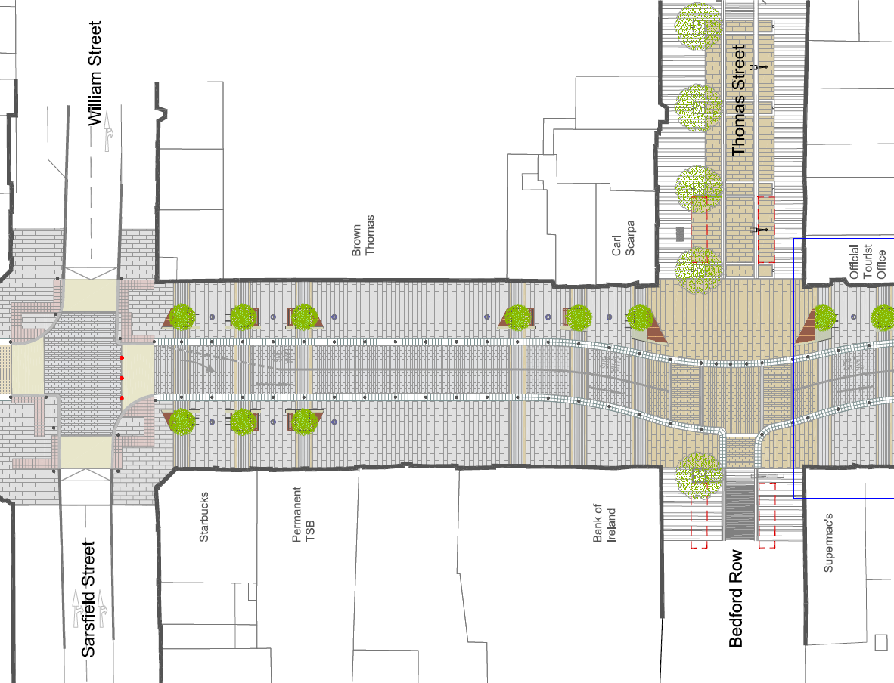

**Figure 2: Proposed Design - William Street to Thomas Street**

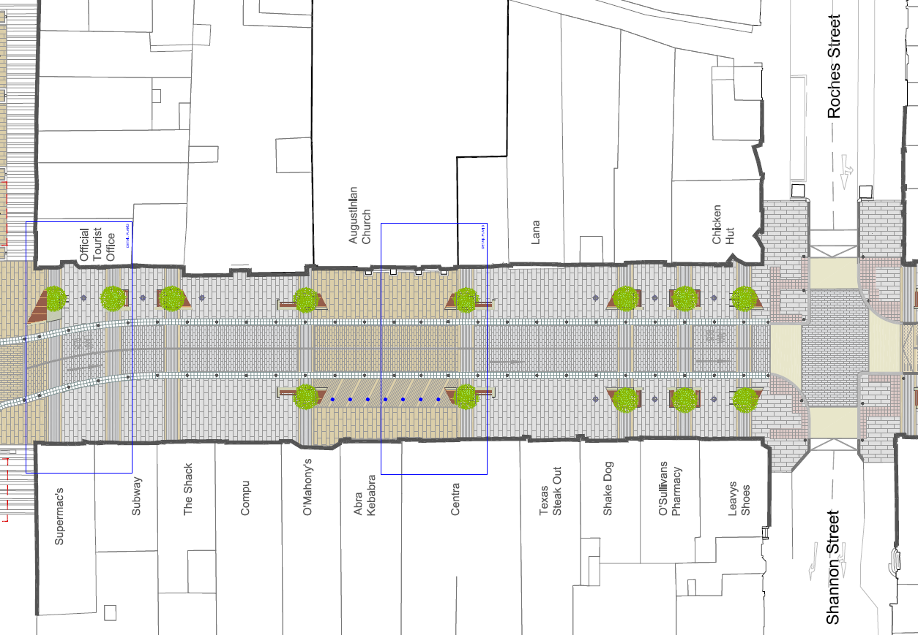

**Figure 3: Proposed Design - Thomas Street to Roches Street**

The proposed shared surface will continue from William Street to Roches Street. A combination of street furniture, tactile paving, bollards and short runs of guard rail will again be used instead of kerbs to delineate the pedestrian space. Two southbound vehicular lanes will be provided, with the left-hand lane dedicated as a bus lane, catering for buses, cyclists, and other public transport vehicles such as taxis, while the right-hand lane will remain as a general vehicular lane.

A total of 18 trees will be planted on these two blocks, with six at either end in a mirrored arrangement of three on each side. These will “bookend” the two central blocks on O’Connell Street which form the core retail centre of the city and the key pedestrian priority area. A further six trees will be located on the eastern side of the street on the approaches to Thomas Street. Seating, other lower-level planting, and bicycle parking areas will be provided between the trees in a similar arrangement to the Denmark Street – William Street block, providing continuity along the street. Areas of planting and street furniture will again act as delineators between the pedestrian area and proposed carriageway, as well as providing rest areas and meeting points for pedestrians and cyclists and alerting motorists to a change in layout at the junctions. The presence of trees will also soften the hard landscaping on the street and introduce a natural element in the built environment.

A horizontal deflection will be introduced in the vehicular route at the junction of O'Connell Street, Thomas Street and Bedford Row. The carriageway will deflect towards Bedford Row at the junction and revert to the centre of O'Connell Street to the south of the junction. Access will be maintained from Bedford Row, while access from Thomas Street will be closed permanently to vehicular traffic. This alignment provides flexibility for future alterations to the street should further public transport priority be deemed appropriate, or indeed further pedestrian priority among other options. The horizontal change in vehicle movement will provide a larger pedestrian plaza area extending and merging into Thomas Street, as well as creating a traffic calming measure to reduce vehicular speeds in this pedestrian-priority area. The central space in this plaza has the potential to accommodate the future installation of public artwork to generate a further focal point for pedestrian gathering. An interactive surface-level water feature will also be installed opposite the Augustinian Church (outlined in bold in **Figure 3** above).

Traffic travelling from Sarsfield Street to William Street (eastbound) and from Roches Street to Shannon Street (westbound) will ramp up and down at the junction with O'Connell Street. No parking or other kerbside activities will be permitted. Existing disabled parking bays, loading bays, taxi ranks etc. will be relocated to nearby side streets. The existing bus stop outside the Augustinian Church will be relocated to south of Roches Street.

* 1. Roches Street to Cecil Street

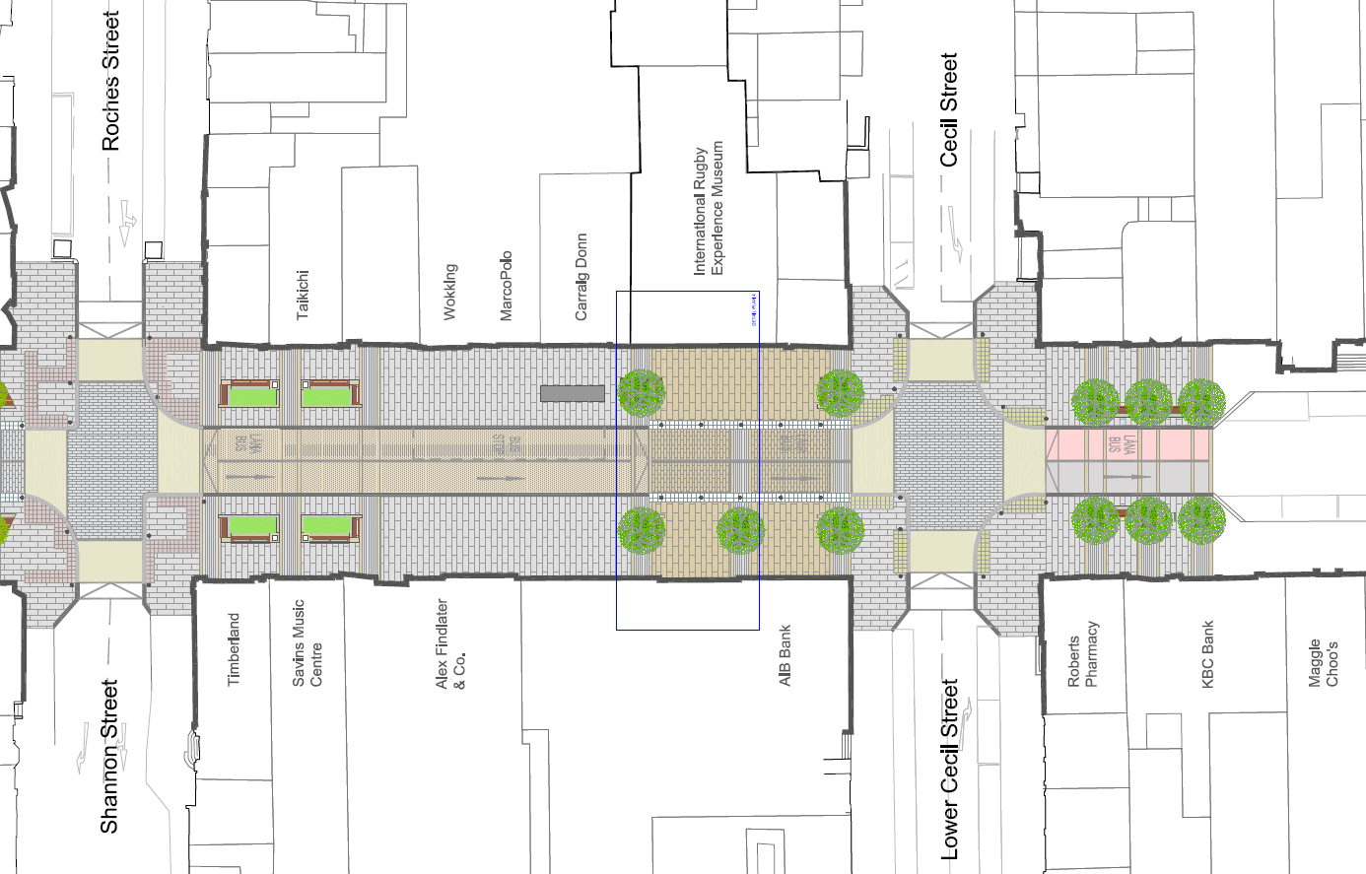

**Figure 4: Proposed Design - Roches Street to Cecil Street**

From Roches Street to Cecil Street and to the immediate south of the junction with Cecil Street, the arrangement of two vehicular lanes travelling from north to south will continue with a bus lane on the left and a general vehicular lane on the right. Southbound traffic will ramp down from the raised junction with Roches Street and there will be a level difference between the footpath and the carriageway on the northern section of this block. The carriageway here will be surfaced in asphalt to denote the non-shared nature of this section of the street. An in-lane bus stop will be provided in this section. No parking or other kerbside activities will be permitted. Existing disabled parking bays, loading bays, taxi ranks etc. will be relocated to nearby side streets.

A total of 11 trees will be planted on this block, around the junction of O'Connell Street and Cecil Street. These will act as a boundary to Phase 1 of the scheme, similar to the arrangements at the William Street and Roches Street junctions. Six trees will be planted on the southern side of the junction in a mirrored arrangement of three on each side. Five trees will be planted on the northern side in a similar arrangement, with three trees on the western side and two on the eastern side in order to frame the façade of the proposed International Rugby Experience. Seating, other lower-level planting, and bicycle parking areas will be provided between the trees on the western side. These will again act as delineators between the carriageway and pedestrian area, as well as providing rest areas and meeting points for pedestrians and cyclists and alerting motorists to a change in layout at the junctions. The presence of trees will also soften the hard landscaping on the street and introduce a natural element in the built environment.

An extended raised table junction at Cecil Street, similar to the shared surface areas further north, will act as a traffic calming measure and provide a sense of place at the proposed International Rugby Experience museum, which will occupy the corner of O'Connell Street and Cecil Street (outlined in bold in **Figure 4** above).

1. Design Statement
   1. Introduction

This section sets out the concepts and standards supporting and informing design decisions and describes the manner in which the proposed development responds to the project objectives.

* 1. Design Context
     1. Environmental Context

The proposed development has been designed with careful consideration to ensure minimal negative impacts on the environment, and with an aim of overall positive impacts. None of the proposals are considered to have any significant long-term impact on the environment, and any impact will largely be short-term during the construction stage. An EIA Screening and AA Screening have been carried out on the proposed development. The reports documenting these screening processes accompany this planning application.

* + 1. Design Standards

The proposed development has been designed with reference to and to comply with the Design Manual for Urban Roads and Streets (DMURS) in terms of the overall principles of design, such as viewing O'Connell Street as both a link and a place and use of the user hierarchy placing pedestrians ahead of motorists, and specific standards, such as lane and carriageway widths and appropriate corner radii.

Consultation with Limerick City and County Council Fire Department has ensured that the design of the proposed development complies with access requirements under the Building Regulations 2006 Technical Guidance Document B Fire Safety. This requires a minimum road width and access routes, which is provided as part of the proposed layout.

* 1. Design Team

The public realm design has been developed by a multidisciplinary Design Team consisting of the following:

* Design Lead including engineering and street operation – Arup
* Public Realm Design – Nicholas de Jong Associates

The environmental aspects of the project have been considered and assessed by an environmental team including:

* Environmental Screening – Arup
* Townscape and Visual Aspect – Nicholas de Jong Associates
* Traffic Modelling – Systra
* Conservation & Cultural Heritage – Judith Hill

The development of the design has been guided by all relevant directorates within Limerick City and County Council.

The O’Connell Street Revitalisation project is designed to provide an area of high quality public realm within the city centre core while facilitating movement through the area, and seeking to future-proof the street for potential alteration as sustainable transport provision increases.

* 1. Meeting Project Objectives
     1. Minimise transport-related impacts on the environment

The proposed development reduces the space on the street dedicated to private vehicles through a reduction in traffic lanes, parking and loading. General traffic will be reduced to one lane for over 270m, from William Street to south of Cecil Street. This will discourage through-traffic from travelling through the city rather than around it, while continuing to provide access to the city centre. A bus lane will be introduced along the same length of the street to encourage use of public transport and bicycles in the city centre, and contribute to increased mode share by sustainable modes. These measures combined will facilitate movement of people into the city as distinct from the movement of cars, and thus reduce the effects of the transport network on the surrounding environment.

* + 1. Moderate unnecessary vehicular traffic in the city centre and on O’Connell Street in particular

As described above, general traffic will be reduced to one lane for over 270m, from William Street to south of Cecil Street. Along with the introduction of raised tables at junctions, and narrower vehicular lanes on O'Connell Street, this will discourage through-traffic from travelling through the city rather than around it, while continuing to provide access to the city centre.

* + 1. Create an attractive public realm to facilitate increased footfall on O’Connell Street

The total pedestrian area on O'Connell Street will be increased by approximately 1,750m2 under the proposed design. This represents a 37% increase on the public realm area at present. Space dedicated to vehicular traffic on the street will reduce by 925m2, a reduction of 28%. The remaining 825m2 of new pedestrian area will be created by reducing on-street parking and relocating disabled parking spaces, taxi ranks, loading bays etc., as shown on drawing number OCS-L-011.

The existing and proposed increased pedestrian area will form the majority of the public realm improvements on the street, with footpaths widened significantly. Wider footpaths will incorporate areas for meeting, numerous seating areas, 43 trees, additional planting including grass and low-level shrubs and flowers. An interactive water feature opposite the Augustinian Church will create a feature of interest in the middle of this block. The raised tables at junctions will provide continuity of movement for pedestrians, while plaza areas at Cruise’s Street, Thomas Street and at the proposed International Rugby Experience will contribute to an increased sense of “place” to foster the idea of the street as a destination as well as a link.

* + 1. Provide improved access to the city centre for all, through an efficient and reliable transport network

The implementation of a bus lane on three blocks of O'Connell Street, Limerick’s main street, creates an opportunity to improve bus service reliability and efficiency. Access to and through the city centre by private car remains possible, however as described above the road space currently allocated to the private car will be redistributed amongst pedestrians (through improved public realm and footpath areas), public transport and cycling (through provision of the bus lane).

The design also permits flexibility in terms of future pedestrianisation and/or public transport provision, whereby it will be possible through the use of automatic bollards to close the section of O'Connell Street between William Street and Roches Street to traffic entirely, or indeed to create a public transport-only corridor should that become viable in the future.

* + 1. Promotion of walking and cycling in the city centre

The proposed design includes widening of footpaths to a minimum width of 4m, with most locations significantly wider than this. Seating areas will be provided throughout in order to provide rest areas for pedestrians, with pedestrian plazas to provide meeting areas on the street in tandem with wide footpaths to allow through movement by pedestrians. The creation of plazas and focusing on the street as a place as well as a link will contribute to the attractiveness of the area, which will encourage walking through more pleasant surroundings.

Due to the existing one-way system within the city centre, and the limited cycle network, it was not proposed to include cycle lanes on Phase 1 of the O'Connell Street Revitalisation as it would not provide additional cyclist connections over the relatively short length of the scheme. However, the inclusion of the bus lane on the eastern side provides a less heavily-trafficked lane for use by cyclists, improving ease of movement southbound. The design will also accommodate with minimal amendments a two-way dedicated public transport corridor with segregated cycleways if required under the Limerick Metropolitan Area Transport Strategy. Bicycle parking stands will be integrated with proposed seating areas to provide safe areas for locking bicycles with passive surveillance.

* + 1. Provide a safer environment for users of the city centre

The scheme has been designed with the aim of improving the safety of all road users on O'Connell Street and the connecting side streets. Narrowing of the carriageway, introducing raised tables at junctions, and providing a shared surface across the street for three and a half of the four blocks will create traffic calming measures to reduce vehicular speeds. The creation of plazas and large areas of public realm will emphasise to motorists on the street that O'Connell Street is a place as well as a link for through movement, and increase visibility of pedestrians and vulnerable road users.

The removal of kerbside activities such as loading and parking will also improve visibility between pedestrians and drivers, and reduce risks for cyclists travelling along the street and pedestrians crossing the street from between parked vehicles. The narrowed carriageway and raised tables will also improve ease of crossing O'Connell Street and the side streets at each junction for pedestrians.

* + 1. Improve ease of movement in the city centre, particularly for vulnerable road users

A number of measures were included in the proposed design in order to improve ease of movement within the study area. These include a shared surface between Denmark Street and Roches Street, which will slow vehicular speeds and provide comfort and more freedom of movement for pedestrians, and in particular mobility impaired pedestrians, by removing kerbs and level differences. Tactile paving will be included along the edge of the carriageway in these areas to guide visually impaired pedestrians.

Raised table crossings at the junctions with side streets will improve ease of crossing for pedestrians by providing a surface at one level along the length of the proposed scheme, which will particularly benefit mobility impaired users.

Provision of a bus lane along three blocks of O'Connell Street will make it easier to access public transport services, and also offer a southbound priority route for cyclists to and through the city centre.

* + 1. Increase public transport accessibility in the city centre

There are currently no public transport priority measures within the city centre. Provision of a bus lane along three blocks of O'Connell Street will improve public transport efficiency, reliability, visibility and accessibility. Removal of on-street parking will improve access to services at bus stops. While the stop outside the Augustinian Church will be relocated south to the next block, an additional bus stop will be provided on Patrick Street in order to improve public transport coverage of the city centre, and the stops on Sarsfield Street and Henry Street will remain under their existing layouts, which are in close proximity to O'Connell Street. The design will accommodate with minimal amendments a two-way dedicated public transport corridor with segregated cycleways if required under the Limerick Metropolitan Area Transport Strategy.

* + 1. Support Limerick’s strategic economic and sustainable planning aims

A number of planning and policy documents, including the Limerick City Development Plan, Limerick 2030, the Mid-West Area Strategic Plan (MWASP) and the Limerick Movement Framework Strategy (MFS), include objectives relating to O'Connell Street. These range from providing for public realm and public transport improvements on O'Connell Street, to potential pedestrianisation of O'Connell Street and pedestrian improvements at junctions, to a city centre transport strategy, which is currently under development by Limerick City and County Council in partnership with the National Transport Authority. The proposed development will support these aims, by providing pedestrian and public realm improvements as set out above, providing a public transport priority corridor, and providing a flexible design which can be adapted to the future needs of the city.

* + 1. Promote low-carbon strategies in accordance with the European Regional Development Fund funding conditions.

The proposed development significantly reduces the space allocated to private cars on O'Connell Street, and provides bus and cyclist priority as well as pedestrian space in its place. This will contribute to the reduction in carbon emissions in the city, and sets a precedent in terms of introduction of public transport priority to encourage further reduction of car usage.

1. Conclusion

This report supports a Part 8 Planning Application for the proposed O’Connell Street Revitalisation Project (Phase 1).

The proposed development will result in substantial improvements to the existing public realm and will enhance the public realm in the city centre, as well as pedestrian, cyclist and public transport access to this area of the city.

The proposed development is considered to be in accordance with the proper planning and sustainable development of the area and is in accordance with local planning policies and objectives.

The potential impacts, including environmental, arising from the scheme have been reviewed and assessed. It is concluded that the construction of the proposed scheme will have no significant impact on the receiving environment, provided the recommendations of the environmental screening reports are followed.

It is recommended that the Council proceed with the proposal as shown on the drawings accompanying this report.