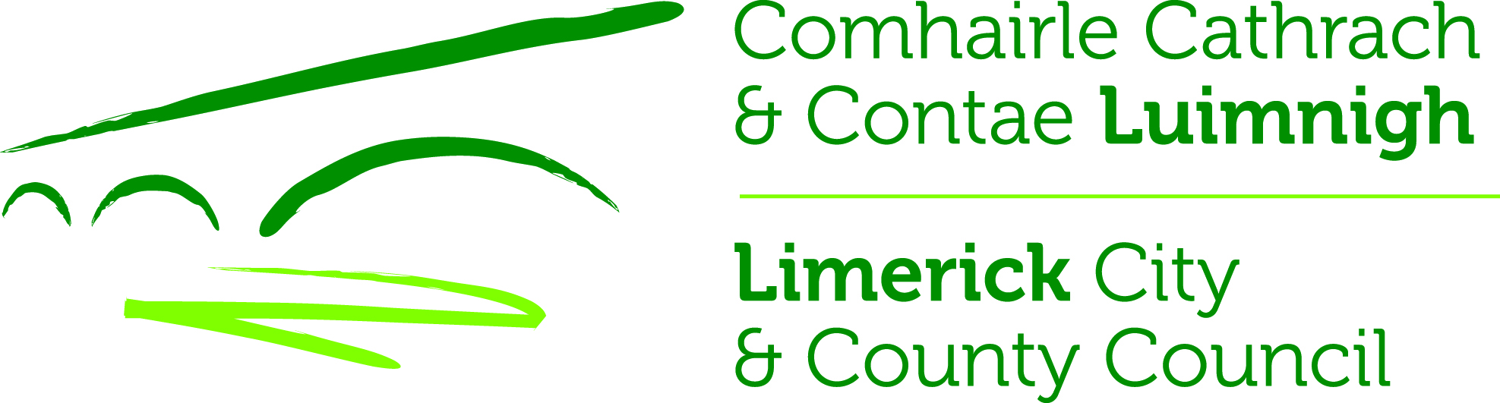
LIMERICK CITY & COUNTY COUNCIL
PLANNING AND ENVIRONMENTAL SERVICES
City & County Council Offices,
Dooradoyle Road (061)556556

Planning and Development Acts 2000 (as amended)
Planning & Development Regulations 2001 (as amended)

PROPOSED DEVELOPMENT BY, ON BEHALF OF OR IN PARTNERSHIP WITH
LIMERICK CITY & COUNTY COUNCIL

OFFICE USE ONLY

CHECKED BY: DATE RECEIVED:
PART 8 FILE NO:

LOCATION OF PROPOSAL:

Address of site of proposed development (e.g. street, townland etc):

Limerick Greenway Hub, Kilreash, Ardagh, Co. Limerick

DETAILS OF PROPOSAL:

Nature and extent of development proposed:

Development of the Limerick Greenway Hub @ Ardagh. The Ardagh Station House, Goods Shed, Railway Carriage and site will become one of the main Visitor Experience and Service Centre Hubs on the Limerick Greenway. Development to include:

- Refurbishment of the Ardagh Station House and Goods Shed (which is a protected structure, RPS 900) and change of use to commercial, community and tourism use.
- The refurbishment and renovation of the Station House and Goods Shed and associated site works.
- Develop a scheme to include toilets, café, retail, bike hire, playground facility, visitor information, interpretation, community space and public realm.
- The provision of car parking spaces, universal access parking spaces, electric vehicle charging point spaces and camper van parking bays.
- Installation of a railway carriage on the site for community, tourism and culture use.
- Provision of an extension to the Station House for café/retail use.
- Provision for an extension to the Goods Shed to facilitate site services for campervan users.
- Provision of a container for bike hire storage.
- Provision of fully serviced site including public lighting, water, broadband, drainage connections, power, etc. and all associated site development works including landscaping scheme.
- New connection to existing public sewer and all associated site works including installation of a holding tank and mechanical pumping system to nearby Irish Water pump station.
- Connection to Irish Water watermain on public road.
- Construct storm water network on site and discharge to outfall.
- Installation of greenway furniture including seating, benches, bins, cycle stands, bike repair station and water refill station.
- The removal of a section of stone wall to facilitate the widening of the existing entrance to accommodate 2-way traffic.

In the case of applications for a material change of use or for retention of such material change of use please state:

(a) Existing Use: Derelict Station House and Goods Shed

(b) Proposed Use: As above

(c) Nature and extent of any such proposed use: As above
___________________________________________________________________
No. of residential units proposed (if applicable)

Total: Houses 0 Apartments 0

Area of site: Hectares 1.15h Acres 2.85a

(1 Hectare = 2.471 acres)

LEGAL INTEREST::

Legal Interest of applicant in site of the proposed development

Owner Yes X No______ Other ____________(Please specify)

If applicant is not the owner, state name and address of owner and include documentary evidence of consent of the owner to make the application

_________________________________________________________________

_________________________________________________________________

PUBLIC NOTICES:

Name of Newspaper in which public notice was published:
Limerick Leader & Weekly Observer

Date of publication: 09/11/2023

Date of erection of Site Notice: 09/11/2023

FLOOR AREA: Residential

- New Building(s) Residential - Floor Area per unit ____________ sq. metres
Gross Floor Area ____________sq. metres

(b) Extension to dwelling Gross Floor Area ________________ sq. metres

(c) Other domestic (sheds, garages Garden shed)
Floor Area per Unit _______________ sq. metres
Gross Floor Area _______________ sq. metres

FLOOR AREA : Other

- Other Development i.e. Car Parks etc. Floor Area per unit _____ sq. metres
Gross Floor Area _____ sq. metres
(e) Change of Use Floor Area per unit ___ sq. metres
Gross Floor Area 239.2 sq. metres

ENVIRONMENTAL IMPACT ASSESSMENT REPORT:
Is an E.I.A.R. submitted with this application: Yes No X

Signed on behalf of Limerick City & County Council:
Ben Noonan (SEE) – Economic Development, Enterprise & Tourism Directorate

Date: 09/11/2023

