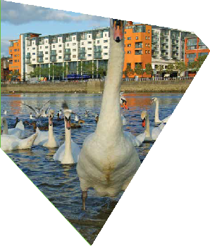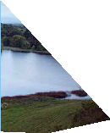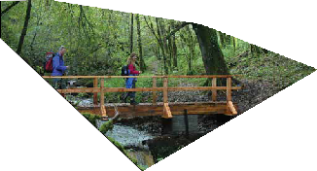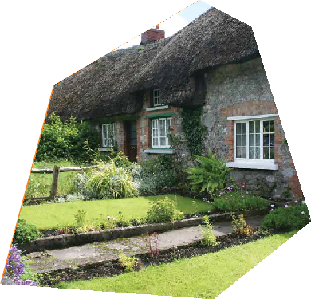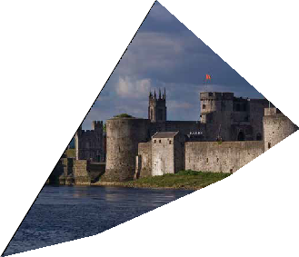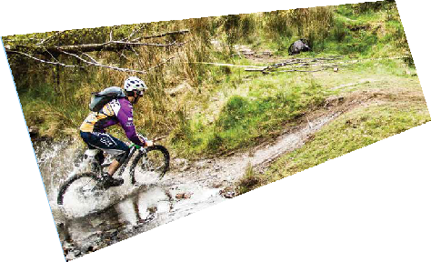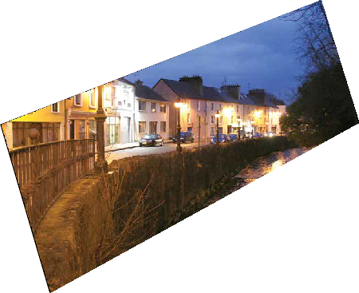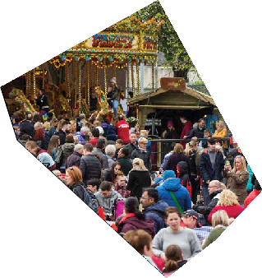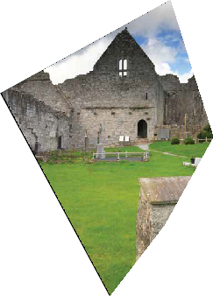
LIMERICK DEVELOPMENT
PLAN 2022-2028
What is your vision for Limerick?

The vision of the Limerick Development Plan should include a single approach to the sustainable growth of Limerick as a whole, with a dynamic city and robust towns, villages and rural areas. At
the core will be cohesive and sustainable communities where opportunities exist and where our cultural, natural and built environment is protected.

What is your vision for Limerick?

Shannon Estuary

N69

Shannon International Airport

Pallaskenry

N18
River Shannon
Castleconnell

Limerick City

M20

M7

Mulkear R.

Murroe
Cappamore

Foynes
Askeaton
Patrickswell
Doon

Glin

Shanagolden

R. Deel

N21
R. Maigue

Rathkeale

Adare

Croom
Caherconlish

Lough Gur
Bruff

N24

Oola

Athea

Abbeyfeale

R. Feale

Newcastle West

Dromcollogher
Ballingarry
N20

Bruree
Hospital

Kilmallock

Kilfinane

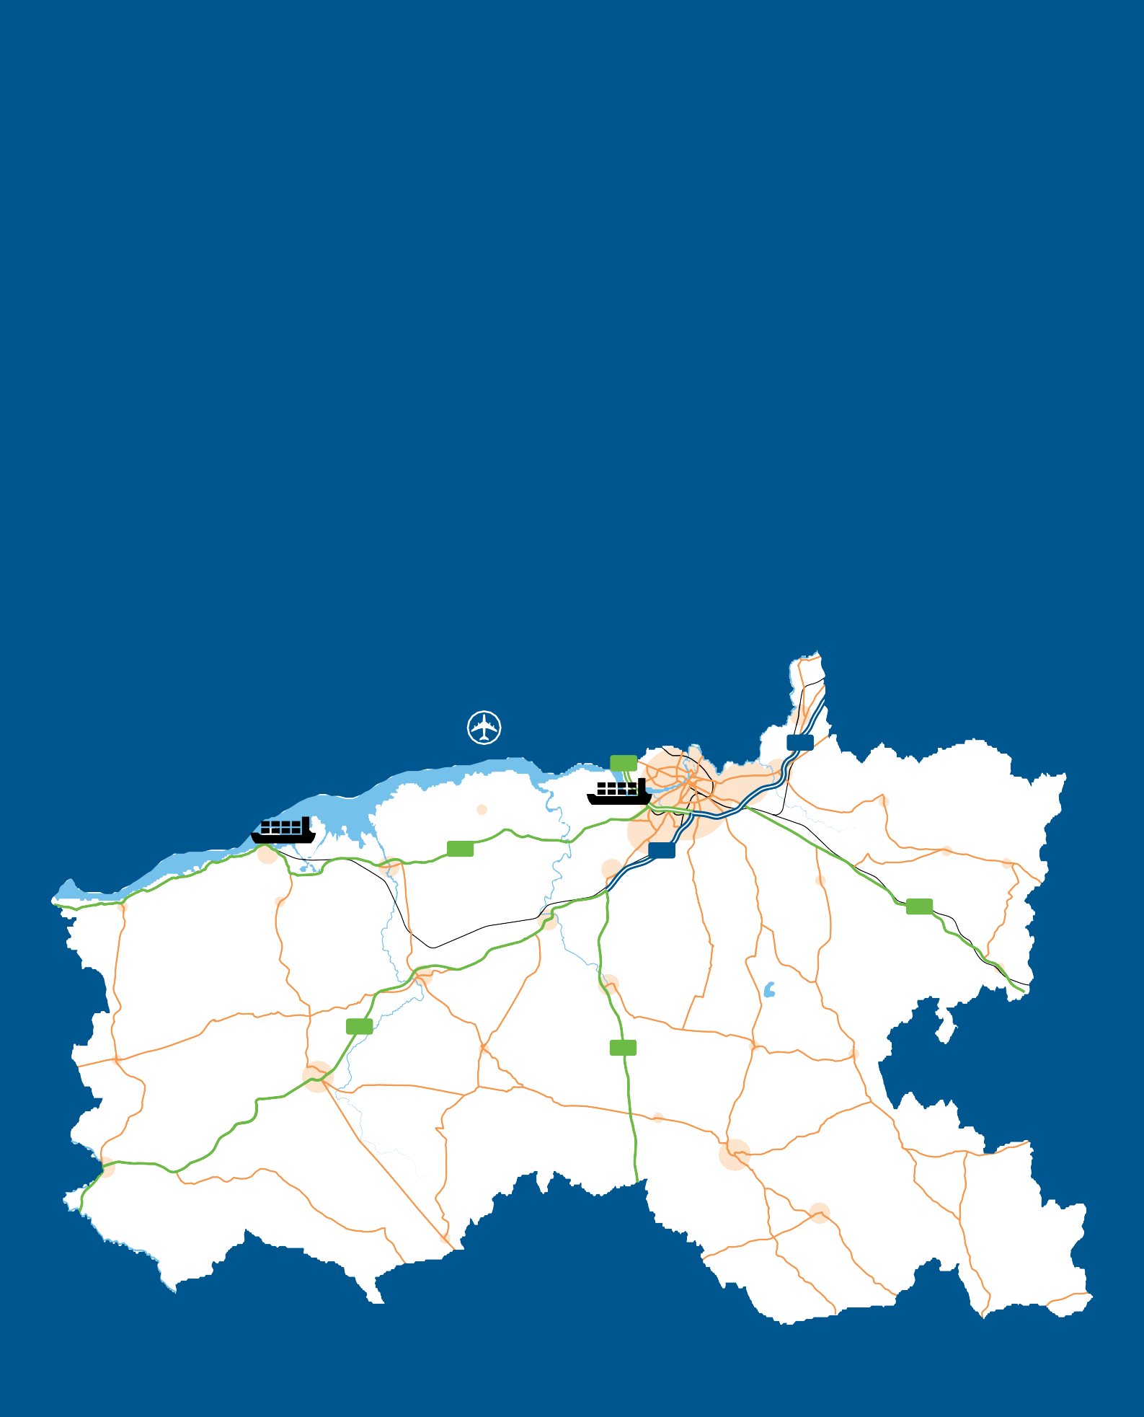

2 \ 3

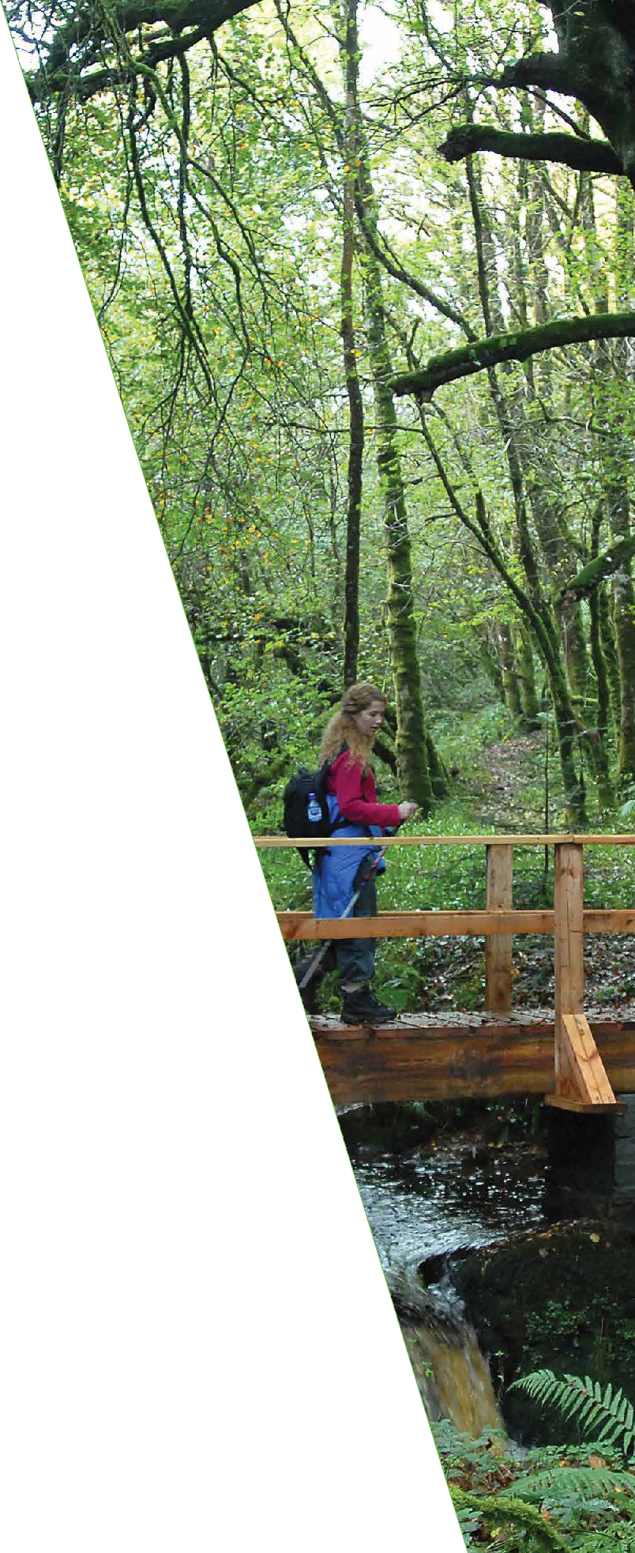

Our Plan for Limerick
Limerick City and County Council is commencing the preparation of the Limerick Development Plan 2022-2028.
The Limerick Development Plan will be the first combined plan for Limerick City and County since the merger of the two local authorities in 2014. The legal basis, function and adoption process for Development Plans is set out in the Planning and Development Act 2000 (amended).
The preparation of the Limerick Development Plan is one of the most important functions of the council acting as the blueprint for the development of Limerick from a physical, economic, social and environmental viewpoint.
The process includes a review of the existing Limerick City Development Plan 2010-2016 (as extended) and the Limerick County Development Plan 2010-2016 (as extended) and will set out the overall strategy for the proper planning and sustainable development of Limerick as a whole over a six year period up to 2028.
The Development Plan review has come at a challenging and unprecedented time where the recovery of our economy, rebuilding of our society, renewing of our communities and responding to the wide ranging
challenges we now face, is critical for our county and indeed our country post the Covid-19 pandemic.

Stage 1
Development
Plan Process
Pre-Draft (Weeks 1 – 48)
August 2020
– June 2021
AUGUST 2020

SEP OCT
NOV DEC
JANUARY 2021

FEB MAR
APR MAY
JUN

August/October 2020
Public Consultation – Issues Paper

November 2020
Chief Executive Report on Consultation
January 2021
Directions from Elected Members

February/March 2021 Preparation of Draft Development Plan

Stage 2

Development Plan
(Weeks 48-85)
June 2021 –
February 2022
JUL AUG
SEP OCT
NOV

DEC
June/August 2021
Public Consultation - Draft Plan

September/October 2021
Chief Executive Report on Submissions

January 2022

Stage 3

Amendments to Draft Plan (Weeks 85-104)
February 2022
– May 2022

4 \ 5
JANUARY 2022

FEB MAR
APR MAY 2022
Consideration of Chief Executive Report by Elected Members

February 2022 Preparation of Material Amendments
February/March 2022
Public Consultation – Material Amendment
April 2022
Chief Executive Report on Submissions
May 2022
Considerations of CE Report by Elected Members
Adoption of Limerick Development Plan 2022-2028

How do you see Limerick in 2028?
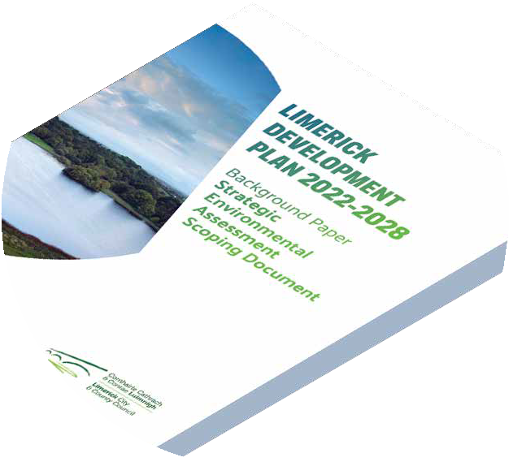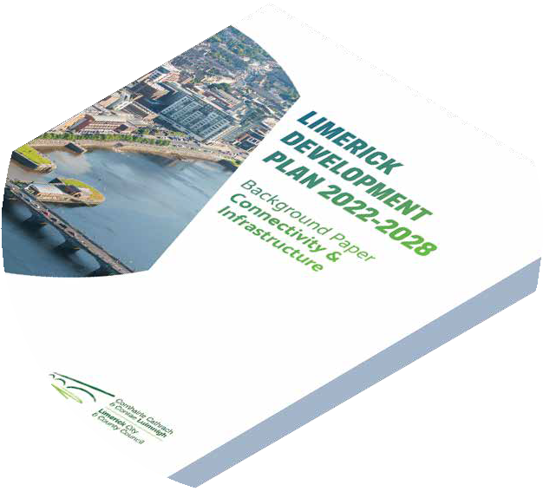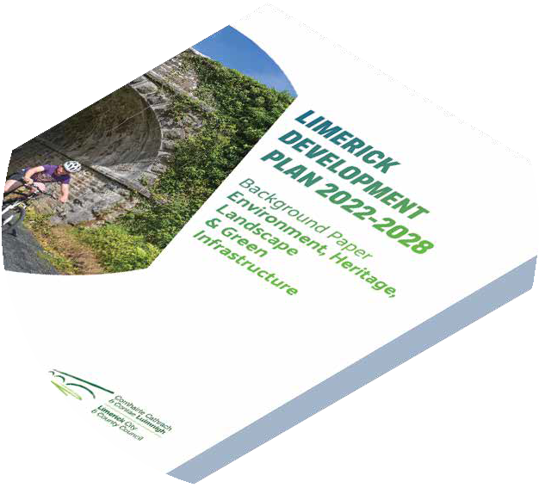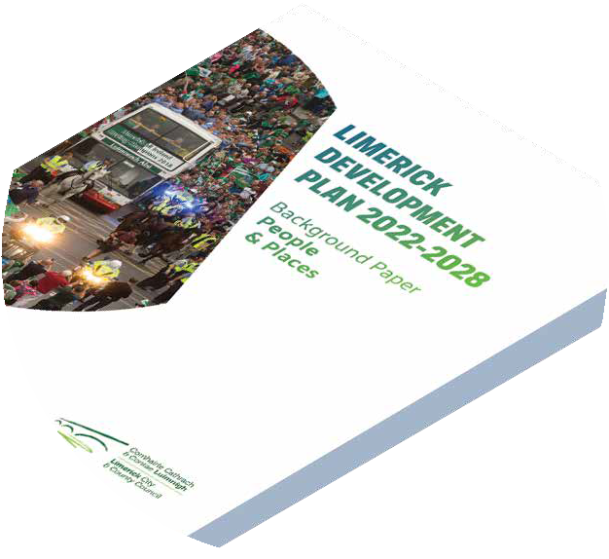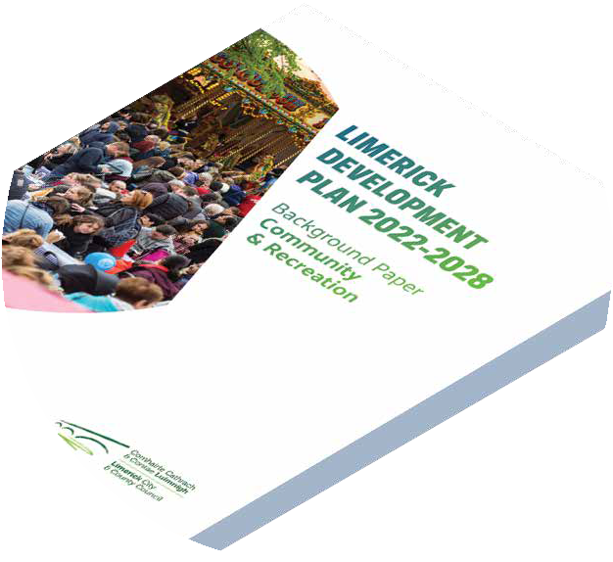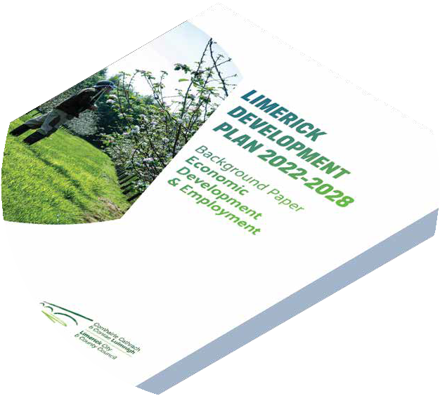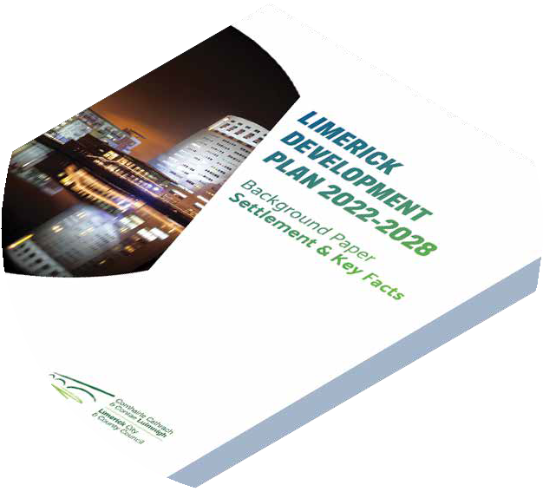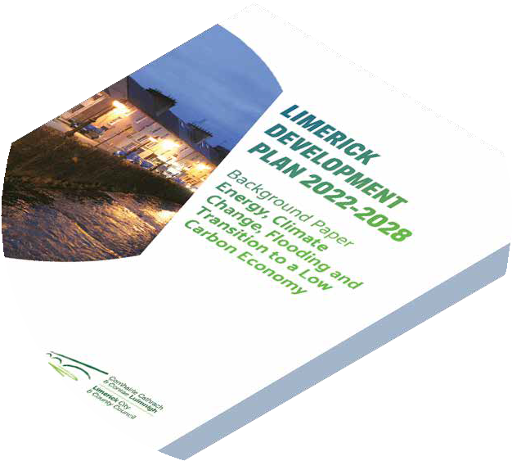The publication of this document, which is the Issues Paper, is the first step in the making of the Limerick Development
Plan. This consultation document presents an overview of the main planning and development issues in Limerick and seeks to encourage public debate on what broad issues should be considered in the new Plan.
The Limerick Development Plan presents an opportunity to the general public to shape Limerick for the future and ‘have your say’ when it comes to important issues such as housing, economic development, community and heritage. You’re input into this process by considering the ‘bigger picture’ issues facing Limerick, is crucial to its success.
Split into eight themes, additional supportive material is included as separate ‘Background Papers’. The issues and questions outlined are by no means exhaustive, instead acting as a guide to stimulate thoughts, feedback and debate

on guiding the future of Limerick.
www.limerick.ie/limerickdevelopmentplan

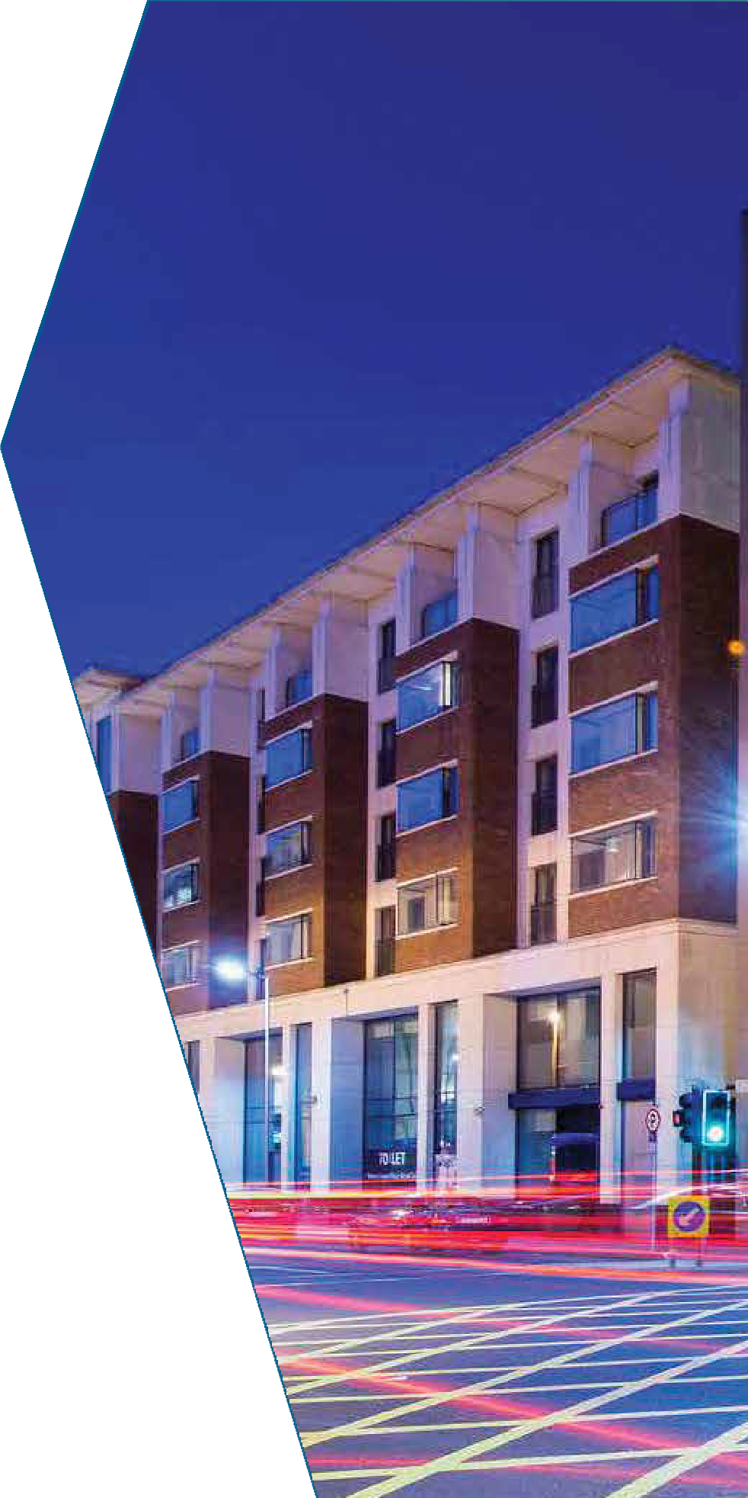Guiding the Plan

6 \ 7

The Limerick Development Plan will be guided by the UN Sustainable Development Goals and will be
consistent with the National Planning Framework ‘Project Ireland 2040’ and the Regional
Spatial and Economic Strategy for the Southern Region in areas such as climate action,
clean energy, sustainable cities and communities, economic growth, reduced
inequalities and innovation and infrastructure, as well as education and health.

United Nations Sustainable Development Goals
The 2030 Agenda for Sustainable Development encourages countries to develop national responses to the
Sustainable Development Goals (SDGs) and incorporate them into planning and policy.
Adopted by all United Nations member states, “Agenda 2030” focuses on 17 Sustainable Development Goals (SDGs) that integrate the three dimensions of

sustainable development – economic, social and environmental.
This application of the SDG’s at local level will allow us to set out clearly what kind of society we want to live in and how we want to measure it. Each theme discussed in the Plan will include an alignment with the UN Sustainable Development Goals
In your opinion,
what UN Sustainability Goals are most relevant for Limerick?

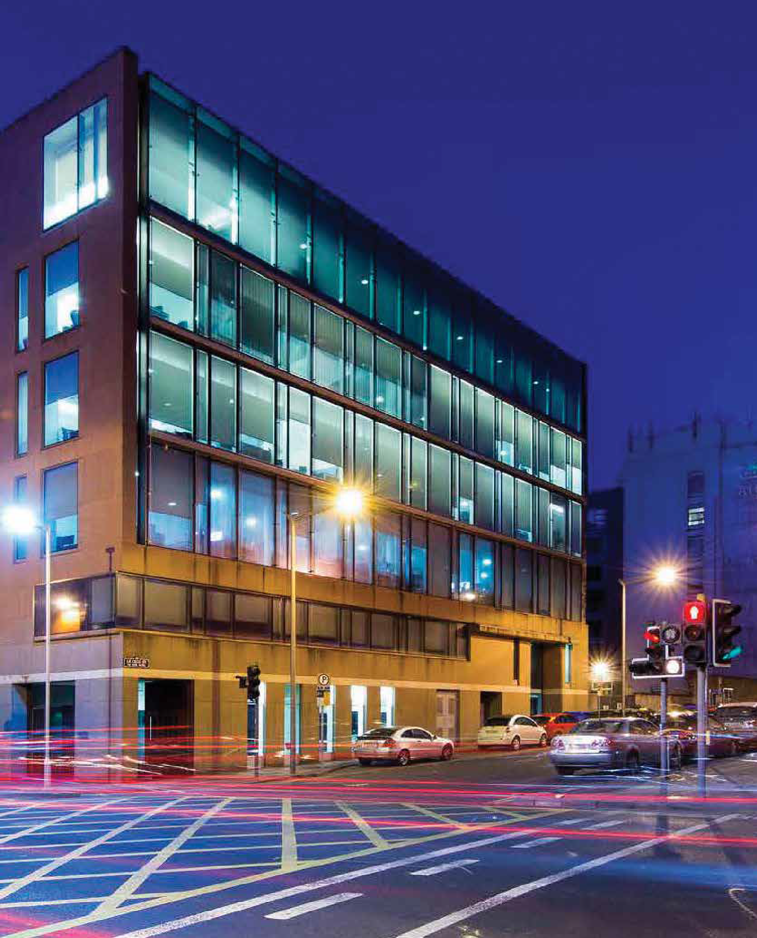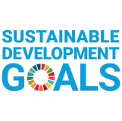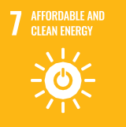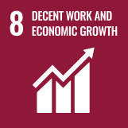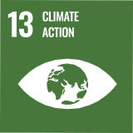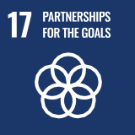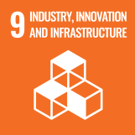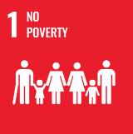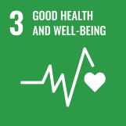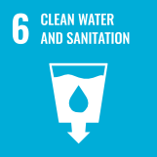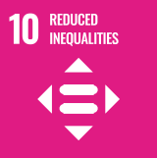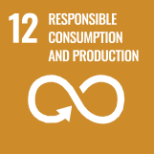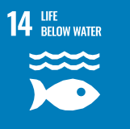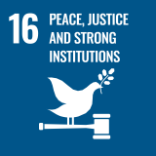

www.un.org/sustainabledevelopment

Project Ireland 2040 – National Planning Framework

The National Planning Framework (NPF) is a national document, which will guide high level strategic planning and development for the country over the next 20+ years. The NPF aims to guide the future development of Ireland taking into account a projected population increase of 1 million people, 660,000 additional jobs and 550,000
homes by 2040.

The NPF’s focus is on compact growth, strengthening rural economies and communities, high-quality international connectivity, a low-carbon and climate- resilient society, sustainable water and environmental resources, access to high- quality health, education and childcare services.
Some of the objectives and projects planned under the NPF for Limerick include
- An additional 56,000 people in Limerick City and Suburbs by 2040
- 50% of new homes will be within the existing built up area in Limerick City and Suburbs and 30% in our towns and villages.
- City Wide public transport network
- Implementation of the Limerick 2030 economic strategy
- Sustainable greenfield development
- Regeneration of City’s Georgian Quarter
- Expansion of third level institutions

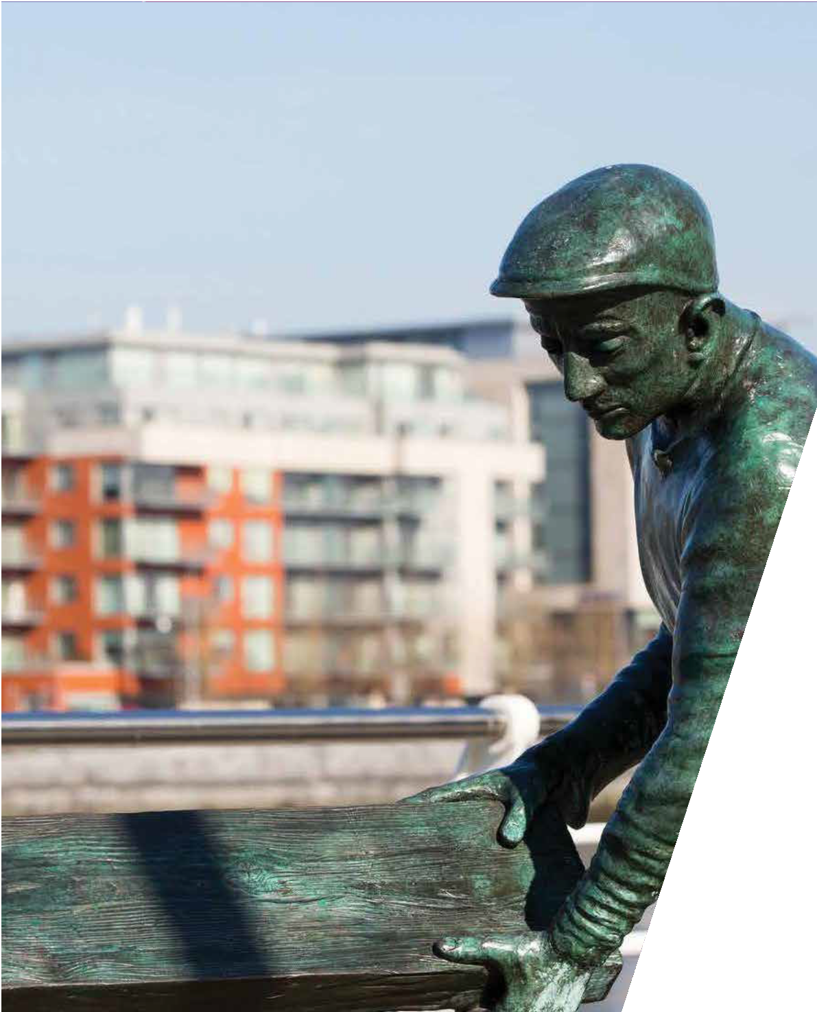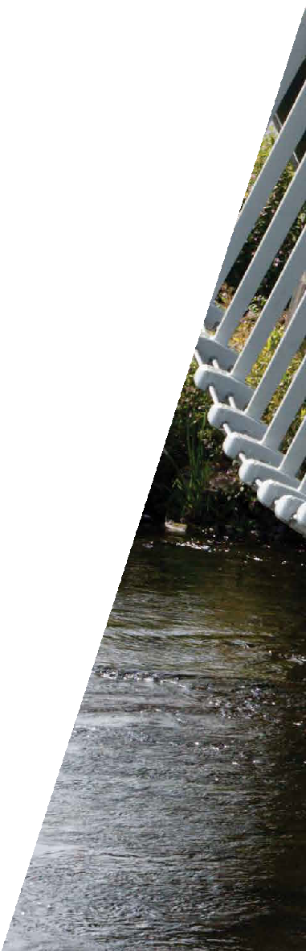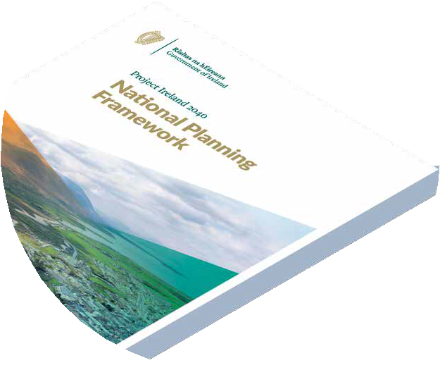
8 \ 9
1. Compact Growth | 2. Enhanced Regional Accessibility | 3. Strengthened Rural Economies and Communities | 4. Sustainable Mobility | 5. A Strong Economy supported by Enterprise,  Innovation and Skills
6. High-Quality International Connectivity | 7. Enhanced Amenity and Heritage | 8. Transition to a Low Carbon and Climate Resilient Society | 9. Sustainable Management of Water, Waste and other Environmental Resources | 10. Access to Quality Childcare, Education and Health  Services

www.npf.ie

Regional Spatial & Economic Strategy

The Regional Spatial and Economic Strategy for the Southern Region (RSES) sets out a 12-year strategic development framework for the delivery of the objectives of the National Planning Framework within the Southern Region.
The RSES includes a Metropolitan Area Strategic Plan for the Limerick – Shannon Metropolitan Area. A key component of the RSES is to strengthen the settlement structure of the Southern Region. This aims to capitalise on the strength of the region’s cities (Limerick, Cork & Waterford), metropolitan areas, key towns, towns and villages and key networks. The RSES also
seeks a revitalised rural area to make it one of Europe’s most creative, innovative, green and liveable regions.

Strengthen our cities and
metropolitan areas; our network of towns; villages and our rural areas

Optimise our international port and digital connectivity

Build an inclusive outward looking international region on the global stage
Enhance transport and
digital connectivity and accessibility allied to settlement hierarchy

Strengthen and protect the region’s diversity, language, culture, recreational assets,
natural & built heritage

Improve the quality of life in the region’s diverse rural communities

Safeguard and enhance
our environment through sustainable development
Transform our transport
systems towards well-functioning, sustainable integrated modes

Provide infrastructure and services in a sustainable,
planned manner

Build a competitive, innovative and productive economy

Improve education, health and public services and facilities for all citizens

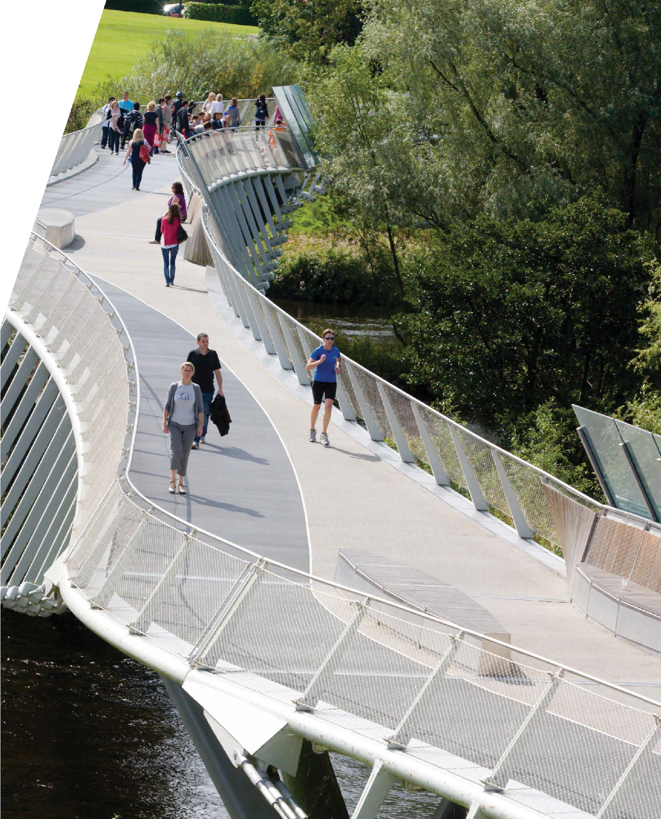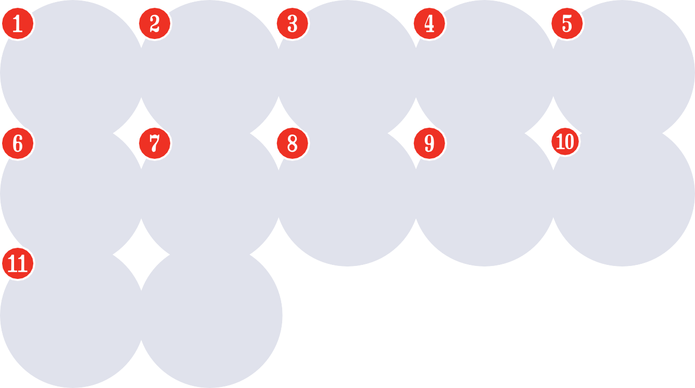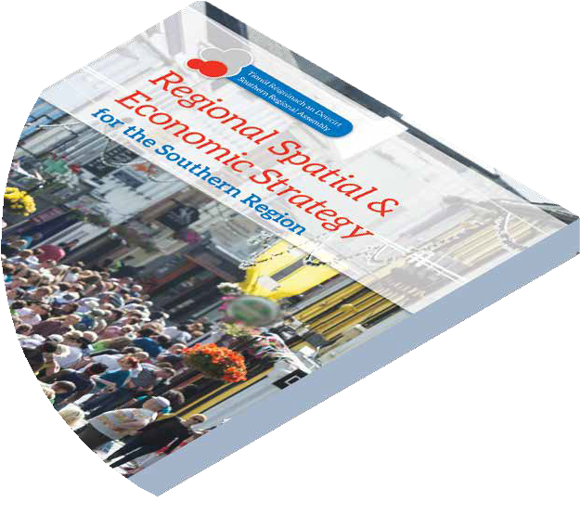
www.southernassembly.ie/regional-planning

People & Places
The National Planning Framework identifies Limerick for significant growth to 2040, which includes a 50% population increase for the city and suburbs. The Limerick Development Plan will play a crucial part
in creating the conditions to accommodate these ambitious targets for Limerick City and suburbs. Development of Newcastle West
as a key town and consolidating Limerick’s towns and villages will also be a key element of the proposed Development Plan.

+3,090
people between 2011 & 2016 Census
Population
The Plan will promote the use of appropriate residential densities and the identification
of infill and brownfield development to consolidate development in the city. The urban centres of our towns and villages need to be reinforced as the central hub of activity resulting in vibrant and bustling towns and villages with a diverse mix of uses.
The Core Strategy sets out key locations for population and housing as required under the Planning and Development Act 2000 (Amended). While the Core Strategy guides the development of designated settlements within Limerick, there remains an ongoing demand for rural one-off dwellings in the
10 \ 11

rural hinterland. The Council acknowledges this demand and seeks to ensure that
a balance is struck between facilitating housing for people who have a rural housing requirement (demonstrating economic and social need) while ensuring that balanced sustainable development takes places in our towns and villages.

County | Limerick
Population 2016 | 195,000
Projected  Population 2026 | 229,000 – 235,500
Projected  Population 2031 | 246,000 – 256,500

Consider the following questions:

How do we encourage more people to live close to where they work so they can walk, cycle or use public transport?

170
Schools (primary, specialist & post primary)

18
libraries
What tools can be used to deliver compact growth on infill and/or brownfield sites in our city, towns and villages?

28
Playgrounds

How do you think we can bring vacant and derelict buildings back into use?

1,666
One-off houses granted 2010-2019
Source: CSO
How can we achieve vibrant
towns and villages, while allowing dispersed rural development?

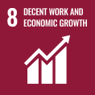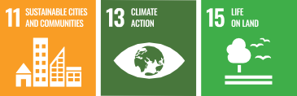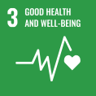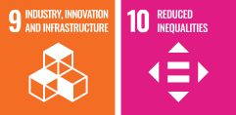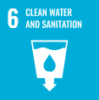Links:

13,135
6.7% of population is 0-4 years
Background Paper:
•
People & Places
  - Settlement and Key Facts

Economic Development & Employment

National and Regional Policy have earmarked Limerick and the Midwest Region as an important driver of national growth and a
key regional centre in the Irish and European economy.
It is crucial that policies and objectives set down in the Limerick Development Plan provide the foundations to bring people and economic activity back into the city
supporting the creation of quality jobs, in the right locations while creating a vibrant county with a high-quality environment.
A key focus of the plan will be strengthening our smaller towns and villages as well as rural areas by investment in services and policy support to return them to the strong, active and economically vibrant local drivers they once were.
The recent brand launch of ‘Limerick: Atlantic Edge, European Embrace’ aims to internationalise Limerick as a destination of inward investment, industry, tourism,
education, the arts and culture and for people to live and work in.
Tourism is increasingly playing a significant role in the growing economy of Limerick.
The Plan has a key role in facilitating the development of Limerick’s tourism potential.

12,000
new jobs created in
Limerick over the
last 5 years
Client Companies
57 home to
IDA Ireland

9,560
activecenterprises
investment in new enterprise and property
€1bn+
infrastructure as part of
Limerick 2030

3 renowned third
level institutions
24,000
3rd Level Students

12 \ 13
Rent Figures
15% lower than national
average

Consider the following questions:

How can we attract new employers and highly skilled works to Limerick?
Employment by Sector, 2016
Suburbs
City &
County
City &
Agriculture,
forestry & fishing
Manufacturing
industries
Transport and
communications
Professional
services
Building and
construction
Commerce
and trade
administration Other
Public
0.3%
Source: Derived from CSO, Census 2016
How can the Development Plan assist in revitalising our
City Centre?
21.1%
25.5%
4.3%
8.7%
23.1%
13.7%
3.2%

16.7%
25.0%
4.4%
7.3%
21.4%
14.9%
4.8%
5.5%

What can the Development Plan do to support tourism in Limerick?
How do we protect traditional on- street retailing with the increase of online shopping?

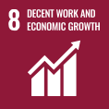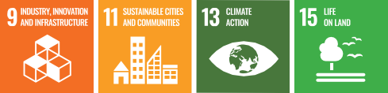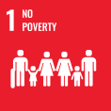Links:
Background Paper:
  - Economic Development and Employment

Connectivity

National and Regional Transport Policy emphasises the need to reduce the demand for travel and the reliance on the private car in favour of public transport, car-pooling, cycling and walking. Current transport trends are unsustainable and in order to meet future travel demand, change is needed.
Limerick City and County Council in partnership with the National Transport Authority are currently preparing the Limerick Shannon Metropolitan Area Transport Plan.
The strategy will consider all transportation modes in developing a comprehensive transport strategy for the area. Movement and transport policy will be a critical aspect of the plan for whole of Limerick playing
a central role in achieving sustainable development.
Connectivity advancement however is not just physical. Telecommunication infrastructure and broadband capacity represent one of the most critical steps in creating a more competitive economy. Limerick City and County Council is committed to examining how Limerick can increasingly use integrated digital
14 \ 15
technologies, ICT, data and analytics to operate in a smarter, more efficient way of living. Limerick’s proactive approach to
smarter technologies can be seen in being awarded the first Irish European ‘Lighthouse’ City and the role out of the European Union
+CityxChange Programme in the city.
Key Enablers

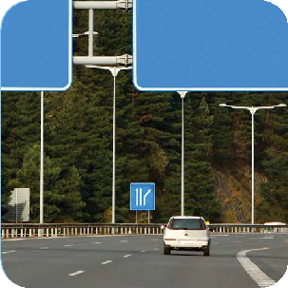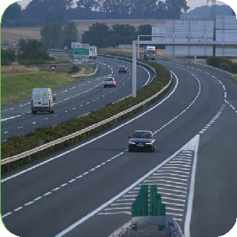
N21/N69
Foynes to Limerick Road Improvement Scheme including Adare Bypass
M20
Limerick to Cork Scheme

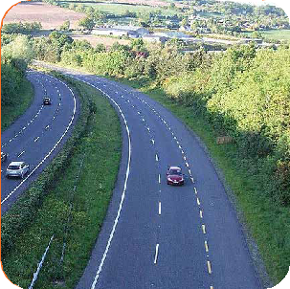
LNDR
Limerick Northern Distributor Route connect N18 to M7
Bypasses
Newcastle West Bypass
Abbeyfeale Bypass

Modal Split

Consider the following questions:

How do we reduce car dependency, and increase cycling, walking and public transport use?
64%
commute by car
commute by public transport
7%

Do you think car parking standards should be reduced for residential developments?
commute by cycling
2%
commute by walking
9%
Where should we locate Park and Stride/Park and Ride facilities?

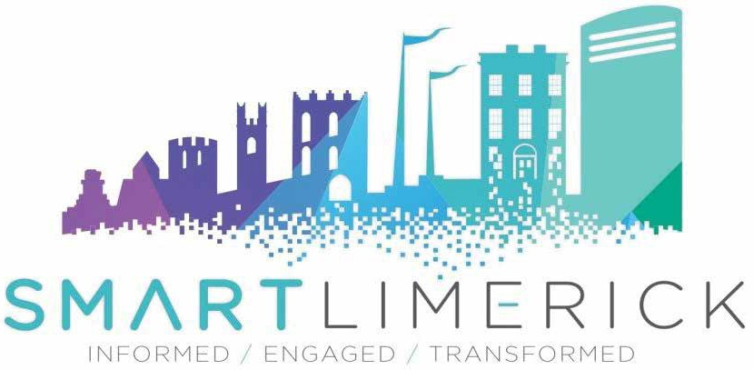How do we create a ‘smarter’ Limerick so as to grow sustainably and attract inward investment?
4th highest penetration of broadband in Ireland
Broadband Coverage:
93% City
58% County

Links:

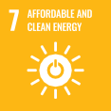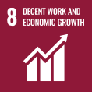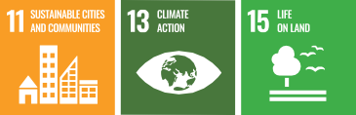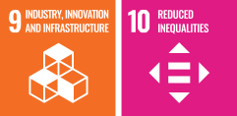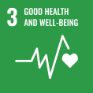
Background Paper:
  - Connectivity and Infrastructure

Infrastructure

The provision of adequate infrastructure is essential for Limerick to function, now
and into the future. The term ‘infrastructure’ encompasses water and wastewater, transport, energy, telecommunications and waste management.
One of the key challenges is the ability to address and keep pace with the infrastructural demands of the growing
City and County while safeguarding public health and managing the protection of key environmental resources.
Limerick has a large number of dispersed towns and villages, many of whom have capacity issues in both water supply and waste water disposal.
Limerick City and County Council supports a low carbon economy and the use of renewable energy for a cleaner future.
Renewable energy comes in many forms including wind energy, solar energy or biomass. Development of alternative energy sources is a priority at National and European level.
The Plan will identify policies for the provision of energy from renewable and indigenous sources in line with National Policy and targets for reducing dependency on fossil fuels and emissions of greenhouse gases.
12
Solar Farms permitted – output capacity of
113.49 MW
15
Windfarms in Limerick
205.75 MW
total output

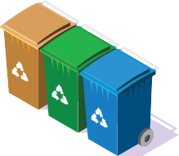16 \ 17
51,140
households (72%) signed up to a waste collection service (2019)

Consider the following questions:

How can we encourage use of renewable energy sources?
How can the Development Plan improve and support the
provision of essential services and infrastructure?

Are there adequate public recycling facilities and services in Limerick?
38%
of treatment plants have some capacity
What measures can be introduced to protect and safeguard the water quality of our rivers and groundwater?
45%
settlement that have a public water supply have some capacity

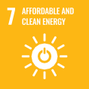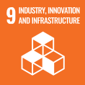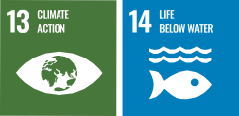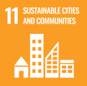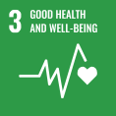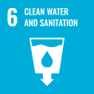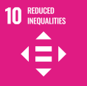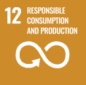Links:

Background Paper:
Team Limerick Cleanup 2019
21,000 91
volunteers from tonnes of litter
646 equating to 3,600
volunteer groups wheelie bins of rubbish
  - Connectivity and Infrastructure
  - Energy, Climate Change, Flooding and Transition to a Low Carbon Economy

Landscape, Heritage &
Green Infrastructure
Limerick’s natural heritage is an integral part of our inheritance and forms part of our sense of identity, providing resources of
social, educational, recreational and aesthetic value. Heritage doesn’t just include buildings, it includes our landscapes, rivers, woodlands, hedgerows, geology, plans and animals.
parks managed by Limerick City & Council Council
21
The demands being placed on our environment, both natural and built, to satisfy the needs of farming, forestry, industry, housing, transport, leisure and urban growth are increasing. We must seek to maintain
‘Let it Bee’
5ha Campaign
a high quality environment while satisfying economic and social need.
Blue and Green Infrastructure can be described as the interconnected networks of land and water around us - nature conservation areas, parks, open space, rivers, floodplains, wetlands, farmland and coastal areas found throughout Limerick. The Limerick Development Plan will aim to identify what green networks/corridors

2 Noise Monitors
Air Quality Monitors
3
require protection and where greenways may be considered for development.

18 \ 19

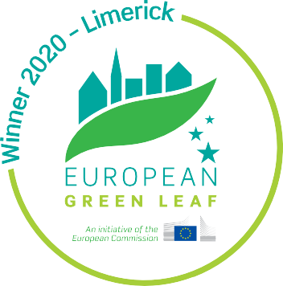
Consider the following questions:

How do we achieve and maintain a balance between development
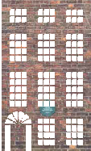pressure and protection of our built and natural heritage?
of Greenway in Limerick
40km
Architectural Conservation Areas
41
Structures
Heritage
2,500
National Inventory of Architectural
Protected Structures 1,400 in the County 381 in Limerick City
1,781

How do we encourage sensitive reuse of redundant or derelict Protected Structures or buildings with heritage value?
What do you think are Limerick’s key cultural and built heritage assets that need to be protected?

How do we promote the health, environment & heritage benefits of Green Infrastructure?

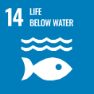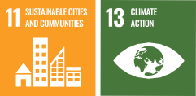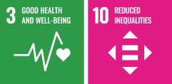Links:
Background Paper:

Green Infrastructure
- Environment, Heritage, Landscape and

Social Community & Recreation

Sustainable communities are those that are economically, environmentally,
socially healthy and resilient. The Limerick Development Plan will have a key role to play in safeguarding, strengthening and consolidating Limerick’s communities by ensuring physical environments are well planned, services and amenities are equal and safe and accessible to all, socially inclusive and to ensure all citizens enjoy optimal health and well-being.
Some of our towns and villages are suffering from vacancy, dereliction and population decline. We need our towns and villages
to be more attractive, vibrant and liveable places that encourage a younger population to choose to live in.
Demographic change has helped make Limerick more diverse and vibrant, with immigration from many different countries contributing to cultural, economic and social diversity. The quality of services and amenities for a diverse and multi-cultural society will be a key determinant to achieve sustainable communities.
Health
Centres
34 Primary Healthy
Centres
4 Family Resource
174 Childcare Facilities
122
in Limerick County
C 53
in Limerick City
B
A

Age

22.99%
Limerick City
25.53%
Limerick County
Population under 18 years of age
Number of population under 24 Years of Age
65,428

20 \ 21

Dependency Ratios
Youth Dependency
Ratio
Nationally
32.3%
Limerick
31%

Population

15%
ethnic or cultural backgrounds
Total Age Dependency
Ratio
Nationally
52.4%
Limerick
52.4%
Consider the following questions:

Do you think there is adequate community facilities in your area?
How can the Plan promote social inclusion and equality for all our citizens?

How can we plan for an aging population?
How can the value of existing community facilities be maximised?

Links:

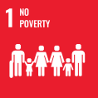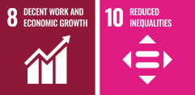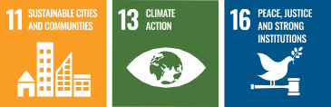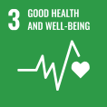
Background Paper:
Nationally
11.4%
Limerick
9.6%
Percentage of population who are non-Irish
  - Community and Recreation

Climate Change & Flood Relief
A new approach is needed to manage our future in a planned, productive and
Residential
23.9%
Source: SEAI
Industry
21.3%
Transport
40%
2.2%
Agricultural
Services
12.7%
Share of energy related CO2 emissions by sector (%), 2018
sustainable way with increased emphasis on travel patterns, energy use and the protection of the environment. The challenges of climate change and the transition to a
low carbon society is a key component of National and Regional Policies and is a
significant cross cutting theme to be included throughout much of the policy and objectives in the Limerick Development Plan.
Climate change brings with it new challenges for Limerick City and County Council in the area of flood management. The challenges relate to extreme weather events and the rise in mean sea-levels with potential storm surges. Comprehensive consideration of flood risk is now a key requirement in the preparation of development plans and
€60m into Flood Relief Schemes
investment proposed
Proposed Schemes:
Limerick City & Environs Flood Relief Scheme Castleconnell Flood Relief Scheme
Athea Flood Relief Scheme
Rathkeale Flood Relief Scheme
in determining planning applications. A Strategic Flood Risk Assessment will be prepared as part of the development plan process which will assess all flood risk in Limerick so as to inform land use planning decisions..

22 \ 23

Examples of Climate Change Impacts in Limerick
2008
Flooding of Newcastle West

2009 2010 2011 2012 2013

2014
Fluvial and Ground water flooding at Kings Island, Limerick City

2014
Fluvial flash floods washed three bridges away at SlieveFelim hills in East County Limerick

2015
Coastal Erosion resulting in partial collapse of N69 at Glin

2016 2017

2018
Drought conditions in East Limerick required the importation of water

2018
Drought conditions resulting in low water levels in River Feale caused difficulty in water abstraction for the Abbeyfeale water supply

2019

2020
Storm Ciara Pluvial Flooding saw Shanagolden Village flooded and N69 East of Foynes flooded

2020
Strong winds and high tides saw flood water top embankments and flood houses on the Mill Road, Corbally

Consider the following questions:

How can the development plan best address the challenges of climate change?

How can we increase awareness and reduce the impacts of climate change in Limerick?
How do you suggest the transition to a low carbon economy be best achieved?

How can we manage pressure for development in flood risk areas?

Links:

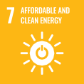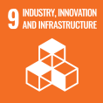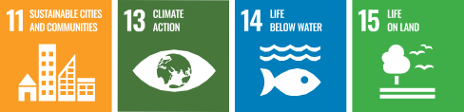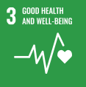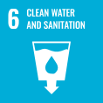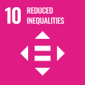
Background Paper:
- Energy, Climate Change, Flooding and Transition to a Low Carbon Economy

Environmental Assessment

Environmental assessments of the Limerick Development Plan 2022-2028 are a crucial element of the process, assessing the potential environmental impacts of the implementation of policies and objectives.
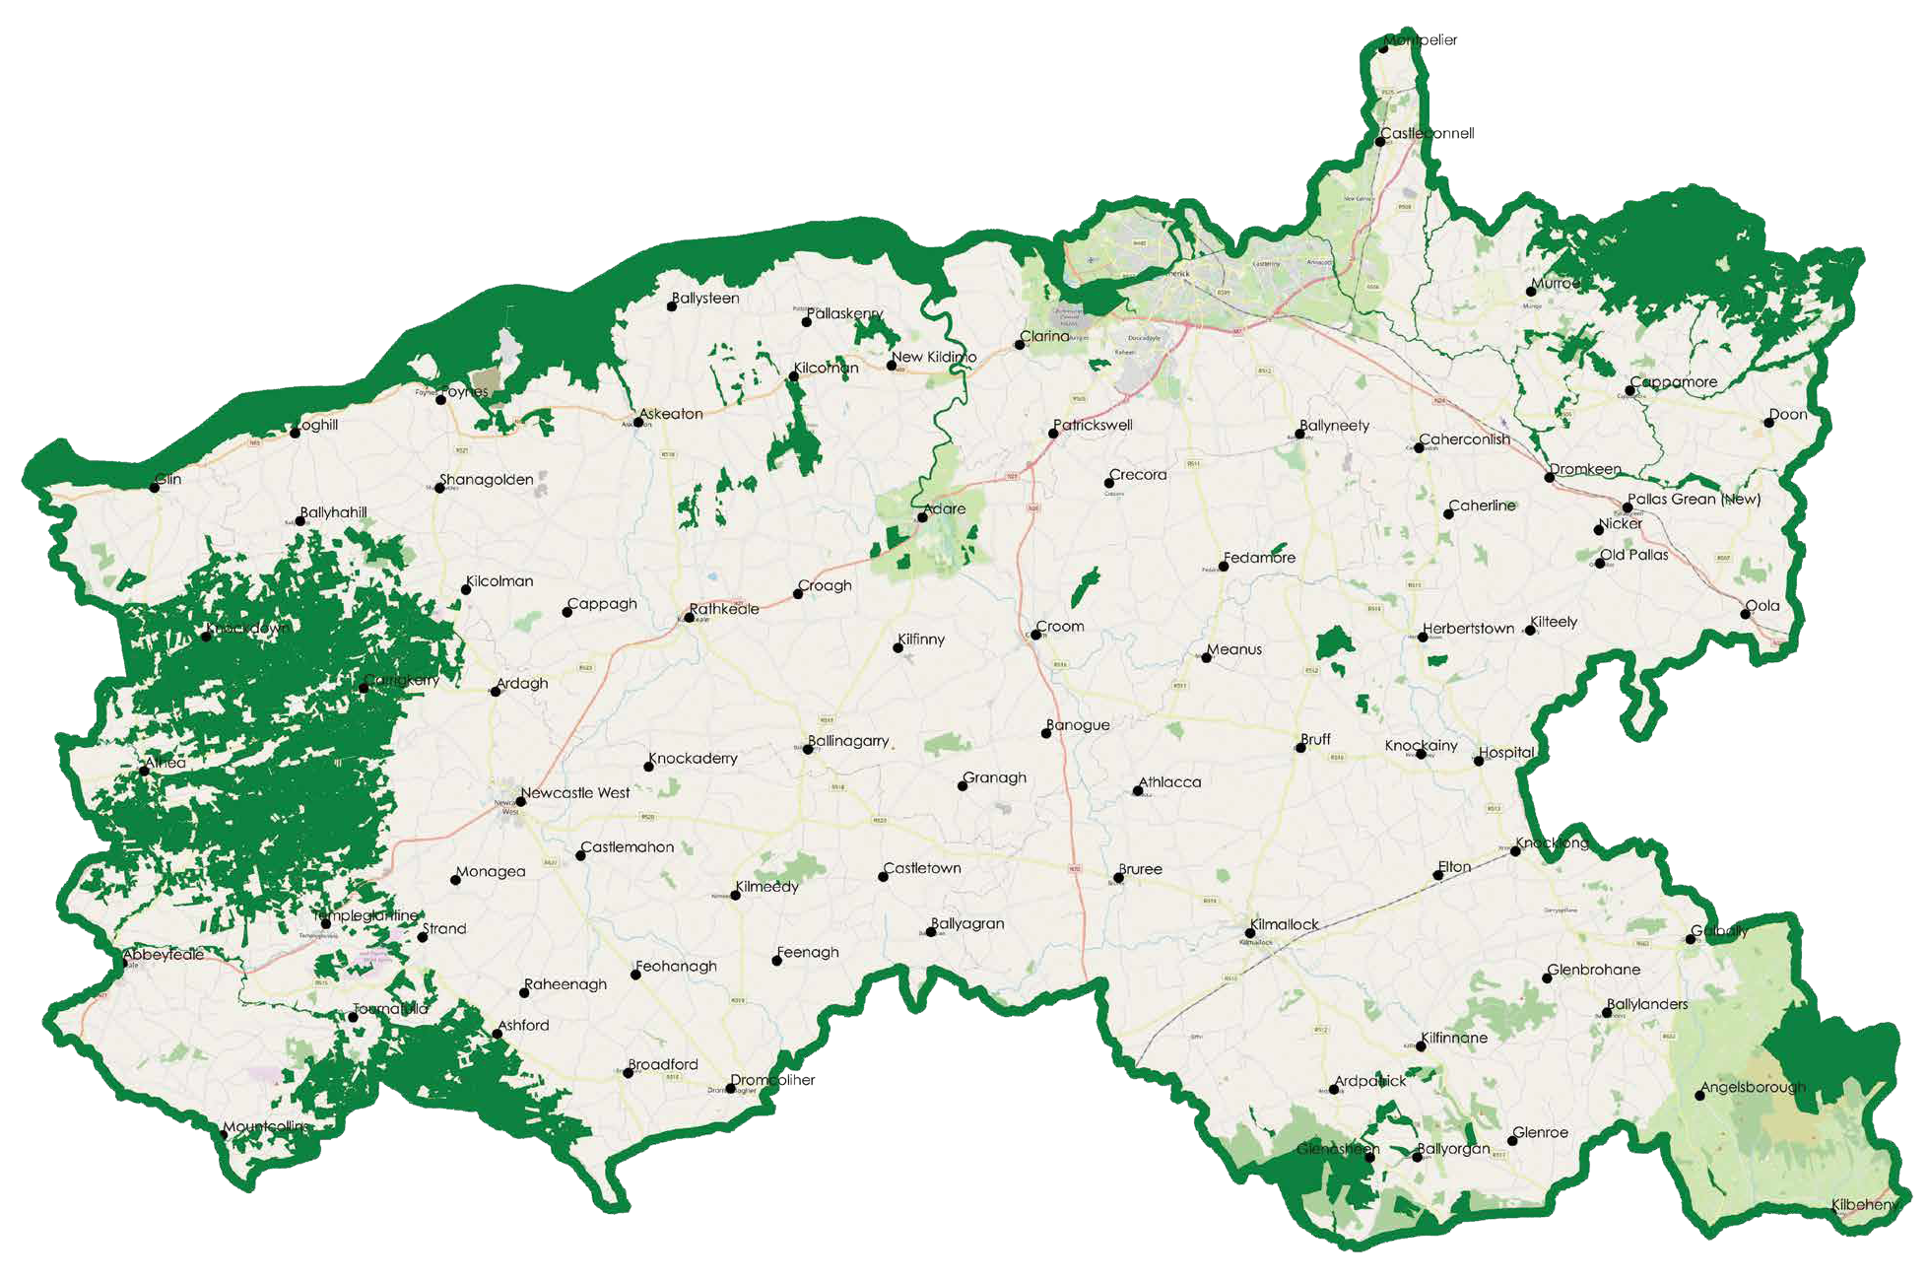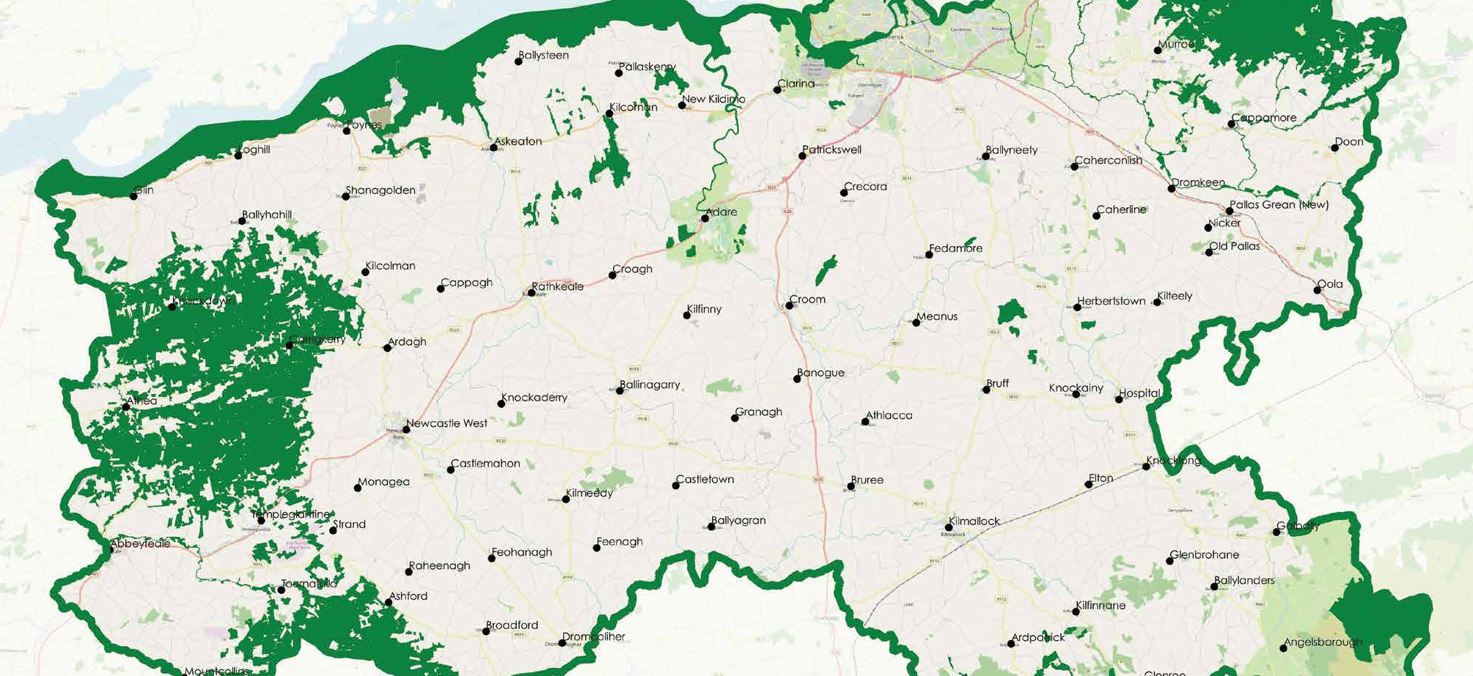Strategic Environmental Assessment (SEA) aims to provide a high level of protection to the environment and to promote sustainable development by contributing to the integration of environmental considerations into the preparation and adoption of the Development Plan. EU Directive 2001/42/EC sets out the provisions in relation to Strategic
Environmental Assessment
Appropriate Assessment is an assessment carried out in accordance with Article 6(3) and 6(4) of the EU Habitats Directive 92/43/ EEC of the implications of the plan, either
individually or in combination with other plans and projects, on protected conservation sites (Natura 2000 sites). The Development Plan can only be adopted if it will not adversely affect the integrity of a Natura 2000 Site.

14

11 3 1 7
17 12
16
6 19 15
10

9

13 18
24 \ 25

8
2 5 4

Consider the following questions:
13%
of Limerick is covered by
EU landscape protected area

What do you consider to be the main environmental issues facing Limerick?
12 Special Area of Conservation:
- Askeaton Fen Complex SAC
- Ballyhoura Mountains SAC
- Barrigone SAC
- Blackwater River (Cork/Waterford) SAC
- Carrigeenamronety Hill SAC
- Clare Glen SAC
- Curraghchase Woods SAC
- Galtee Mountains SAC
- Glen Bog SAC
- Glenstal Wood SAC
- Lower River Shannon SAC
- Tory Hill SAC
How can we ensure that Limerick’s environment is protected?

Can you identify other environmentally sensitive areas in Limerick?
What are the main threats to biodiversity in Limerick?
3 Special Protection Areas:
Limerick Hills and Mount Eagle SPA
- River Shannon and River Fergus Estuaries SPA
- Slievefelim to Silvermines Mountains SPA
13 Stack’s to Mullaghareirk Mountains, West

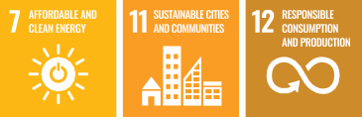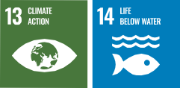Links:

Background Paper:
4 Natural Heritage Areas:
- Carrigkerry Bogs NHA
- Moyreen Bog NHA
- Lough Gay Bog NHA
- Grageen Fen and Bog NHA
  - Strategic Environmental Assessment Scoping Document
  - Environment, Heritage, Landscape and Green Infrastructure

How to
find out more
Public meetings will be held,
by appointment only and subject to government guidance, on the following dates:

7TH SEPTEMBER 2020
Corporate Headquarters, Limerick City and County Council, Merchant’s Quay, Limerick, V94 Eh90 from 2.00 pm – 7.00 pm
8TH SEPTEMBER 2020
Newcastle West Municipal Office, V42 EH73
from 2.00 pm – 7.00 pm
9TH SEPTEMBER 2020
Cappamore – Kilmallock Municipal Office, V35 K497 from 2.00 pm to 7.00 pm
14TH SEPTEMBER 2020
Corporate Headquarters, Limerick City and County Council, Merchant’s Quay, Limerick, V94 Eh90 from 2.00 pm to 7.00 pm
15TH SEPTEMBER 2020
Rathkeale House Hotel, V94 NP64 from 2.00pm to 7.00pm
Book an appointment by emailing
devplan@limerick.ie or 061-556508

26 \ 27

A webinar will be hosted by Limerick City and County Council on
THURSDAY 17TH SEPTEMBER 2020
AT 7PM, on the proposed Limerick Development Plan 2022 – 2028.
For full details log on to www.limerick.ie to
register for this event.

Data Protection Note:
Submissions received by the Planning Authority will be published on Limerick City & County Council website on www.limerick.ie/limerickdevelopmentplan within 10 working days of receipt, along with your name in accordance with the Planning and Development Act 2000 (Amended). Your contact details will not be published. Please do not include personal, confidential or other sensitive information in submissions.
Queries: Email devplan@limerick.ie

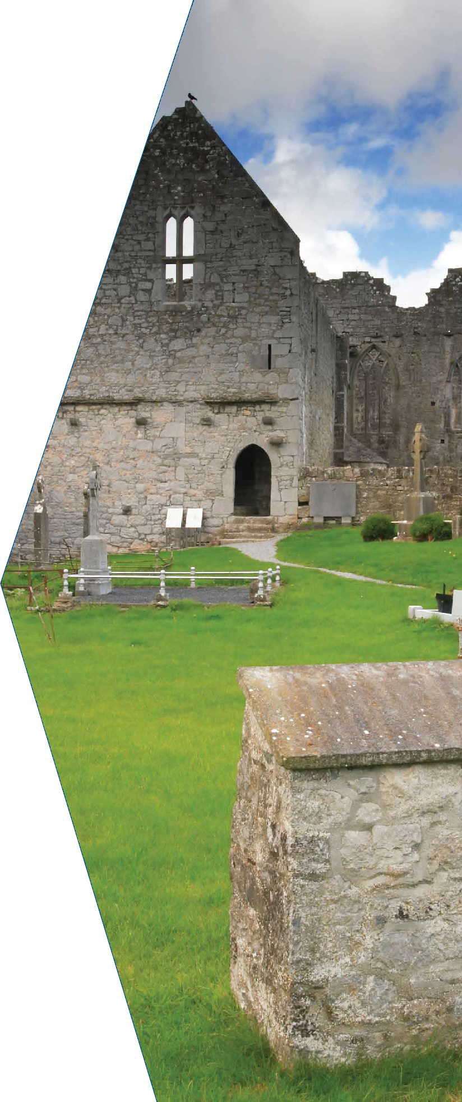

How to
make a submission
You can make a submission through our online portal https://mypoint.limerick.ie
Alternatively you can email
devplan@limerick.ie

or write to
Forward/ Strategic Planning, Limerick City & County Council, Merchant’s Quay,
Limerick V94 EH90.

The deadline for submissions is
Monday 12 October 2020 at 5pm.

