Barnakyle
Patrickswell
Co. Limeirck

03 Sep 2021
Dear Sir/Madam
I wish to make the following submission with suspect to the Zoning of lands for residential use in the Draft Limerick Development Plan 2022-2028.
My name is Patrick Heffernan, and I am the owner of approx. 75 acres of farm land at Barnakyle, Patrickswell, Co. Limerick. My land is located to the north of the residential zoned development (Planning Reference 1810), on the other side of the Limerick to Patrickswell Road.
On 9 February 2018, I retained GARLAND, Consulting Engineers, who carried out a technical review the 1810 Reference planning application, which has since been granted.
My submission is to request that one of my fields as outlined by the drawing below (in Red) should be zoned residential to allow for some additional residential development in the future.

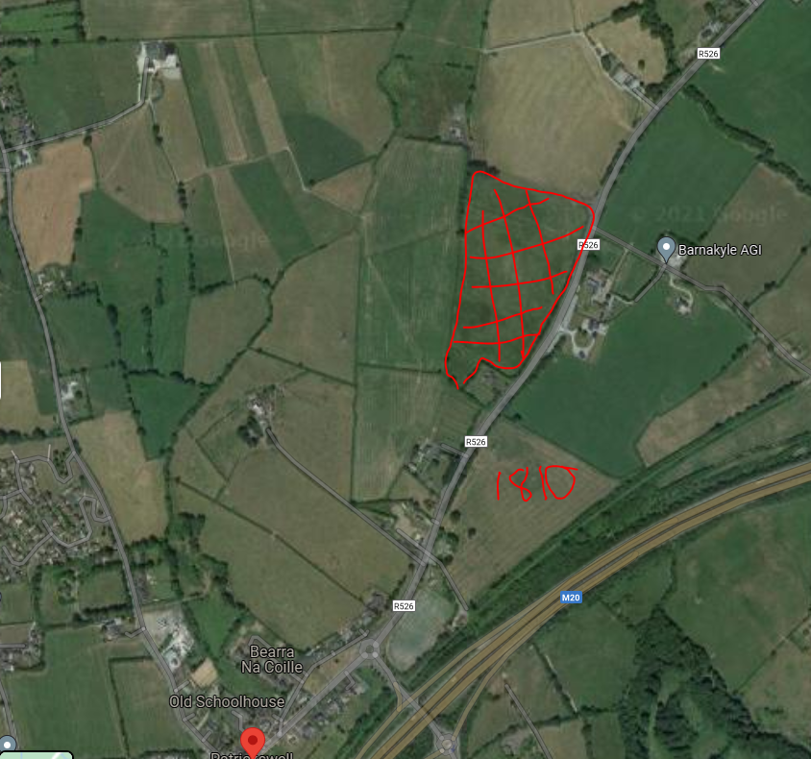

Kind Regards
Patrick Heffernan

