Garryowen Area Profile
Contents
1. Garryowen Area 1
2. Population 3
2.1. Population - Garryowen 3
2.2. Population – Garryowen surrounds 4
3. Family Structure 5
3.1. Family Structure – Garryowen 5
3.2. Family Structure – Garryowen surrounds 7
4. Deprivation, 2006 – 2016 8
4.1. Deprivation – Garryowen 8
4.2. Deprivation – Garryowen surrounds 10
5. Unemployment 12
5.1. Unemployment Blackspots 12
5.2. Unemployment - Garryowen 13
5.3. Unemployment - Garryowen surrounds 15
6. Educational Attainment 16
6.1. Educational Attainment – Garryowen 16
6.2. Educational Attainment – Garryowen surrounds 19
References 22

Garryowen Area

Garryowen is situated in Limerick city. The area categorised as Garryowen in this document consists of the Electoral Division (ED) of Singland A and Abbey D as well as four selected Small Areas (SAs) within the ED of Market. These SAs are on the Garryowen side of Cathedral Place and include SA 128029001, 128029002, 128029008, and 128029009. Map 1 provides a view of Garryowen within Limerick City while Map 2 shows a close-up view of Garryowen and surrounds. The maps below show the core area of Garryowen outlined in dark blue. The area outlined in light blue shows the areas surrounding Garryowen which are considered important parts of the wider Garryowen community. These areas include the remaining five SAs in Market (128029003, 128029004, 128029005, 128029006, and 128029007); five SAs in Singland B that border St. Patrick's Road (128036001, 128036002, 128036003, 128036004, and 128036009), and the ED of Abbey C which consists of three SAs.

Map 1. Garryowen and surrounds situated in Limerick City
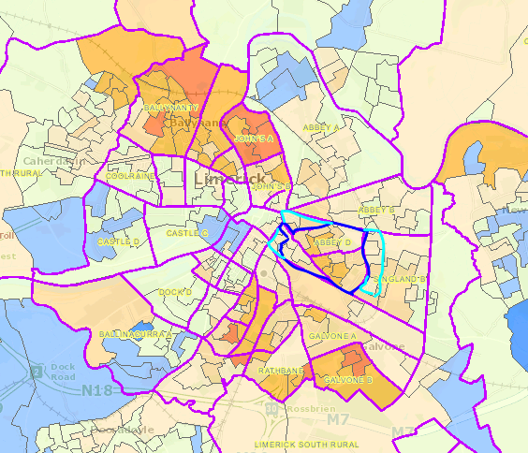
Garryowen (Core Area)
Surrounds of Garryowen
Source: Pobal Maps, Pobal HP Deprivation Indices [online] available at: https://maps.pobal.ie/

Map 2. Garryowen and surrounds
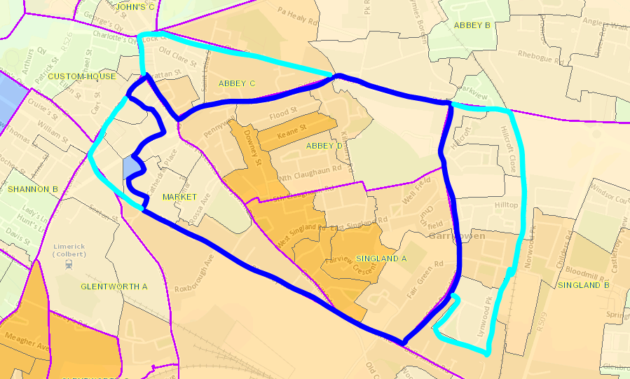
Garryowen (Core Area)
Surrounds of Garryowen
Source: Pobal Maps, Pobal HP Deprivation Indices [online] available at: https://maps.pobal.ie/

This document provides data on five areas of interest:
- Population;
- Family Structure;
- Deprivation;
- Unemployment; and
- Educational Attainment.
In this document data is provided for the Garryowen (core) area followed by data for the surrounds of Garryowen. Where possible data relevant to the area outlined in the maps above is used, however in some cases data reflects the entire ED as opposed to the selected SAs within an ED, in these cases it is noted clearly that the data is for the entire ED.
In addition, data has been included for comparison. Depending on the variable, this includes national level data and/or data for Limerick city and county as well as data for another disadvantaged area in Limerick City. The disadvantaged area chosen for comparison is Moyross. The area of Moyross is in North Limerick City and is spread across parts of the Electoral Divisions (EDs) of Ballynanty and Limerick North Rural. It is part of the Limerick Regeneration Project.

Population

Population - Garryowen
The population of Garryowen in 2016 was 4,060. It has stayed relatively stable over the previous 10 years (see Figure 1). There is a slightly higher percentage of females (51%) to males (49%) which is consistent with the Irish average (see Table 1). When looking at young people, 24% of the population in Garryowen is 18 years of age or under and 32% are 24 years of age or under. This is just under the national average where the percentages are 26% and 33% respectively. Having said this, there is still a large number (1,284) of children and young people (0-24 year olds) in the area.

Figure 1. Population Trend in Garryowen, 2006, 2011 and 2016.

Source: Central Statistics Office - Census 2016 Small Area Population Statistics (SapMap) [online] available at: http://census.cso.ie/sapmap/

Table 1. Population of Garryowen, 2016.
 | Total | % of Total | Male | Female
Total population | 4,060 | 100% | 1,970 (49%) | 2,090 (51%)
0 to 4 years | 285 | 7% | 143 (50%) | 142 (50%)
5 to 15 years | 523 | 13% | 251 (48%) | 272 (52%)
16 to 24 years | 476 | 12% | 228 (48%) | 248 (52%)
Total 0 to 18 | 966 | 24% | 474 (49%) | 492 (51%)
Total 0 to 24 years | 1,284 | 32% | 622(48%) | 662 (52%)
Total 65 and over | 617 | 15% | 268 (43%) | 349 (57%)
Source: Central Statistics Office - Census 2016 Small Area Population Statistics (SapMap) [online] available at: http://census.cso.ie/sapmap/

Population – Garryowen surrounds
Overall, the population within the surrounds of Garryowen has increased, this is particularly notable in the SAs in Market while the population in the other areas has stayed relatively stable (see Figure 2). When looking at young people, 25% of the population is 18 years of age or under and 34% are 24 years of age or under. This is similar to the national average where the percentages are 26% and 33% respectively (see Table 2).

Figure 2. Population Trend in the surrounds of Garryowen, 2006, 2011 and 2016.

Source: Central Statistics Office - Census 2016 Small Area Population Statistics (SapMap) [online] available at: http://census.cso.ie/sapmap/

Table 2. Population of the surrounds of Garryowen, 2016.
 | Total | % of Total
Total population | 3,169 | 100%
0 to 4 year olds | 245 | 8%
5 to 15 year olds | 431 | 14%
16 to 24 year olds | 402 | 13%
Total 0 to 18 | 800 | 25%
Total 0 to 24 | 1,078 | 34%
65 year and over | 289 | 9%
Source: Pobal Maps, Geoprofiling Reports [online] available at: https://maps.pobal.ie/

Family Structure

Family Structure – Garryowen
Overall, in Ireland a quarter of families with children are lone parent families. However, as with many areas of disadvantage Garryowen sees elevated rates of lone parent families (see Figure 3). In Garryowen 50% of families with children are lone parent families, 43% of these are headed by a mother and 7% are headed by a father. These figures found in Garryowen are not dissimilar to those found in the Moyross area for example, where 54% of families are headed by a single mother and 6% of families are headed by a single father (see Table 3 and Figure 4). The lone parent ratio for each Small Area in Garryowen is presented below in Table 4.

Figure 3. Number of Families in Garryowen by type, 2016.

Source: Central Statistics Office - Census 2016 Small Area Population Statistics (SapMap) [online] available at: http://census.cso.ie/sapmap/

Table 3. Number and percentage of Families by type in Garryowen, Moyross and Nationally, 2016.
 |  | Couples with children | Mothers with children | Fathers with children
Number of Families | Garryowen | 379 (50%) | 323 (43%) | 51 (7%)
 | Moyross | 167 (41%) | 222 (54%) | 23 (6%)
 | Ireland | 643,904 (75%) | 189,112 (22%) | 29,705 (3%)
Source: Central Statistics Office - Census 2016 Small Area Population Statistics (SapMap) [online] available at: http://census.cso.ie/sapmap/

Figure 4. Percentage of Families by type in Garryowen, Moyross and Nationally, 2016

Source: Central Statistics Office - Census 2016 Small Area Population Statistics (SapMap) [online] available at: http://census.cso.ie/sapmap/

Table 4. Lone Parent Ratio in Garryowen, 2016.
Within ED | Small Area ID | Lone Parents Ratio 2016
Abbey D | 128004001 | 42.00
 | 128004002 | 42.00
 | 128004003 | 52.00
 | 128004004 | 78.00
 | 128004005 | 45.00
 | 128004006 | 50.00
 | 128004007 | 62.00
Singland A | 128035001 | 28.00
 | 128035002 | 47.00
 | 128035003 | 71.00
 | 128035004 | 50.00
 | 128035005 | 44.00
 | 128035006 | 35.00
Market | 128029001 | 32.00
 | 128029002 | 32.00
 | 128029008 | 53.00
 | 128029009 | 38.00
Notes:
Lone Parent Ratio in Limerick City and County: 22.86
Lone Parent Ratio in Limerick City (SICAP Lot area - Limerick Urban): 30.94
Lone Parent Ratio Range in Garryowen: 28.00 to 78.00.
Source: Pobal Maps, Geoprofiling Reports [online] available at: https://maps.pobal.ie/

Family Structure – Garryowen surrounds
While the lone parent rate in the surrounds of Garryowen is lower than in the core Garryowen area, it is still higher than the national average (see Table 5). In addition, there are certain Small Areas where the lone parent rate is particularly high (see Table 6).

Table 5. Number and percentage of Families by type in the surrounds of Garryowen, Garryowen and nationally, 2016.
 |  | Couples with children | Mothers with children | Fathers with children
Number of Families | Garryowen Surrounds | 348 (63%) | 174 (32%) | 27 (5%)
 | Garryowen (core area) | 379 (50%) | 323 (43%) | 51 (7%)
 | Ireland | 643,904 (75%) | 189,112 (22%) | 29,705 (3%)
Source: Central Statistics Office - Census 2016 Small Area Population Statistics (SapMap) [online] available at: http://census.cso.ie/sapmap/

Table 6. Lone Parent Ratio in the surrounds of Garryowen, 2016.
With ED | Small Area ID | Lone Parents Ratio 2016
Abbey C | 128003001 | 60.00
 | 128003002 | 54.00
 | 128003003 | 48.00
Market | 128029003 | 27.00
 | 128029004 | 35.00
 | 128029005 | 62.00
 | 128029006 | 37.00
 | 128029007 | 9.00
Singland B | 128036001 | 28.00
 | 128036002 | 23.00
 | 128036003 | 38.00
 | 128036004 | 40.00
 | 128036009 | 33.00
Notes:
Lone Parent Ratio in Limerick City and County: 22.86
Lone Parent Ratio in Limerick City (SICAP Lot area - Limerick Urban): 30.94
Lone Parent Ratio Range in the immediate surrounds of Garryowen: 9.00 to 62.00.
Source: Pobal Maps, Geoprofiling Reports [online] available at: https://maps.pobal.ie/

Deprivation, 2006 – 2016

Table 7. HP Deprivation Scores and Labels.
Index Score | Label
30 to 40 | Extremely affluent
20 to 30 | Very affluent
10 to 20 | Affluent
0 to 10 | Marginally above average
0 to -10 | Marginally below average
-10 to -20 | Disadvantaged
-20 to -30 | Very disadvantaged
-30 to -40 | Extremely disadvantaged
Source: Hasse and Pratscke (2017) The 2016 Pobal HP Deprivation Index for Small Areas (SA). Introduction and Reference Tables

Deprivation – Garryowen
Garryowen is a disadvantaged area of Limerick according to the HP deprivation indices. Since 2006 the level of deprivation has stayed relatively stable, improving slightly from -16.31 (disadvantaged) in 2006 to -15.06 (disadvantaged) in 2016 (see Table 8). However, at Small Area level there are areas which are very disadvantaged as well (see Table 9). The levels of deprivation in some of the Small Areas in Garryowen reach levels such as -24.5 (very disadvantaged), -24.91 (very disadvantaged), and -26.21 (very disadvantaged). These levels of deprivation are comparable to some of the Small Areas in Moyross. The overall level of deprivation in Moyross is -26.71 (Very disadvantaged). Map 3 shows the changing deprivation levels over time.

Table 8. Relative Deprivation Score in Garryowen at ED level, 2006 - 2016.
ED Name | Deprivation Score 2006 | Deprivation Score 2011 | Deprivation Score 2016
Abbey D | -18.97  Disadvantaged | -17.07  Disadvantaged | -15.94  Disadvantaged
Singland A | -17.75  Disadvantaged | -18  Disadvantaged | -18.86  Disadvantaged
Selected SAs within Market | -7.42  Marginally below average | -6.47  Marginally below average | -6.35  Marginally below average
TOTAL | -16.31  Disadvantaged | -15.29  Disadvantaged | -15.06  Disadvantaged
Source: Pobal Maps, Geoprofiling Reports [online] available at: https://maps.pobal.ie/

Table 9. Relative Deprivation Score in Garryowen at SA level, 2006 - 2016.
Small Area ID | Within ED | Deprivation Score 2006 | Deprivation Score 2011 | Deprivation Score 2016
128004001 | Abbey D | -17.7 | -20.6 | -20.15
128004002 |  | -3.7 | -1.2 | -5.33
128004003 |  | -18.1 | -19.4 | -16.12
128004004 |  | -18.8 | -20.7 | -17.57
128004005 |  | -25.8 | -21.3 | -24.5
128004006 |  | -21.5 | -18 | -14.01
128004007 |  | -20.4 | -16.1 | -12.03
128035001 | Singland A | -14.8 | -11.8 | -10.4
128035002 |  | -17.3 | -23 | -19.62
128035003 |  | -26.2 | -24.1 | -24.91
128035004 |  | -21.2 | -24.3 | -26.21
128035005 |  | -19.5 | -19.4 | -21.86
128035006 |  | -9.7 | -10 | -14.45
128029001 | Market | -11.4 | -11.4 | -14.11
128029002 |  | -4.6 | -4.3 | -3.75
128029008 |  | -14.9 | -4 | -4.09
128029009 |  | 1 | -6.3 | -4.94
Total Garryowen |  | -16.31 | -15.29 | -15.06
Total Moyross |  | -25.46 | -24.70 | -26.71
Source: Pobal Maps, Geoprofiling Reports [online] available at: https://maps.pobal.ie/

Map 3. Relative Deprivation Indices in Garryowen from 2006 to 2016.
2006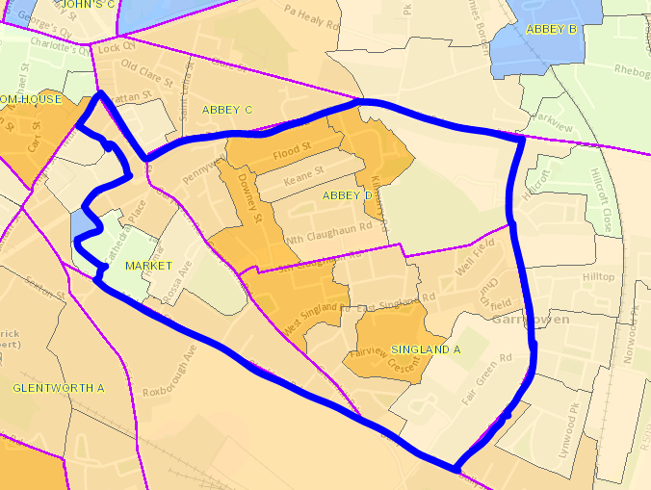 | 2011  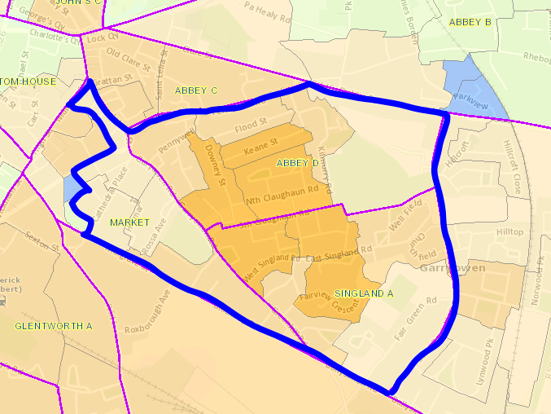
2016  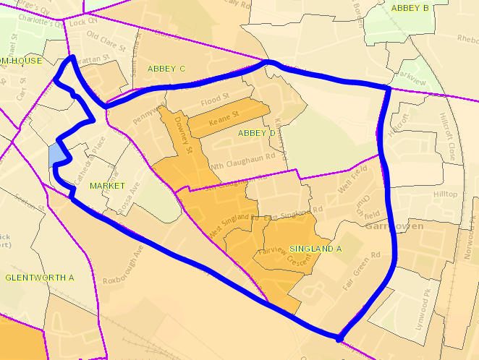 | 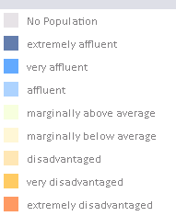
Source: Pobal Maps, Pobal HP Deprivation Indices [online] available at: https://maps.pobal.ie/

Deprivation – Garryowen surrounds
The surrounds of Garryowen are less disadvantaged than the core area of Garryowen. Overall, the surrounds of Garryowen are marginally below average however, there are some Small Areas reaching levels of deprivation such as -18.01 (disadvantaged) and -18.11 (disadvantaged) (see Table 10). Map 4 shows the changing deprivation levels over time.

Map 4. Relative Deprivation Indices in the surrounds of Garryowen from 2006 to 2016.
2006  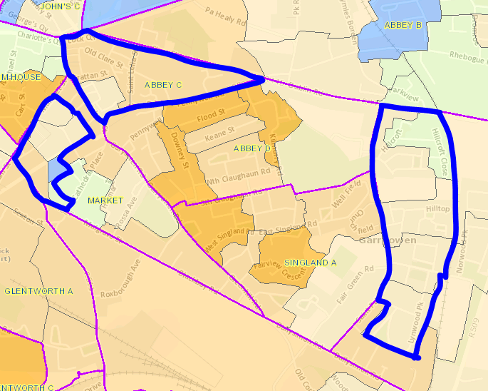 | 2011  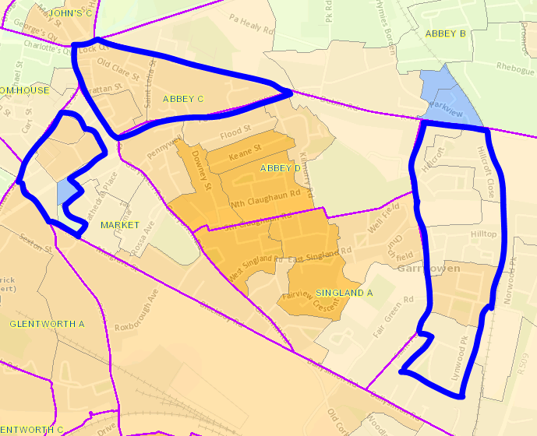
2016
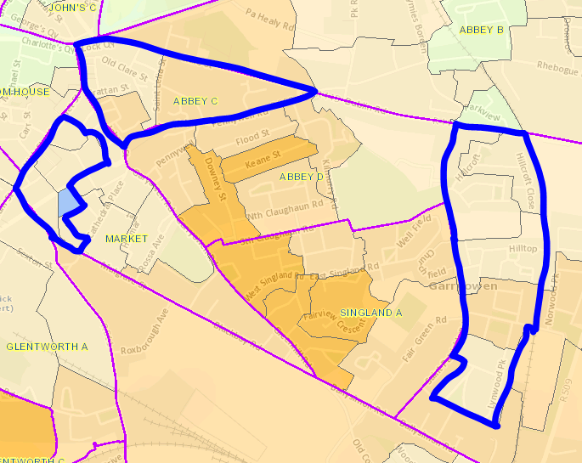
Source: Pobal Maps, Pobal HP Deprivation Indices [online] available at: https://maps.pobal.ie/

Table 10. Relative Deprivation Score in the surrounds of Garryowen at SA level, 2006 - 2016.
Small Area ID | Within ED | Deprivation Score 2006 | Deprivation Score 2011 | Deprivation Score 2016
128003001 | Abbey C | -18.2 | -17.4 | -18.01
128003002 |  | -8.8 | -15.5 | -15.97
128003003 |  | -10.4 | -10.8 | -7.1
128029003 | Market | -4.6 | -19.2 | -6.48
128029004 |  | -14.1 | -6.3 | -7.09
128029005 |  | -4.4 | -15.5 | -7.18
128029006 |  | 9.6 | 0.4 | -4.65
128029007 |  | 18 | 14.1 | 11.95
128036001 | Singland B | -0.6 | -2.1 | -3.7
128036002 |  | 0.2 | -4.5 | -2.78
128036003 |  | -8 | -8.7 | -4.78
128036004 |  | -8.8 | -15 | -18.11
128036009 |  | -9.3 | -5.8 | -8.94
Total |  | -6.8 | -7.3 | -6.3
Source: Pobal Maps, Geoprofiling Reports [online] available at: https://maps.pobal.ie/

Unemployment

Unemployment Blackspots
In 2016 the national unemployment rate was 12.9%. As stated in the Census 2016 Summary Results - Part 2 an unemployment blackspot is defined as “an ED whose labour force exceeded 200 persons and where the unemployment rate (on a Principal Economic Status basis) exceeded 27 per cent” (CSO, 2017, P.25). In 2016 there were 79 such blackspots in Ireland. Limerick city has 38 EDs in total and of this 17 were unemployment blackspots in 2016.

Unemployment Blackspots in Garryowen:
- Singland A, Limerick City (Unemployment rate: 33.6%)

Unemployment Blackspots in the surrounding areas:
- Abbey C, Limerick City (Unemployment rate: 41.9%) Note: Abbey C has the 4th highest unemployment rate in Ireland and is part of the area classified as the surrounds of Garryowen within this document.
- St. Laurence, Limerick City (Unemployment rate: 39.2%)
- Glentworth A, Limerick City (Unemployment rate: 33.7%).

Map 5.Unemployment Blackspots in Garryowen and surrounding areas, 2016.
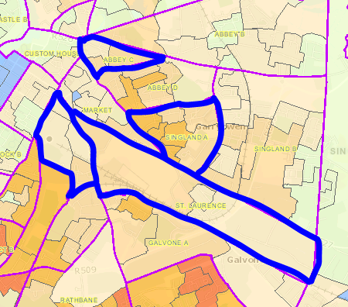
Sources: CSO (2017) Census 2016 Summary Results - Part 2.
Pobal Maps, Pobal HP Deprivation Indices [online] available at: https://maps.pobal.ie/

Unemployment - Garryowen
In 2016 the national unemployment rate was 12.9%. In Limerick City and County the rate was higher at 16.59% for males and 14.71% for females. In Garryowen these rates are higher again. In 2016, the male unemployment rate at ED level in Garryowen ranged from26.6% to 41.5% (see Figure 5 and Table 11), but reaches as high as 64.5% at Small Area level. For females, the unemployment rate at ED level ranges from 22.4% to 27.5% (see Figure 5 and Table 11), reaching 39.3% at Small Area level.

Table 11 presents the unemployment rate for males and females for different areas as a means of comparison. The ED of Ballynanty has been included in this table as part of the ED of Ballynanty forms part of the Moyross area, a well documented Regeneration area in Limerick. The male unemployment rate in Ballynanty is 42.4% while the female unemployment rate is 45.3%. These figures, particularly those for the male unemployment rate, are comparable to the data in Garryowen (eg. Singland A male unemployment is 41.5% while Ballynanty male unemployment is 42.4%).

The overall unemployment rate in Garryowen has risen between 2006 and 2016. This period was highly influenced by the economic recession. Figure 5 illustrates that change in unemployment rate over this time period, showing a peak in 2011 and a subsequent decline by 2016. Map 6 illustrates the areas where the highest levels of unemployment are found at Small Area level.

Map 6. Percent of labour force unemployed in Garryowen, by Small Area in 2016.
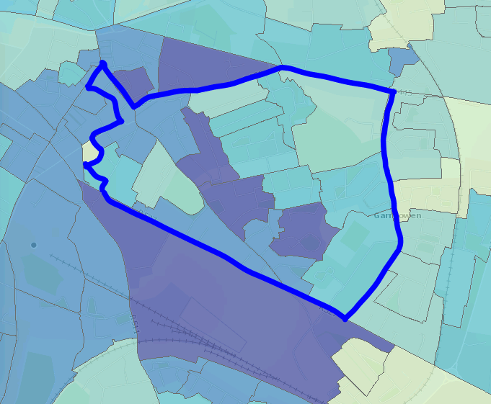
Source: Airo, Census 2016 Viewer [online] available at: http://airomaps.nuim.ie/id/Census2016/
Figure 5. Unemployment Rate in Garryowen by gender, 2006 to 2016.

Note: Data refers to entire EDs as opposed to selected Sas within an ED.
Source: Pobal Maps, Geoprofiling Reports [online] available at: https://maps.pobal.ie/

Table 11. Unemployment rates in Garryowen and other areas for comparison, 2016
Area | Male | Female
Ireland | 13.7% | 12%
Limerick City and County | 16.60% | 14.70%
Market | 26.60% | 22.90%
Abbey D | 30.90% | 22.40%
Singland A | 41.50% | 27.50%
ED of Ballynanty  (see note below) | 42.40% | 45.30%
Note: This ED has been included for comparison as part of this ED forms part of the Moyross area which is a Regeneration area.
Source: Pobal Maps, Pobal HP Deprivation Indices [online] available at: https://maps.pobal.ie/

Unemployment - Garryowen surrounds
The overall unemployment rate in the surrounds of Garryowen are higher than the national average. Overall, the unemployment rate has risen between 2006 and 2016. This period was highly influenced by the economic recession. Figure 6 illustrates that change in unemployment rate over this time period, showing a peak in 2011 and a subsequent decline by 2016. Map 7 illustrates the areas where the highest levels of unemployment are found at Small Area level.

Map 7. Percent of labour force unemployed in the surrounds of Garryowen, by Small Area in 2016.
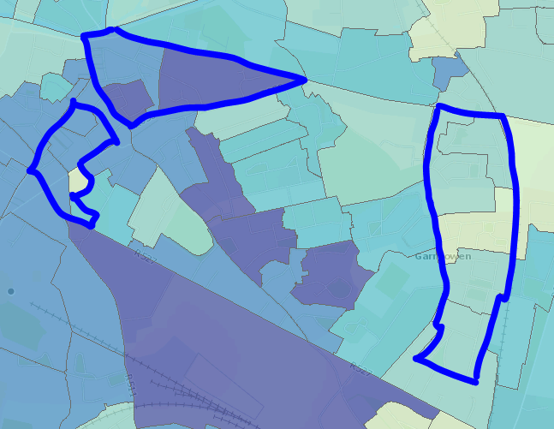
Source: Airo, Census 2016 Viewer [online] available at: http://airomaps.nuim.ie/id/Census2016/

Figure 6. Unemployment Rate in the surrounds of Garryowen by gender, 2006 to 2016.

Note: Data refers to entire EDs as opposed to selected SAs within an ED.
Source: Pobal Maps, Geoprofiling Reports [online] available at: https://maps.pobal.ie/

Educational Attainment

Educational Attainment – Garryowen
In Limerick City and County, in 2016, the proportion of the population with primary education only was 14.60%. In the majority of Small Areas in Garryowen (12 out of 17 Small Areas), the proportion of population with primary education only is above 20% (see Table 12). Looking at all the Small Areas the proportion of population with primary education only ranges from 12% to 35%, this can be compared to data from Moyross where the range is from 23% to 49%.

In Limerick City and County, in 2016, the proportion with third level education was 31.92%. In the majority of Small Areas in Garryowen (12 out of 17 Small Areas), the proportion of population with third level education is below 20% (see Table 12). Looking at all the Small Areas in Garryowen the proportion of population with third level education ranges from 3.97% to 30.95%, this can be compared to data from Moyross where the range is from 1.16% to 7.03%.

Figure 7 and Figure 8 compare the educational attainment of EDs in Garryowen with the Limerick city and county average, while Figure 9 and Figure 10 show the change in educational attainment in Garryowen over time.

Table 12. Educational Attainment in Garryowen, 2016.
Small Area ID | Within ED | Proportion with Primary Education Only 2016 (%) | Proportion with third level education 2016 (%)
128004001 | Abbey D | 32.00 | 7.87
128004002 |  | 15.00 | 27.27
128004003 |  | 25.00 | 15.07
128004004 |  | 33.00 | 9.02
128004005 |  | 33.00 | 6.80
128004006 |  | 26.00 | 7.81
128004007 |  | 27.00 | 18.32
128035001 | Singland A | 14.00 | 15.23
128035002 |  | 32.00 | 6.83
128035003 |  | 35.00 | 6.04
128035004 |  | 23.00 | 3.97
128035005 |  | 26.00 | 6.45
128035006 |  | 22.00 | 16.50
128029001 | Market | 18.00 | 22.69
128029002 |  | 16.00 | 27.46
128029008 |  | 12.00 | 30.95
128029009 |  | 22.00 | 29.63
Limerick City and County |  | 14.60 | 31.92
 |  | Higher proportion population with Primary Education Only than the city and county average 2016 | Lower proportion population with third level education than the city and county average 2016
Source: Pobal Maps. Geoprofiling Reports [online] available at: https://maps.pobal.ie/ and Pobal Maps, Pobal HP Deprivation Indices [online] available at: https://maps.pobal.ie/

Figure 7. Proportion of population in Garryowen with Primary Education only, 2016.

Note: Data refers to entire EDs as opposed to selected SAs within an ED.
Source: Pobal Maps. Geoprofiling Reports [online] available at: https://maps.pobal.ie/

Figure 8. Proportion of population in Garryowen with Third Level Education, 2016.

Note: Data refers to entire EDs as opposed to selected SAs within an ED.
Source: Pobal Maps. Geoprofiling Reports [online] available at: https://maps.pobal.ie/

Figure 9. Proportion of population of Garryowen with Primary Education only. 2006 and 2016.

Note: Data refers to entire EDs as opposed to selected SAs within an ED.
Source: Pobal Maps. Geoprofiling Reports [online] available at: https://maps.pobal.ie/

Figure 10. Proportion of population of Garryowen with Third Level Education, 2006 and 2016.

Note: Data refers to entire EDs as opposed to selected SAs within an ED.
Source: Pobal Maps. Geoprofiling Reports [online] available at: https://maps.pobal.ie/

Educational Attainment – Garryowen surrounds
In Limerick City and County, in 2016, the proportion of the population with primary education only was 14.60%, while the proportion with third level education was 31.92%. In the surrounds of Garryowen just over half of the Small Areas have a higher proportion of the population with primary education only, while in all but one Small Area in Garryowen the proportion of the population with third level education is lower than the Limerick average (see Table 13).

Figure 11 and Figure 12below compare the educational attainment of EDs in the surrounds of Garryowen with the Limerick city and county average, while Figure 13 and Figure 14 show the change in educational attainment in the surrounds of Garryowen over time.

Table 13. Educational Attainment in the surrounds of Garryowen, 2016.
Small Area ID | Within ED | Proportion with Primary Education Only 2016 (%) | Proportion with third level education 2016 (%)
128003001 | Abbey C | 29.00 | 18.12
128003002 |  | 23.00 | 13.46
128003003 |  | 12.00 | 20.43
128029003 | Market | 19.00 | 16.50
128029004 |  | 16.00 | 22.83
128029005 |  | 22.00 | 24.72
128029006 |  | 9.00 | 22.81
128029007 |  | 1.00 | 47.92
128036001 | Singland B | 7.00 | 24.26
128036002 |  | 6.00 | 23.42
128036003 |  | 12.00 | 13.89
128036004 |  | 21.00 | 8.93
128036009 |  | 22.00 | 15.82
Limerick City and County |  | 14.60 | 31.92
 |  | Higher proportion population with Primary Education Only than the city and county average 2016 | Lower proportion population with third level education than the city and county average 2016
Source: Pobal Maps. Geoprofiling Reports [online] available at: https://maps.pobal.ie/

Figure 11. Proportion of population in the surround of Garryowen with Primary Education only, 2016.

Note: Data refers to entire EDs as opposed to selected SAs within an ED.
Source: Pobal Maps. Geoprofiling Reports [online] available at: https://maps.pobal.ie/

Figure 12. Proportion of population in the surrounds of Garryowen with Third Level Education, 2016.

Note: Data refers to entire EDs as opposed to selected SAs within an ED.
Source: Pobal Maps. Geoprofiling Reports [online] available at: https://maps.pobal.ie/
Figure 13. Proportion of population in the surrounds of Garryowen with Primary Education only, 2006 and 2016.

Note: Data refers to entire EDs as opposed to selected SAs within an ED.
Source: Pobal Maps. Geoprofiling Reports [online] available at: https://maps.pobal.ie/

Figure 14. Proportion of population in the surrounds of Garryowen with Third Level Education, 2006 and 2016.

Note: Data refers to entire EDs as opposed to selected SAs within an ED.
Source: Pobal Maps. Geoprofiling Reports [online] available at: https://maps.pobal.ie/

References

Airo, Census 2016 Viewer [online] available at: http://airomaps.nuim.ie/id/Census2016/ (accessed July 2019).

CSO. Census 2016 Small Area Population Statistics (SapMap) [online] available at: http://census.cso.ie/sapmap/ (accessed July 2019).
CSO (2017) Census 2016 Summary Results - Part 2. [online] available at: https://www.cso.ie/en/media/csoie/newsevents/documents/census2016summaryresultspart2/Census_2016_Summary_Results_%E2%80%93_Part_2.pdf (accessed July 2019.

Hasse and Pratscke (2017) The 2016 Pobal HP Deprivation Index for Small Areas (SA). Introduction and Reference Tables. [online] available at: https://www.pobal.ie/app/uploads/2018/06/The-2016-Pobal-HP-Deprivation-Index-Introduction-07.pdf

Pobal Maps. Geoprofiling Reports [online] available at: https://maps.pobal.ie/ (accessed July 2019).

Pobal Maps, Pobal HP Deprivation Indices [online] available at: https://maps.pobal.ie/ (accessed July 2019)

.

The area of Moyross contains the following Small Areas: 127105027; 127105028; 127105030; 127105031; 128007007; 128007008; 128007009; 128007010; 128007011; 128007012; and 128007013.
The overall deprivation score in Moyross is -26.71 where individual SAs range from -24.13 to -29.91.
This includes unemployment blackspots in the areas categorised as the surrounds of Garryowen within this document but also any unemployment blackspots in the EDs adjacent to Garryowen.

