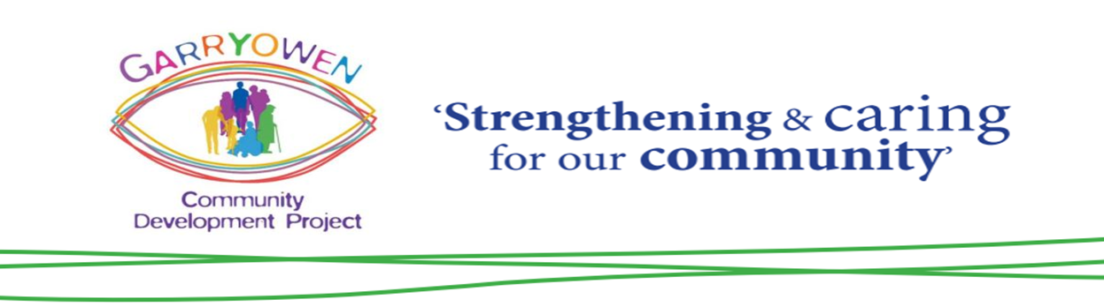

Outline Proposal for the 1st Phase Development of a Purpose-Built Community Centre

Summary
Garryowen CDP has an ambitious vision to provide a comprehensive range of services to all sections of the community in Garryowen. Ultimately, this realisation of this vision will include a comprehensive early years’ services, a community café, integrated sports facilities and a multi-purpose community facility providing space, services and activities for every age group. This proposal focuses on the 1st phase of that vision, which is to develop a community space which enables Garryowen CDP to build on the currently portfolio of activities which we have maintained without the advantage of a dedicated space.

Demographic Analysis:
Much of the housing in Garryowen was built by the local authority in the 1950s and is now home to 4146 people. Garryowen has historically been a working-class area of relatively high employment, familial stability and educational attainment when contrasted with other high density urban communities in Limerick.
However, this demographic has changed in recent years as evidenced by the findings of the 2016 Census; 48% of families are now single-parent families; Of the 2,869 adults of working age in the community, only 1,210 are in employment (i.e 20.4%.) Demographics are trending towards less stable families, higher unemployment and increased percentage of the population under 18 years (21% are under 18 years and 7.8% are under 7 years). The community is home to both the smallest and largest DEIS schools in the city, both of whom are dealing with increasing demand for enrolment.

Community Needs

In the summer of 2016 the CDP conducted a door to door survey of 1200 homes within Garryowen in which 84% of respondents identified a need for a community centre. The survey also identified a need for service provision in the following areas:

Early Years Services
While GCDP operates a limited service (weekly parent and toddler group) there is no community based early years’ service in the area (the nearest community childcare services are in King’s Island, Henry Street and Our Lady of Lourdes). GCDP operates a parent child home visiting programme, but currently staff have no office space from which to work.

Youth Provision
While a number of services operate in the area (youth clubs, youth outreach, Scouts, Garda Youth Diversion) there is no adequate space from which to operate. The current GCDP in John St operates youth clubs on 4 nights a week, but there is little or no space for storage, office, one-to-one and small group meetings. The management of GCDP is constantly having to manage youth space in the centre with other demands of the community, particularly around adult education.

Adult Based Services
High unemployment rates indicate a need for a more effective community-based response. Information supports are currently provided through the SICAP programme, but again, there is no meeting or reception space for clients in the current premises. The capacity to support the community with information and one-to-one supports, including mentoring and referral to other services is critically limited.
Community based adult education services are hampered by lack of space, infrastructure (including accessible IT) and other supports. Initiatives to promote the physical and mental health of adults in the community through the Community Sports Hub are limited through the lack of defined space for organised indoor and outdoor activities, as well as for storage of equipment.

Older Persons Services
Based on 2016 census figures, the Garryowen area is home to nearly 600 people over 65 years of age. There are several older persons groups in the community receiving little or no support from state or voluntary services. GCDP currently supports more than 100 older people through hosting clubs, providing support for outings and assisting groups with grant applications, but support is minimal. Efforts are hampered by lack of adequate space and staff capacity.

Cross Cutting Issues
Anti-social behaviour has become an ever-increasing issue within the community. Recent high-profile incidents, along with low level youth nuisance and vandalism, have given rise to a climate of instability, in particular for older residents (14% of community members over 65 yrs.) While GCDP continues to lobby for an increased garda presence, a greater level of community activities and services targeting those at risk of anti-social behaviour is required to address this.

Garryowen CDP History & Track Record
Formed as a limited company in 2008 Garryowen CDP is now in its fourth premises in 10 years. Originally renting space in the Garda Youth Diversion Project in John St, to the Brass and Reed Band Hall in Garryowen Road, to Cathedral Court and now back in John St. Garryowen CDP was established under the auspices of PAUL Partnership, which recognised that social exclusion and poverty was increasingly an issue across different communities and that the traditional picture of poverty and inequality being polarised in 5 main local authority housing estates was no longer valid. The Garryowen Community Development Project Board is made up from volunteers from the area, partner organisations such as Geraldine’s AFC, Richmond RFC, St. John’s Scouts, St Johns Youth Club, An Garda Siochana and PAUL Partnership. The committee also has strong links with other groups within the community such as senior citizens, women’s groups and local schools.
With support from PAUL, but also because there remains an active and dynamic community in the area, Garryowen CDP continues to sustain itself despite the lack of facilities. Residents remain committed to improving the area. Sporting groups such as Geraldine AFC and Richmond RFC are thriving and have successfully developed ambitious new sporting facilities.
In those 10 years the Board, staff and volunteers of Garryowen CDP have been able to develop and grow the services with minimum funding. Garryowen CDP employs 11 staff (Project Manager, PCHP Coordinator, an Early Intervention/Youth Worker, Sports Hub Coordinator and 6 Home Visitors. 3 detached youth workers employed by LYS work out of the premises under a joint management arrangement and a Caretaker (CE) is also allocated from PAUL Partnership. Total staff complement is therefore 15. A total of 17 volunteers regularly support the Board and staff.
GCDP has shown itself to have an effective track record with the implementation of the following services:
Service | Partners/Funders | Numbers Supported
Parent and Toddler Group | LSSC/Start Right | 15-20
PCHP (Home Visiting Programme) | NCI/Clancourt/ESB | 40+ on caseload & expanding
Youth Groups Tue to Fri 5 groups | PAUL/Regeneration/LYS | 70+
Detached Youth Work | LYS/LCETB | New Programme
3rd Level Bursary Grants | Limerick City CDP | Approx 35 annually
Adult Education Classes ( 12 classes) | LCETB | 100+
SICAP Individual and Group Clients | PAUL/Pobal | 27 individuals 5 groups
Sports Hub | LSP/Sport Ireland | New Programme
Older Persons (5 clubs) | SICAP/Volunteers | 100+

Plans & Cost Estimates

The green space adjacent to the playing fields on St Patrick’s Road is currently under long term lease to Richmond RFC. This sight has been identified by the Garryowen CDP as a location which is properly sited to house a community centre. Agreement in principle has been reached with Richmond for the site to be developed as a Community Centre. The site is approximately 50m x 80M.
This site is ideally placed and has numerous advantages:
- Greenfield site
- Access roads for construction, development
- Good access for use by the Garryowen community but also easily accessible to nearby community members (e.g. Lynwood, Norwood, Rhebogue)
- Existing infrastructure (plumbing, sewage etc.)
- A central location within the geographical area
This site has also been identified by the community as an appropriate location for a centre (72% of those in the door to door survey identified this as their preferred location for a centre). Richmond RFC are working collaboratively with the CDP and are open to exploring this area as a green field site for a community centre. An initial architects drawing has been commissioned by GCDP.

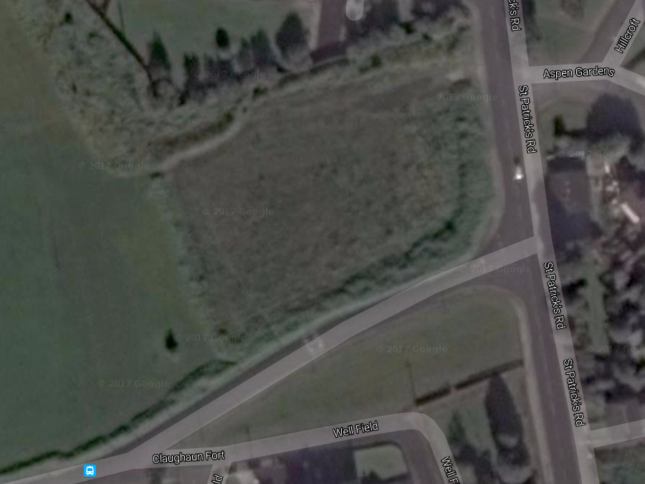

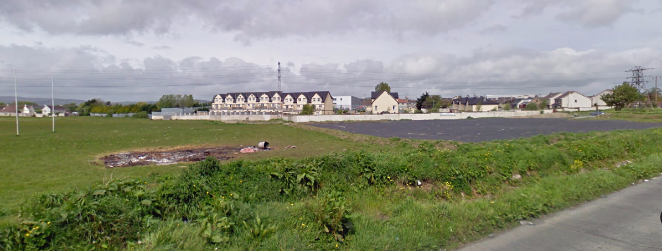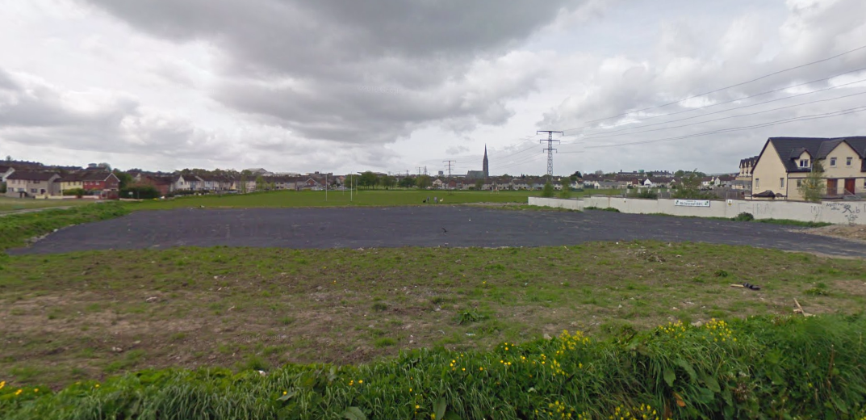
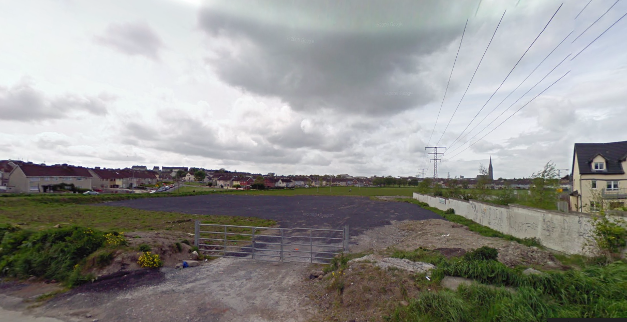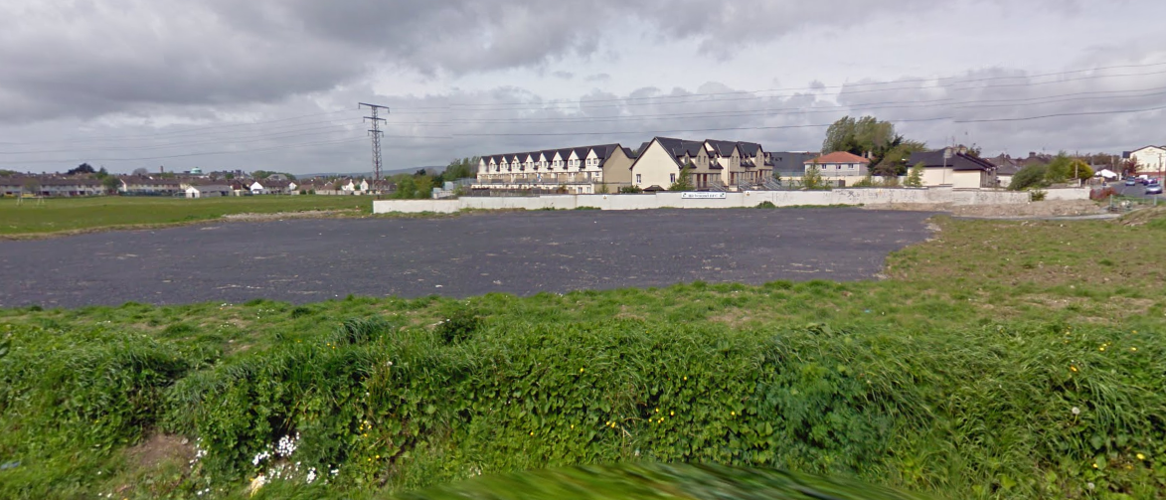

Development Principles
- Fit-for-purpose approach to design and development
- Cost, size and design of Centre to correspond with community capacity to raise on-going running and upkeep costs
- Welcoming and aesthetically pleasing design and appearance, in keeping with Garryowen Community
- Use local labour where possible
- Plan for future usage / expansion
- Minimum community disruption during build

Use Specific Requirements (Internal and External)
- Adhere to ‘Building for Everyone: A Universal Design Approach’. Best practice guidance on how to design, build and manage buildings and spaces so that they can be readily accessed and used by everyone, regardless of age, size ability or disability. http://universaldesign.ie/Built-Environment/Building-for-Everyone/
- Adhere to ‘We Like This Place: Guidelines for the design of Childcare Facilities.’ Guidance on best practice in the planning, design and adaptation of childcare facilities and draw attention to the current statutory requirements. http://www.dcya.gov.ie/documents/publications/welikethisplace.pdf
- Changing and shower facilities fit-for-purpose for youth and adult teams and groups. Richmond RFC to consult.
- Changing and shower facilities to include separate access
- Centre security to consider individual facility access
- New-tech ready. Sufficient electric outlets, phone and internet connectivity points
- Glass panels on all internal doors (frosted glass on the toilet doors). Child Protection.
- Noise reduction due to multi-use of centre

