Document:
Appropriate Assessment Screening

Project:
Improvement works at Bóthair Buí Road, Newcastle West, Co. Limerick.

Prepared for:
Limerick City and County Council.

Prepared by:
Rory Dalton, Independent Ecologist

Table of Contents
Statement of Competence 3
1. Introduction 3
1.1 Appropriate Assessment Process 4
1.2 Methodology 5
2. Description of the Site and Proposed works 6
2.1 Description and Location of the Site 6
2.2 Proposed Works 6
3. Natura 2000 Sites and The Proposal 8
3.1 Natura 2000 Sites within the 15km Zone of Influence 8
3.2 Natura 2000 Sites and their Designations 8
3.3 Natura 2000 Sites excluded from further assessment 10
4. Natura 2000 Sites and Potential Impacts 11
4.1 Sources, Pathways and Receptors 11
4.2 Lower River Shannon SAC 13
4.2.1 Pressures and Threats 13
4.2.2 Assessment of Potential Impacts 14
4.3 Stack’s to Mullaghareirk Mountains, West Limerick Hills and Mount Eagle SPA 16
4.3.1 Assessment of Potential Impacts 17
4.4 Cumulative Impacts 18
5. Conclusion 18
6. Bibliography 19
7. Maps 20

Statement of Competence
Rory is an independent ecological consultant with a decade of experience across a range of disciplines including aquatic ecology, habitats, mammals, and birds. He also carries out a range of species-specific and research-based studies. He graduated from University College Cork with a BSc. Hons in Environmental and Earth Science, after which he spent three years working with a leading ecological consultancy in Limerick. He then set up his own company and has been running it since. Sectors he works in include, conservation, solar farms, wind farms, roads and bridges, grid connections, housing, greenways, instream civil works, drinking water etc. The projects he is involved with range in size from small bridge surveys to the largest wind energy project in the country and the largest water quality project in Europe. He carries out work for a number of State Bodies, Semi-State Bodies, Engineering Consultants, Ecology Consultants, Environmental Consultants and Laboratories.

- Introduction

Rory Dalton was appointed by Limerick City and County Council to prepare a document for the appropriate assessment for Improvement works to be undertaken at Bóthair Buí, Newcastle West, Co. Limerick. The proposed project (detailed in section 2 below) consists of the construction of new footpaths on Bóthair Buí Road, in Newcastle West town. The site begins approximately 120 meters north of the junction of Bóthair Buí Rd and lower Knockane Road and ends approximately 190 meters further along Bóthair Buí road, just past Scoil Mhuire agus Ide sportsfield.

1.1 Appropriate Assessment Process

An Appropriate Assessment is undertaken to establish if any proposed plan or project is likely to have a significant effect or impact on any site that has been designated under: the E.U. Habitats Directive (92/43/EEC) i.e. SAC; or the E.U. Birds Directive (79/409/EEC as amended 2009/147/EC) i.e. SPA. Collectively, SAC’s and SPA’s are known as Natura 2000 sites. The need to undertake one or more stages of this process has arisen from Articles 6(3) and 6(4) of the aforementioned Habitats Directive; where the former Article is primarily concerned with the protection of sites from likely significant effects and the latter allows derogation from such protection in very specific circumstances involving imperative reasons of overriding public interest.
Article 6(3) of the Habitats Directive requires that:
“Any plan or project not directly connected with or necessary to the management of the site but likely to have a significant effect thereon, either individually or in combination with other plans or projects, shall be subject to appropriate assessment of its implications for the site in view of the site's conservation objectives. In the light of the conclusions of the assessment of the implications for the site and subject to the provisions of paragraph 4, the competent national authorities shall agree to the plan or project only after having ascertained that it will not adversely affect the integrity of the site concerned and, if appropriate, after having obtained the opinion of the general public.”
And Article 6(4) of the Habitats Directive requires that:
“If, in spite of a negative assessment of the implications for the site and in the absence of alternative solutions, a plan or project must nevertheless be carried out for imperative reasons of overriding public interest, including those of a social or economic nature, the Member State shall take all compensatory measures necessary to ensure that the overall coherence of Natura 2000 is protected. It shall inform the Commission of the compensatory measures adopted.”
In Stage 1, a screening process is undertaken to identify whether significant impacts on a Natura 2000 site are likely to arise from the project or plan in question. If significant impacts are likely to occur or if it is unclear whether significant impacts are likely to occur, then the process moves on to Stage 2 where an AA considers potential mitigation measures for adverse impacts. If it is considered that mitigation measures will not be able to satisfactorily reduce potential adverse impact on a Natura 2000 site then an assessment of alternative solutions is considered in Stage 3. This is then followed by Stage 4 in the event that adverse impacts remain and the proposed activity or development is deemed to be of Imperative Reasons of Overriding Public Interest (IROPI), allowing an assessment of compensatory measures to be considered. The outcome of a Stage 2 and higher assessment is presented in a report known as a Natura Impact Statement (NIS). While an AA NIS is provided by the advocate of the plan or project in question, the AA NIS itself is undertaken by the competent authority.

1.2 Methodology

Documents associated with the proposed project and relevant ecology databases were consulted as part of this assessment, with a site walkover also undertaken. Furthermore, the following guidelines were used in the completion of this assessment;
- Assessment of Plans and Projects Significantly Affecting Natura 2000 Sites – European Commission Methodical Guidance on the provisions of Article 6(3) and 6(4) of the ‘Habitats’ Directive 92/43/EEC (European Commission 2001)
- Integrated Biodiversity Impact Assessment – Streamlining AA, SEA and EIA Processes: Practitioner’s Manual (EPA 2013)
- Appropriate Assessment of Plans and Projects in Ireland – Guidance for Planning Authorities (DoEHLG 2009)

The Screening Stage of Appropriate Assessment is used to identify whether the Plan, either alone or in combination with other plans or projects, is likely to have a significant effect on a Natura 2000 site. This report follows European Commission (2001) guidance which recommends that screening should follow a four step process as outlined below:
- : Determine whether the plan is directly connected with or necessary to the management of the site.
- : Describe the plan and other plans and projects that, ‘in combination’, have the potential to have significant effects on a European site.
- : Identify the potential effects on the European site.
- : Assess the significance of any effects on the European site.

In stage 2 the potential impacts to conservation interests of the Natura site are looked at in depth and mitigations are put forward to avert these impacts. Each impact is assessed with reference to the conservation interest to which it applies in a case-specific manner. Mitigations are then tailored to each specific situation

- Description of the Site and Proposed works

2.1 Description and Location of the Site

The proposed project is located within the urban environs of Newcastle West, on Bóthair Buí Road. The site begins approximately 120 meters north of the junction of Bóthair Buí Rd and lower Knockane Road and ends approximately 190 meters further along Bóthair Buí road, just past Scoil Mhuire agus Ide sportsfield.

The west of the site of proposed works is predominately adjacent to land zoned, R1 new/proposed residential. While housing is the primary goal for this development land it is also envisaged that services such as, recreation, education, crèche/playschool, clinic/surgery uses, sheltered housing and small corner shops could also be developed here, subject to the preservation of neighbouring residential amenity. There is some land zoned R2 - existing residential, adjacent to the north west section of the site by the junction of Chapel Close and Bóthair Buí Road. The land to the east of the site, on the other side of Bóthair Buí Road, is zoned R2 - existing residential.

  - Proposed Works

Outline Construction Methodology
Limerick City and County Council have outlined that the works involve the construction of a new footpath running north on Bóthair Buí Road, in Newcastle West town, beginning approximately 120 meters north of the junction of Bóthair Buí Rd and lower Knockane Road and ends approximately 190 meters further along Bóthair Buí road, just past Scoil Mhuire agus Ide sportsfield.
.
- The new footpaths will be approximately 190 meters in length.
- The southernmost section of the development will connect with a currently existing footpath on Bóthair Búi road.
- The northernmost section will end just before some private residences before the junction with Chapel Close.
- The majority of the proposed development site is on a road verge with grassy verges with a hedgerow.

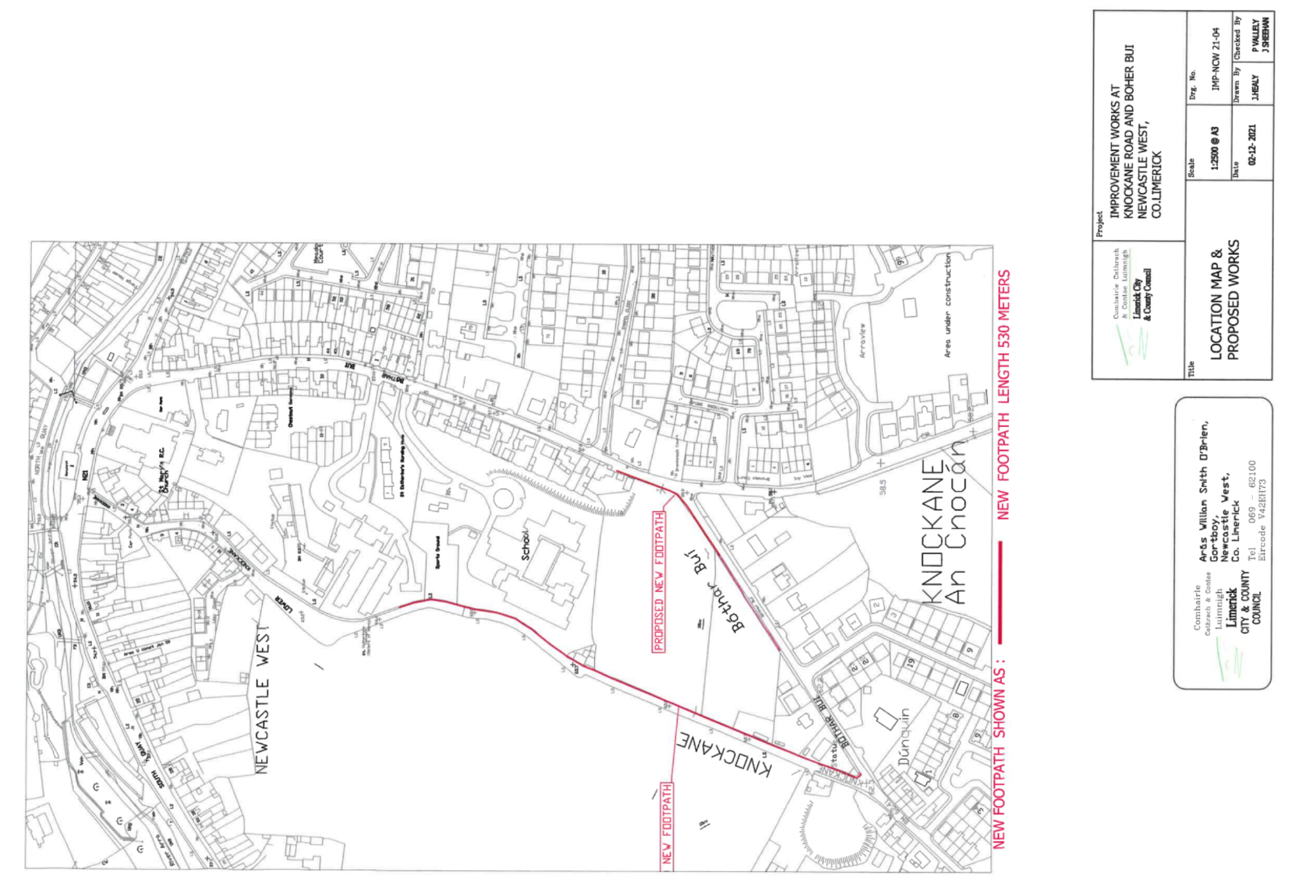
Figure 1 – Proposed site for development on Bothar Bui Road, Newcastle West, Co. Limerick.

- Natura 2000 Sites and Proposal

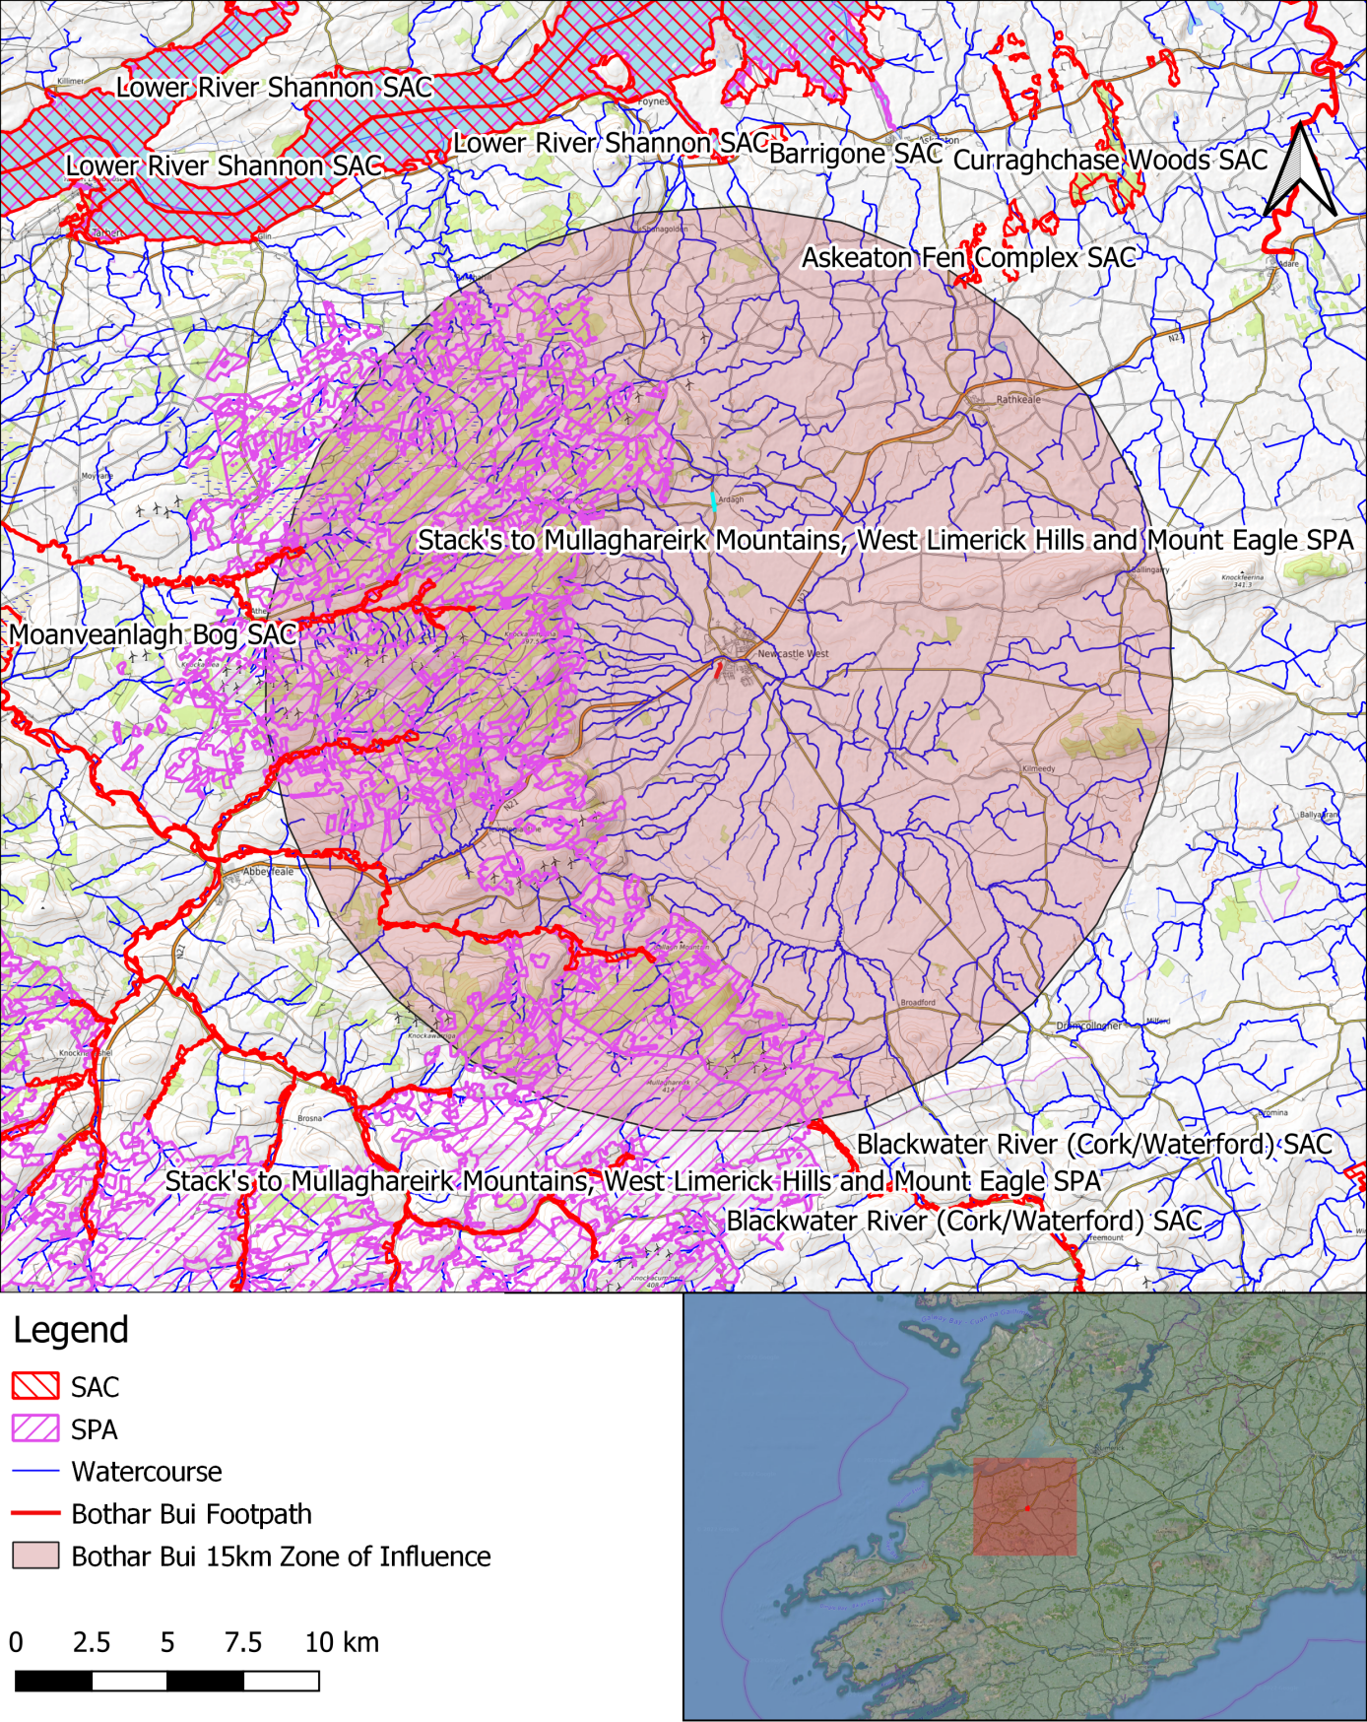
Figure 2 - the proposed footpath within the context of local Natura 2000 sites
3.1 Natura 2000 Sites within the 15km Zone of Influence
Natura Site | Distance between study site and Natura 2000 site | Hydrological/ecological connection?
Lower River Shannon SAC (002165) | 10.0Km | No
Stack's to Mullaghareirk Mountains, West Limerick Hills and Mount Eagle SPA (004161) | 4.4Km | No
Askeaton Fen Complex SAC (002279) | 14.7Km | No
Blackwater River (Cork/Waterford) SAC (002170) | 15Km | No

3.2 Natura 2000 Sites and their Designations
Natura Site | Designated Features
Lower River Shannon SAC (002165) | [1110] Sandbanks  [1130] Estuaries  [1140] Tidal Mudflats and Sandflats  [1150] Coastal Lagoons*  [1160] Large Shallow Inlets and Bays  [1170] Reefs  [1220] Perennial Vegetation of Stony Banks  [1230] Vegetated Sea Cliffs  [1310] Salicornia Mudflats  [1330] Atlantic Salt Meadows  [1410] Mediterranean Salt Meadows  [6410] Molinia Meadows  [3260] Floating River Vegetation  [91E0] Alluvial Forests*  [1029] Freshwater Pearl Mussel (Margaritifera margaritifera)  [1095] Sea Lamprey (Petromyzon marinus)  [1099] River Lamprey (Lampetra fluviatilis)  [1096] Brook Lamprey (Lampetra planeri)  [1106] Atlantic Salmon (Salmo salar)  [1349] Bottle-nosed Dolphin (Tursiops truncatus)  [1355] Otter (Lutra lutra)
Stack's to Mullaghareirk Mountains, West Limerick Hills and Mount Eagle SPA (004161) | (A082) Hen Harrier (Circus cyaneus)
Askeaton Fen Complex SAC (002279) | [7210]Calcareous fens with Cladium mariscus and species of the Caricion davallianae [7210]Alkaline fens [7230]
Blackwater River (Cork/Waterford) SAC (002170) | (1130) Estuaries  (1140) Mudflats and sandflats not covered by seawater at low tide  (1220) Perennial vegetation of stony banks  (1310) Salicornia and other annuals colonising mud and sand  (1330) Atlantic salt meadows (Glauco-Puccinellietalia maritimae)  (1410) Mediterranean salt meadows (Juncetalia maritimi)  (3260) Water courses of plain to montane levels with the Ranunculion fluitantis and Callitricho-Batrachion vegetation  (91A0) Old sessile oak woods with Ilex and Blechnum in the British Isles  (91E0) Alluvial forests with Alnus glutinosa and Fraxinus excelsior (Alno-Padion, Alnion incanae, Salicion albae)  (1029) Margaritifera margaritifera (Freshwater Pearl Mussel)  (1092) Austropotamobius pallipes (White-clawed Crayfish)  (1095) Petromyzon marinus (Sea Lamprey)  (1096) Lampetra planeri (Brook Lamprey)  (1099) Lampetra fluviatilis (River Lamprey)  (1103) Alosa fallax fallax (Twaite Shad)  (1106) Salmo salar (Salmon)  (1355) Lutra lutra (Otter)  (1421) Trichomanes speciosum (Killarney Fern)

3.3 Natura 2000 Sites excluded from further assessment

Natura Site | Rationale for exclusion from further assessment
Askeaton Fen Complex SAC (002279) | The site of the proposed works exists 14.7km from this SAC. These Calcareous and Alkaline fens will not be affected by the works due to the scale and nature of the development and the characteristics of the SAC’s conservation interests. There is no hydrological connection to this habitat and the proposed works have no potential to cause negative impacts to this SAC.
Blackwater River (Cork/Waterford) SAC (002170) | This SAC is excluded from further assessment. It exists 15Km from the site of the proposed works. There is no hydrological connection as it exists in a different catchment from the proposed works. Hence the works have no potential to cause any negative impacts to its conservation interests. The distance of the SAC from the site also ensures that disturbance during the construction of the footpaths will have no impact on the SAC.

- Natura 2000 Sites and Potential Impacts

4.1 Sources, Pathways and Receptors

Source | Pathway | Receptor
Construction Phase
Earthworks can cause the input of silt / fine sediment to a watercourse and pose the risk of introducing hydrocarbons should an incident arise | During the course of the works silts and sediment will be produced during the clearing of site and construction of the footpaths. During these works surface water runoff could carry silt and sediment into the storm water drains on Bóthair Buí Road.  The only hydrological connection exists via ground water soakage to the nearest water source which is, at the closest point, 310 meters away. Also, due to the nature and scale of the proposed works the amount of earth works will be small. The amount of silt or sediment produced with potential to end up in the storm drains will be of little significance.  Additionally, the works will not all be carried out in one go but rather will be carried out in sections of 50m - 100m at a time, lessening the amount of earth/sediment exposed at one time  A substantial portion of the works to be carried out, during the installation of the construction of the footpath, are on grassy verges bounded by vegetated ditches. During these sections these vegetated boundaries will help to filter and settle out any silt laden surface water that is produced.  There are no storm water drains within the Bothar Bui site and so all precipitation will percolate via the ditch to groundwater meaning that there will be no dirty water incident on the watercourse | Each receptor (designated feature) is explored in detail in sections 4.2, 4.3 and 4.4.
Construction works can cause the input of cementitious material and silt / fine sediment to a watercourse | The proposed works has the potential to produce cementitious material during the construction of the footpaths due to, for example, pouring of concrete and cutting precast concrete kerbs, which has the potential to enter the storm drains during times of rain. The footpath is 310m at its closest point from a watercourse, the Arra River. The Arra River flows into the Deel which flows into the Shannon Estuary ~30km downstream of Newcastle West.  Additionally, the works will not all be carried out in one go but rather will be carried out in sections of 50m - 100m at a time, lessening the amount of earth/sediment exposed at one time  There are no storm water drains within the Bothar Bui site and so all precipitation will percolate via the ditch to groundwater meaning that there will be no dirty water incident on the watercourse  This distance, in combination with the small scale of the works, ensures that no pathway for pollutants is present | Each receptor (designated feature) is explored in detail in sections 4.2, 4.3 and 4.4.
Physical disturbance can can arise from noise associated with construction; mainly by machinery and to a lesser degree power tools and hammering | Due to the scale of the works, noise disturbance from machinery and power tools during the development is not likely to be significantly elevated above normal levels of the town of Newcastle West. Also due to the distance from the site of the proposed works to the surrounding SPAs and SACs, with the closest being Stack's to Mullaghareirk Mountains, West Limerick Hills and Mount Eagle SPA, 4.4 kms away, no significant pathway for disturbance exists. | Each receptor (designated feature) is explored in detail in sections 4.2, 4.3 and 4.4.
Destruction of habitat | The amount of habitat to be removed in order to install the new sections of footpath will be small, and no habitats within, connected to, or important for Natura 2000 sites will be impacted. | Each receptor (designated feature) is explored in detail in sections 4.2, 4.3 and 4.4.
Operational Phase
Disruption to the hydrology of a catchment can arise from creating new hard-stands | The nature of the works will not present any significant alterations to the hydrology of the catchment. Any sections of new hard stand will be adjacent to a road way and will be relatively small in nature and not of such significance to alter the hydrology of a catchment. | Each receptor (designated feature) is explored in detail in sections 4.2, 4.3 and 4.4.
Physical disturbance can can arise from noise associated with habitation | During the operational phase of the development the amount of noise pollution will not be increased. As the proposed works will be undertaken in order to install new footpaths there will be no increase in traffic volume or disturbance. | Each receptor (designated feature) is explored in detail in sections 4.2, 4.3 and 4.4.

4.2 Lower River Shannon SAC

This very large site stretches along the Shannon valley from Killaloe in Co. Clare to Loop Head/ Kerry Head, a distance of some 120 km. The site thus encompasses the Shannon, Feale, Mulkear and Fergus estuaries, the freshwater lower reaches of the River Shannon (between Killaloe and Limerick), the freshwater stretches of much of the Feale and Mulkear catchments and the marine area between Loop Head and Kerry Head. The vast majority of the surface area is estuarine, however, the site also encompasses extensive river corridors, and so as a whole the site is varied in nature.
This site is of great ecological importance. It is designated for 11 marine/estuarine habitats, two terrestrial habitats, one freshwater habitat, 5 freshwater species, one marine mammal, and one semi-aquatic mammal. It includes the largest estuarine habitat in the country.
4.2.1 Pressures and Threats
Pressures and threats within this SAC are summarised in the following table
Level | Threat and Pressure Code | Inside or outside SAC | Threat and Pressure
Low | C01.01.02 | Inside | Removal of beach materials
Low | F01 | Inside | Marine and Freshwater Aquaculture
Low | F03.01 | Inside | Hunting
Low | E03 Inside | Inside | Discharges
Medium | J02.01.01 | Inside | Polderisation [drainage of wetlands]
Low | J02.12.01 | Inside | Abandonment of management of water bodies
Low | G01.01 | Inside | nautical sports
Low | J02.10 | Inside | management of aquatic and bank vegetation for drainage purposes
Medium | A04 | Inside | grazing
Low | B | Inside | Sylviculture, forestry
Medium | H04 | Outside | Air pollution, air‐borne pollutants
Low | D01.01 | Inside | paths, tracks, cycling tracks
Medium | E03 outside | Outside | Discharges
Medium | J02.01.02 | Outside | reclamation of land from sea, estuary or marsh
Low | I01 | Inside | invasive non‐native species
Medium | E01 | Outside | Urbanised areas, human habitation
Medium | A08 | Outside | Fertilisation
Medium | K02.03 | Outside | eutrophication (natural)
Medium | A08 | Inside | Fertilisation
Low | C01.03.01 | Inside | cutting of peat

4.2.2 Assessment of Potential Impacts

Conservation Interest | Assessment of Potential Impacts
Sandbanks which are slightly covered by sea water all the time [1110]  Estuaries [1130]  Mudflats and sandflats not covered by seawater at low tide [1140]  Coastal lagoons [1150]  Large shallow inlets and bays [1160]  Reefs [1170]  Perennial vegetation of stony banks [1220]  Vegetated sea cliffs of the Atlantic and Baltic coasts [1230]  Salicornia and other annuals colonising mud and sand [1310]  Atlantic salt meadows [1330]  Mediterranean salt meadows [1410]  Floating River  Vegetation [3260]  Molinia meadows on calcareous, peaty or clayey-silt-laden soils [6410]  Alluvial forests with Alnus glutinosa and Fraxinus excelsior [91E0]  Freshwater Pearl Mussel [1029]  Sea Lamprey [1095]  Brook Lamprey [1096]  River Lamprey [1099]  Salmon [1106]  Common Bottlenose Dolphin [1349]  Lutra lutra (Otter) [1355] | The site of the proposed works exists 9 km from this SAC at the closest point. The closest possible hydrological connection to the SAC from the site of the proposed works is via the Shanngarry stream, 310 meters away via ground water soakage; there are no stormwater drains within the footprint of the proposal and so precipitation will percolate to ground water thereby filtering it. The Shanngarry flows into the River Arra, and subsequently into the River Deel which discharges into the Shannon estuary approximately 31 km downstream.  During the course of the works sediment and cementitious materials will be produced in the demolition of the old footpaths and also the construction of the new sections.  The scale of the proposed works is small. The amount of silt or sediment produced will be small, and the lack of storm water drains means that the proposed works site is hydrologically isolated. The hydrological isolation of the site from the Lower River Shannon SAC further negates this risk.  A substantial portion of the works to be carried out, during the installation of the new sections of footpath, are on grassy verges bounded by vegetation and gravel road verges. These vegetation and gravel boundaries will help to filter and settle out any silt laden surface water that the project is capable of producing.  Due to the site's hydrological isolation and distance from the SAC combined with the scale and nature of the proposed works no negative impacts for these habitats or species are envisaged.

4.3 Stack's to Mullaghareirk Mountains, West Limerick Hills and Mount Eagle SPA

The Stack’s to Mullaghareirk Mountains, West Limerick Hills and Mount Eagle SPA is a very large site centred on the borders between the counties of Cork, Kerry and Limerick. The site is skirted by the towns of Newcastle West, Ballydesmond, Castleisland, Tralee and Abbeyfeale. The mountain peaks included in the site are not notably high or indeed pronounced, the highest being at Knockfeha (451 m). Other mountains included are Mount Eagle, Knockanefune, Garraunbaun, Taur, Rock Hill, Knockacummer, Mullaghamuish, Knight’s Mt, Ballincollig Hill, Beennageeha Mt, Sugar Hill, Knockanimpuba and Knockathea, amongst others. Many rivers rise within the site, notably the Blackwater, Owentaraglin, Owenkeal, Glenlara, Feale, Clydagh, Allaghaun, Allow, Oolagh, Galey and Smerlagh.
The site consists of a variety of upland habitats, though almost half is afforested. The coniferous forests include first and second rotation plantations, with both pre-thicket and post-thicket stands present. Substantial areas of clear-fell are also present at any one time. The principal tree species present are Sitka Spruce (Picea sitchensis) and Lodgepole Pine (Pinus contorta). A substantial part (28%) of the site is unplanted blanket bog and heath, with both wet and dry heath present. The vegetation of these habitats is characterised by such species as Ling Heather (Calluna vulgaris), Bilberry (Vaccinium myrtillus), Common Cottongrass (Eriophorum angustifolium), Hare’s-tail Cottongrass (Eriophorum vaginatum), Deergrass (Scirpus cespitosus) and Purple Moor-grass (Molinia caerulea). The remainder of the site is mostly rough grassland that is used for hill farming. This varies in composition and includes some wet areas with rushes (Juncus spp.) and some areas subject to scrub encroachment.
The site is a Special Protection Area (SPA) under the E.U. Birds Directive, of special conservation interest for Hen Harrier. This SPA is a stronghold for Hen Harrier and supports the largest concentration of the species in the country. A survey in 2005 recorded 45 pairs, which represents over 20% of the all-Ireland total. A similar number of pairs had been recorded in the 1998-2000 period. The mix of forestry and open areas provides optimum habitat conditions for this rare bird, which is listed on Annex I of the E.U. Birds Directive. The early stages of new and second-rotation conifer plantations are the most frequently used nesting sites, though some pairs may still nest in tall heather of unplanted bogs and heath. Hen Harriers will forage up to c. 5 km from the nest site, utilising open bog and moorland, young conifer plantations and hill farmland that is not too rank. Birds will often forage in openings and gaps within forests. In Ireland, small birds and small mammals appear to be the most frequently taken prey.
Short-eared Owl, a very rare species in Ireland, has been known to breed within the site. Nesting certainly occurred in the late 1970s and birds have been recorded intermittently since. The owls are considered to favour this site due to the presence of Bank Voles, a favoured prey item. Merlin also breed within the site but the size of the population is not known. Red Grouse is found on some of the unplanted areas of bog and heath – this is a species that has declined in Ireland and is now Red-listed.

The Stack’s to Mullaghareirk Mountains, West Limerick Hills and Mount Eagle SPA is of ornithological importance because it provides excellent nesting and foraging habitat for breeding Hen Harrier and is one the top sites in the country for the species. The presence of three species, Hen Harrier, Merlin and Short-eared Owl, which are listed on Annex I of the E.U. Birds Directive is of note.

4.3.1 Assessment of Potential Impacts

Conservation Interest | Assessment of Potential Impacts
(A082) Hen Harrier (Circus cyaneus) | The site of the proposed works exists 4.4 km from this SPA at the closest point.  An Irish National Hen Harrier Survey undertaken by Ruddock et al (2012) found that the majority of breeding pairs, 43.8%, of hen harriers nested primarily in second rotation plantation forest habitats, while 24.4% nested in heather habitats. However studies undertaken of the foraging activity of hen harriers continued to indicate that hen harriers favour open moorland while hunting, avoiding intensive agricultural areas and particularly avoiding urban areas. Their diets, consisting of birds and mammals, are regularly composed of ground nesting birds such as the meadow pipit and skylark, which do not nest within the footprint of the works. No suitable nesting habitat or suitable foraging habitat for hen harriers exists within or surrounding the footprint of the works.  As the Stack's to Mullaghareirk Mountains, West Limerick Hills and Mount Eagle SPA is 4.4Km from the site of the proposed works, there is no significant pathway for noise disturbance from machinery and power tools during the development to negatively impact the SPA. During the operational phase of the works no additional disturbance will be generated hence, no significant pathway for disturbance exists.  No negative impacts are envisaged for this species

4.5 Cumulative Impacts
Given the absence of pathways for the sources identified in Section 4.1 above, combined with the nature and scale of the works, it can be said with reasonable confidence that there will be no cumulative impact to any of the conservation interests on the Lower River Shannon SAC or the Stack's to Mullaghareirk Mountains, West Limerick Hills and Mount Eagle SPA arising from this proposal.

5. Conclusion
In conclusion the construction of footpaths on Bóthair Buí road, Newcastle West, Co. Limerick will not cause adverse impacts on the conservation objectives of any Natura 2000 Site .

6. Bibliography

Department of Environment, Heritage & Local Government (DoEHLG). 2009. Appropriate Assessment of Plans and Projects in Ireland – Guidance for Planning Authorities. DoEHLG, Dublin
Environment Agency's 'River Habitat Survey in Britain and Ireland Field Survey Guidance Manual 2003'
European Commission. 2001. Assessment of Plans and Projects Significantly Affecting Natura 2000 Sites – European Commission Methodical Guidance on the provisions of Article 6(3) and 6(4) of the ‘Habitats’ Directive 92/43/EEC. European Commission DG Environment, Oxford UK.
European Commission (2018). Managing Natura 2000 sites. The provisions of Article 6 of the Habitats Directive 92/43/EEC. Brussels, 21.11.2018 C(2018) 7621 final.
Environmental Protection Agency (EPA). 2013. Integrated Biodiversity Impact Assessment – Streamlining AA, SEA and EIA Processes: Practitioner’s Manual. EPA STRIVE Programme 2007–2013; Report Series No. 106. EPA, Wexford.
EPA(2020) EPA map viewer. Last accessed on 15.04.2022 at https://gis.epa.ie/EPAMaps
NPWS (2012) Conservation Objectives: Lower River Shannon SAC 002165. Version 1.0. National Parks and Wildlife Service, Department of Arts, Heritage and the Gaeltacht.
NPWS (2015) Conservation objectives for Stack's to Mullaghareirk Mountains, West Limerick Hills and Mount Eagle SPA. Department of Housing, Local Government and Heritage.
NPWS (2019) The Status of EU Protected Habitats and Species in Ireland. Volume 2: Habitat Assessments
NPWS (2018) Conservation objectives for Askeaton Fen Complex SAC 002279 . Version 1.0. National Parks and Wildlife Service, Department of Arts, Heritage and the Gaeltacht.
NPWS (2012) Conservation objectives for Blackwater River (Cork/Waterford) SAC. Version 1.0. National Parks and Wildlife Service, Department of Arts, Heritage and the Gaeltacht.
Ruddock, M. & Dunlop, B.J., O’Toole, L., Mee, A., Nagle, T. (2012) Republic of Ireland National Hen Harrier Survey 2010. Irish Wildlife Manual, No. 59. National Parks and Wildlife Service, Department of Arts, Heritage and the Gaeltacht, Dublin, Ireland.

https://www.npws.ie/sites/default/files/protected-sites/natura2000/NF002165.pdf

