6/05/2022

Works consisting of the building of footpaths on the L7089, Abbeyfeale, Co. Limerick.
Environmental impact assessment screening.
Prepared, on behalf of Limerick County Council, by Rory Dalton, Independent Ecologist

Table of Contents

Introduction 3
Legislative Context 3
Brief Description of the Sites and Proposed works 4
Site Description and Location 4
Proposed Works 4
EIA Screening Checklist 6
Annex III Screening Selection Criteria 15
Characteristics of Project 16
The size of the project 16
The cumulation with other projects 16
The use of natural resources 16
The production of waste 17
Pollution and nuisances 17
The risk of accidents 18
Location of Project 18
The existing land use 18
The relative abundance, quality and regenerative capacity of natural resources in the area 19
The absorption capacity of the natural environment 19
Characteristics of the Potential Impact 19
Human Beings 20
Biodiversity and Water 20
Land, Soil, Air and Climate 22
Material Assets, Heritage and the Landscape 23
Conclusion 24
Bibliography 25
Relevant Maps 26

Introduction
Rory Dalton was appointed by Limerick Co. Council to undertake an Environment Impact Assessment Screening for works to be undertaken on the L7089 road in Abbeyfeale, Co. Limerick. The proposed project (detailed below) consists of the construction of a footpath in Abbeyfeale town, Co. Limerick. It is proposed to install a section of footpath to a total length of approximately 600 meters on the L 7089.

These proposed works are intended to enhance the experience of the public by creating a safer environment for pedestrians and motorists alike.

Legislative Context

EIA is a procedure required under the terms of European Union Directives 85/337/EEC and 97/11/EC on assessment of the effects of certain public and private projects on the environment. Article 2 of the Directives requires that “Member States shall adopt all measures necessary to ensure that, before consent is given, projects likely to have significant effects on the environment by virtue, inter alia, of their nature, size or location are made subject to a requirement for development consent and an assessment with regard to their effects.” Article 8 then requires that “The results of consultations and information gathered pursuant to [the EIA procedure] must be taken into consideration in the development consent procedure”
The requirements for screening are contained in Article 4 of Directive 97/11/EC. Article 4(1) requires that “…projects listed in Annex I shall be made subject to an assessment…”. EIA is therefore mandatory for the categories of projects listed in Annex I and Member States’ legislation must provide for this. The Annex I list defines about 21 categories of projects for which EIA is mandatory. Screening of these projects must lead to a “yes” decision that EIA is required. Article 4(2) requires that for “…projects listed in Annex II, the Member States shall determine through (a) a case-by-case examination, or (b) thresholds and criteria set by the Member State”
In this case, the project type is listed in Annex ll and is being dealt with in a case-by-case examination.

Brief Description of the Sites and Proposed works

Site Description and Location
Abbeyfeale is a historic market town in County Limerick, Ireland, near the Kerry/Limerick border. The town is on the N21 road from Limerick to Tralee, about 21 kilometres south-west of Newcastle West, 16 kilometres south-east of Listowel and 38 kilometres north-east of Tralee. The town is built on the western bank of the River Feale, in the foothills of the Mullaghareirk Mountains.

The site of the proposed works exists on the outskirts of the town. It is proposed to install a section of footpath to a total length of approximately 600 meters, on the L 7089 otherwise known as St. Ita’s Road. The road comprises predominantly private residential properties, GZT zone R2 - Existing residential and agricultural land. There is also the entrance to a reservoir in the center of the site of the proposed work GZT zone: N2.1 - Water. There is also a portion of land adjacent to the L7089 zoned GZT Zone: R1 - New/proposed residential.

The northernmost section of the site of the proposed works begins at the junction of the L 7089 and the L 7050 and extends south west along the L7089 for approximately 600 meters. It is proposed to construct the footpath on the eastern side of the road.

Proposed Works
Limerick City and County Council have outlined that the works involve the replacement of existing footpaths within the outskirts of Abbeyfeale
- Existing footpath to be dug up using small excavator, and rubble to be removed from the site to the council compound or to a licensed waste disposal site. For greenfield sections, the same general principal applies
- Some sections of the existing footpath are narrow, and may need to be widened. Where kerb replacement is required, this will be carried out prior to the pouring of footpath concrete in order to attain the heights for the concrete. Kerbing will either be precast kerbs placed as standard, or a shuttered kerb which is filled with a relatively dry mix and let to set over night or over a number of days. Similarly, in greenfield sections, the kerbing will be laid and allowed to set prior to the pouring of concrete. This shutter will be struck out prior to the pouring of the footpaths and will ensure that the cell to be poured is sealed in terms of concrete leaking out onto the road.
- This works area will move along on a rolling basis as the old footpath is being excavated and the new footpath is being laid. The excavation work will be carried out by a small team in short sections (30 to 80m) to avoid excessive disturbance to members of the public using the footpath. The works area will be marked out with cones and an alternative footpath provided adjacent to the footpath being worked on.
- Devices (PVC Screed, expansion joint filler foam etc) to facilitate expansion/contraction will be placed at regular intervals in line with the levels of the footpath.
- Concrete pours will consist of one load of concrete (circa 8m³) being poured at a time and allowed to set before the next load arrives. This will equate to approximately 20-40m of footpath and the small team will work on levelling, screeding, floating and finishing the concrete. Pours will only be carried out during dry weather to ensure the quality of the finished surface and also to eliminate risk to the aquatic environment. In the unlikely event of unexpected rain, any uncured concrete will be covered in plastic sheeting; 50m length of which will be kept onsite at all times.
- On sloped areas, baffles of potato sacking/ hemp fibre will be placed at 90 degrees to the kerb will be placed every 10m to ensure that sediment which may become mobilised in a shower is minimised, similarly any entrances to the stormwater drainage system adjacent to the works will be covered with potato sack/hemp fibre.
- The rolling works area will be finished, brushed and cleaned, along with the road adjacent, as the works moves along to ensure overall tidiness of the village and to ensure the footprint of the works remains small.
- The Council will inspect the site intermittently to ensure that the site is in good condition and that the method outlined above is followed

The methodology above will be applied to the following sections:

- The northernmost section of the site of the proposed works begins at the junction of the L 7089 and the L 7050 and extends south west along the L7089 for approximately 600 meters.
- The southernmost point of the proposed works ends at a property known as Fitzgerald's farmhouse, accommodation and equestrian center.
- It is proposed to construct the footpath on the eastern side of the road.

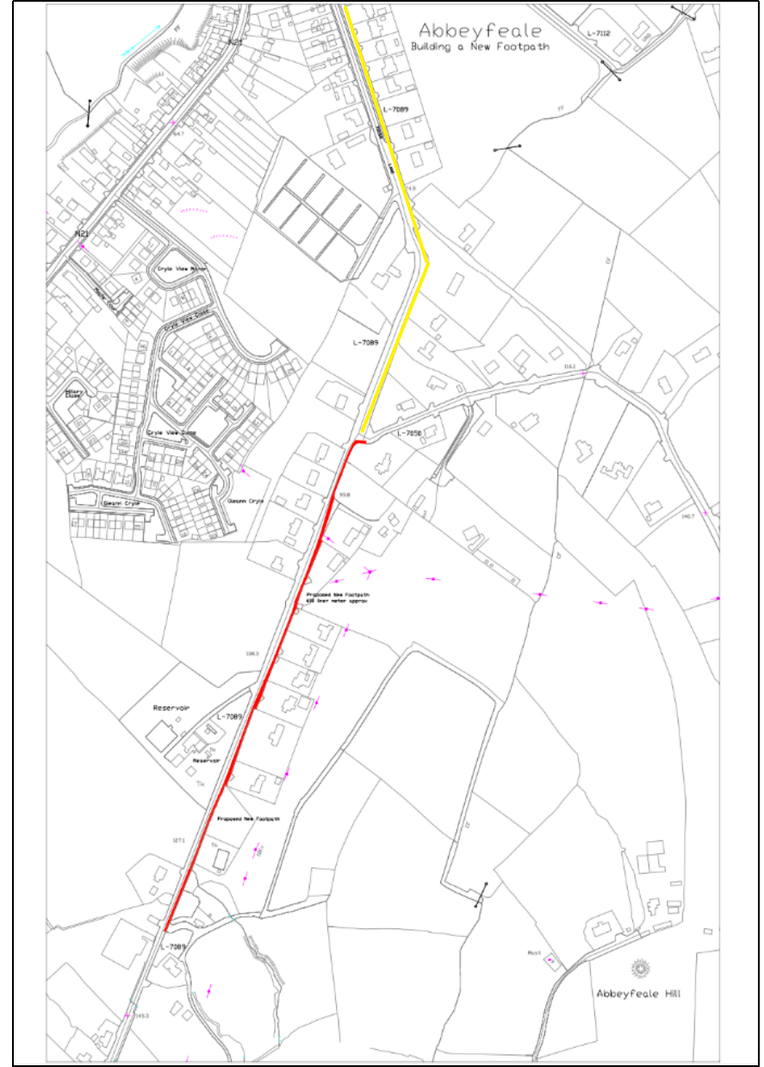
Figure 1 – Footpath works to be carried out in Abbeyfeale, the new footpath is in red, existing footpath to be re-done is in yellow.

EIA Screening Checklist

Questions to be Considered | Yes/No  Brief explanation | Is this likely to result in a significant effect?  Yes/No/? – Why?
1. Will construction, operation or decommissioning of the Project involve actions which will cause physical changes in the locality (topography, land use, changes in water bodies, etc)? | Yes. However, the changes will be minor, Involving the construction of new footpath and update of existing. Much of the works will be undertaken on surfaces such as amenity grassland, gravel road verges and hard stand surfaces, which exist in front of private residential properties. Some grassy verges and a small section of hedgerow will be affected. Changes of land use will involve changing these verges and borders to a footpath. No water bodies will be affected. | No; any changes will be minor in nature and serve only to benefit the local community.
2.Will construction or operation of the Project use natural resources such as land, water, materials or energy, especially any resources which are non-renewable or in short supply? | Yes  Construction phase: Materials (cement, gravel, concrete, water) and energy (diesel)for construction.  Operational Phase: No | No  These resources are not in short supply.
3. Will the Project involve use, storage, transport, handling or production of substances or materials which could be harmful to human health or the environment or raise concerns about actual or perceived risks to human health? | Construction phase - Yes:  Cement,fuels and lubricants  Operational phase - No | No  Works will be carried out utilizing best practices guidelines and standard operating procedures
4. Will the Project produce solid wastes during construction or operation? | Construction phase - Yes:  Some solid waste will be produced during the clearing and leveling of ground to facilitate the construction of the new footpaths.  Operational phase: No | No  The amount of waste produced will be minimal, and will be managed by a licensed contractor
5. Will the Project release pollutants or any hazardous, toxic or noxious substances to air? | Construction phase - Yes:  Exhaust fumes from the machinery will be slightly elevated from normal levels  Operational phase - No:  As normal | No  Exhaust fumes from the machinery will only be slightly elevated from normal levels
6. Will the Project cause noise and vibration or  release of light, heat energy or electromagnetic  radiation? | Construction phase - Yes:  Machinery and power tools will cause noise and vibration.  Operational phase - No: | No  Noise and vibration will not be far above existing levels, and the machinery being used will be relatively small and typical of any minor road works
7. Will the Project lead to risks of contamination of land or water from releases of pollutants onto the ground or into surface waters, groundwater, coastal waters or the sea? | Construction phase - Yes:  There is the risk of suspended solids (dust from rubble, mud, cement) or fuel/lubricant spills entering the ground water during times of rain.  Operational phase - No: | No  The site of the proposed works is 250 meters from the nearest watercourse. This is dealt with in extensive detail in the AA Screening Section 4.1
8. Will there be any risk of accidents during construction or operation of the Project which could affect human health or the environment? | Construction phase - Yes:  As with any construction site there are risks involved for the workers and for the environment by way of accidents  Operational phase - No: | No  All workers are aware of the dangers of working on a building site, they are used to working on sites and will have completed their SafePass. Additionally the sections of the site which are being worked on will be fenced off to the public.
9. Will the Project result in social changes, for example, in demography, traditional lifestyles, employment? | Yes:  There will be social changes, however they are all positive. The creation of the footpaths will enhance the lives of the locals and provide a safer environment for pedestrians, cyclists and motorists alike. | No  Only positive changes as previously explained
10. Are there any other factors which should be considered such as consequential development which could lead to environmental effects or the potential for cumulative impacts with other existing or planned activities in the locality? | No  There are no consequential developments anticipated from this project. There are no anticipated cumulative impacts with planned activities in the locality. There are no cumulative impacts with existing activities in the locality | No  No significant impact in this regard
11. Are there any areas on or around the location which are protected under international or national or local legislation for their ecological, landscape, cultural or other value, which could be affected by the project? | Yes  There are two Natura 2000 sites near the area, the Lower River Shannon SAC which is 250 meters and the Stack's to Mullaghareirk Mountains, West Limerick Hills and Mount Eagle SPA which exists 4km away from the site.  There are a number of protected structures and monuments near and in Abbeyfeale including a number. which are no longer evident. The closest of these is a mound which is 800 meters from the site of the proposed works. There are also a number of protected structures in Abbeyfeale including a number of houses, a bank, a public house, a cinema and a graveyard. | No  An Appropriate Assessment Screening has been carried out which addresses the issue of the SPA and the SAC  The proposed works do not have potential to affect these protected monuments of national value.
12. Are there any other areas on or around the location which are important or sensitive for reasons of their ecology e.g. wetlands, watercourses or other water bodies, the coastal zone, mountains, forests or woodlands, which could be affected by the project? | No  The works are small scale and in the outskirts of a town which are alreagy built up.  Important or sensitive habitats which could potentially be impacted by the project have been dealt with as part of the AA Screening | No
13. Are there any areas on or around the location which are used by protected, important or sensitive species of fauna or flora e.g. for breeding, nesting, foraging, resting, overwintering, migration, which could be affected by the project? | Yes  The River Feale and its corridor hosts variety of mammals, fish and plants. Additionally Stack's to Mullaghareirk Mountains, West Limerick Hills and Mount Eagle SPA is a specially protected area for the Hen Harrier. | No  As can be seen in the AA screening, the proposal does not have the capacity to cause significant SAC or the SPA.
14. Are there any inland, coastal, marine or underground waters on or around the location which could be affected by the project? | Yes  The proposed works also has some potential to cause pollutants to reach the river Feale during the course of the works. | No  As can be seen in the AA screening, the proposal does not have the capacity to cause significant impacts on the Feale and no significant incidence of pollution to the groundwater is envisaged.
15. Are there any areas or features of high landscape or scenic value on or around the location which could be affected by the project? | No  The scale and nature of the works will ensure no feature of scenic value will be affected | No  The scale of the works are minor and serve only to enhance the public's experience using the L7089 road, Abbeyfeale.
16. Are there any routes or facilities on or around the location which are used by the public for access to recreation or other facilities, which could be affected by the project? | Yes  The People living on the L7089 and the L7050 will be minorly and temporarily affected. The L7089 Road is on the outskirts of Abbeyfeale town and hence only those living on the L7089 and the L7050 or using these roads as a commuter route to recreational facilities, etc, will be temporarily affected by the works. | No  No significant effects are envisaged. During the course of the works the public will retain use of these routes. The new footpath will actually allow the public easier and safer access in the long term.
17. Are there any transport routes on or around the location which are susceptible to congestion or which cause environmental problems, which could be affected by the project? | Construction phase - Yes:  The People living on the L7089 and the L7050 will be temporarily affected for the duration of the works. Various entrances to residential properties, adjacent to the works, will also be affected in terms of nuisance by the works..  Operational phase - No | No  The impact on traffic will be small and of a short duration. Adequate traffic management will be in place and managed by a competent contractor.
18. Is the project in a location where it is likely to be highly visible to many people? | Yes  The proposed works will take place on the L7089 and part of the L7050. | No  The proposal is designed and intended to positively impact the lives of locals and visitors
19. Are there any areas or features of historic or cultural importance on or around the location which could be affected by the project? | No  There are a number of protected structures and monuments near Abbeyfeale, a number of which are no longer evident. The closest of these is a mound which is 800 meters from the site of the proposed works. There are also a number of protected structures in Abbeyfeale including a number of houses, a bank, a public house, a cinema and a graveyard. However the project has no means of affecting these monuments and protected structures. | No  The scale and nature of the works ensures there will be no negative effects for these structures.
20. Is the project located in a previously undeveloped area where there will be loss of greenfield land? | No  The majority of the works will be undertaken on surfaces such as amenity grassland, gravel road verges and hard stand surfaces, which exist in front of private residential properties. Some grassy road verges and a small section of hedgerow will be set back | No  No significant impact
21. Are there existing land uses on or around the location e.g. homes, gardens, other private property, industry, commerce, recreation, public open space, community facilities, agriculture, forestry, tourism, mining or quarrying which could be affected by the project? | Yes  The proposed works take place on a public road, the L7089 on which a number of residential properties exist. There is also a reservoir on this section of roadway and a working farm/equestrian center and agricultural land | No  There will be no significant impact on these properties or facilities. The proposal is designed and intended to enhance the local land use and to positively impact the lives of locals
22. Are there any plans for future land uses on or around the location which could be affected by the project? | Yes  There are a number of planning applications in the area surrounding the proposal. Most are permission requests for the building of new private dwellings or private dwellings seeking to renovate and/or build small extensions. There are no applications (infrastructure, commercial etc) within the locality that will cause a cumulative impact with the current proposal. | No  The current proposal will not affect any other planning application in the vicinity.
23. Are there any areas on or around the location which are densely populated or built-up, which could be affected by the project? | Yes  The site of the proposed works exists within a residential environment. For the duration of the works the local population will be affected in various ways, for example, some traffic disruption, enhanced noise levels and the area will be somewhat unsightly while the works are underway. | No  The proposal is designed and intended to enhance the local land use and to positively impact the lives of locals
24. Are there any areas on or around the location which are occupied by sensitive land uses e.g. hospitals, schools, places of worship, community facilities, which could be affected by the project? | Yes  The Church of the assumption is 975 meters away. Coláiste Íde agus Iosef is approximately 1.1 kilometers from the site at the closest point. Abbeyfeale medical center is roughly 436 meters from the proposed works.  There is also a range of establishments and facilities within the town such as shops, supermarkets, bars, post office, etc. | No  The scale and nature of the works will negate the impact of disturbance to these facilities.  The proposal is designed and intended enhance the local land use and to positively impact the lives of locals
25. Are there any areas on or around the location which contain important, high quality or scarce resources e.g. groundwater, surface waters, forestry, agriculture, fisheries, tourism, minerals, which could be affected by the project? | Yes  The area surrounding Abbeyfeale town is also predominantly agricultural land. | No  The proposal will also not negatively impact agriculture in the vicinity as it has neither the capability to significantly pollute or cause highly elevated levels of disturbance.
26. Are there any areas on or around the location which are already subject to pollution or environmental damage e.g. where existing legal environmental standards are exceeded, which could be affected by the project? | No  The proposed works will not add sewage or other pollutants to the current network. | No  The current proposal is not a “significant additional commercial/residential development” and does not, in itself add additional sewage to the network.
27. Is the project location susceptible to earthquakes, subsidence, landslides, erosion,  flooding or extreme or adverse climatic conditions e.g. temperature inversions, fogs, severe winds, which could cause the project to present environmental problems? | No  Additionally, he proposed works will not add significant additional volumes of water to the storm water network. | No  No significant impact

Annex III Screening Selection Criteria

Article 4(3) of Directive 97/11/EC requires that Competent Authorities must take into account the
selection criteria set out in Annex III of the Directive when making screening decisions on a case-by-case basis and when setting thresholds and criteria for projects requiring EIA. The criteria are set out under three headings as follows:

Characteristics of Project

The size of the project

The site of the proposed works exists on the outskirts of the town. It is proposed to install a section of footpath to a total length of approximately 600 meters of new footpath and 400m of repairs to existing footpath, on the L 7089 otherwise known as St. Ita’s Road.
These works are relatively minor in nature and the size of this project alone is not sufficient to warrant an EIA

The cumulation with other projects
There are a number of planning applications in the area surrounding the proposal. Most are permission requests for the building of new private dwellings or private dwellings seeking to renovate and/or build small extensions. There are no applications (infrastructure, commercial etc) within the locality that will cause a cumulative impact with the current proposal.

During the operational phase of this development there will be no pollutants or sewage produced by the project and hence it is not envisaged that the proposal will have a cumulative impact with these plans.

The use of natural resources
The major use of natural resources associated with the proposal are in the form of construction materials, gravel, tar, cement and water will constitute the main components of what will be used for the build. Timber and iron will be used in relatively small amounts for elements such as form-work, signage etc. Fuel and lubricants will be used in the machinery. During the operational phase, there will be no additional use of natural resources. None of these natural resources are in short supply and the amounts to be used in the proposal are small, so in that respect the use of natural resources within the project can be screened out without an EIA

The production of waste
Waste production from the proposal will be limited to the construction phase. It will consist mainly of rubble and spoil from demolition of the existing footpaths, some soil as a result of preparing ground for the installation of the new footpaths, and protective wrapping and packaging from elements such as construction materials, signage, other deliveries, workers lunches etc. It will be taken care of by a licensed contractor, or stored to be used as infill. Waste from the operational phase will be from normal public use at similar rates to those that exist today. With this in mind, the production of waste is not likely to cause significant impacts and therefore does not warrant an EIA.

Pollution and nuisances
In a project such as this there is the capacity for pollution, mainly through fuel or other on-site chemicals being spilled either in-situ or becoming incident on a water body. There is also the capacity for suspended solids to become incident on a water body. However the site of the proposed works is 250 meters from the nearest water course at the closed point and has a weak hydrological connection via ground water soakage. The work on the L7089 road will be carried out in a manner that allows for a team doing sections of the work rather than the whole road being converted into a building site; this means the potential for pollution will be smaller as the amount of machinery and exposed land will be smaller.

There is a certain nuisance to business and daily life while works are ongoing, however the nuisance will be short lived, and the end result will benefit the entire community therefore nuisance is not a significant issue.

There will be no additional pollution or nuisance generated during the operational phase. In all, the potential for significant impacts arising from pollution and nuisance is low, and therefore does not require an EIA.

The risk of accidents
Risks of accidents from the construction phase of the works will be the same as any other roadwork/landscaping site. All workers are aware of the dangers of working on a building site and on a public road. They are used to working on sites and have completed their SafePass. Additionally the public will be excluded from the sections of the site which are being worked on.

Increased risk of accidents from the operational phase are not envisaged; to the contrary, the installation of the new footpaths should make it safer for pedestrians, cyclists and motorists alike.

The risk of accidents has not changed significantly in a manner that would warrant an EIA

Location of Project

The existing land use
The existing land use of the footprint of the proposal is typical to that of a peri-urban to rural residential setting. Much of the works will be undertaken on surfaces such as amenity grassland, gravel road verges and hard stand surfaces, which exist in front of private residential properties. Some grassy verges and a small section of hedgerow will be affected. Due to the scale of the works, there are no indications that the current proposal will cause significant impacts to the existing land use and therefore an EIA is not required in this regard.

The relative abundance, quality and regenerative capacity of natural resources in the area
The footprint of the proposed works are typical of minor road works within a suburban/town setting. As a result the proposed development will have very minimal impact, if any, on the quality and regenerative capacity of the natural resources in the area as much of the site is currently under artificial surfaces such as gravel road verges, amenity grassland, and hard stands.. This matter is discussed further in the AA Screening.

The absorption capacity of the natural environment
In terms of surface water, the absorption capacity of the footprint of the proposal will not be significantly different from that of the existing situation; As there will however, be some new hard stand surfaces created due to the installation of the new footpaths a minor volume of additional surface water will be directed into the storm water drainage system during times of heavy rain. A substantial portion of the works to be carried out are bounded by vegetated verges. These vegetated boundaries will help to filter and settle out any surface water runoff that the project is capable of producing.
Given the scale and nature of the works and the distance from the proposal to the a water source it is not envisaged that the project will have a significant impact on the absorption capacity of the surrounding natural environment.

Characteristics of the Potential Impact
In general, all potential impacts relate to the construction stage , potential impacts relating to the operational stage are generally positive.

Human Beings
The extent of the impact (geographical area and size of the affected population) | People living on the L7089 and L7050, or in neighbouring areas will be impacted during the construction phase by increased noise levels and traffic disturbance. Commuters using the route will also be affected.
The magnitude and complexity of the impact | The impact will consist of traffic nuisance, increase in noise levels, and potentially airborne dust from the construction phase. However in magnitude the impact is small and will benefit the residents in the long term.
The probability of the impact | Almost certain
The duration, frequency and reversibility of the impact | For the duration of the works
Requirement for EIA | No

Biodiversity and Water
The extent of the impact (geographical area and size of the affected population) | The footprint for the works is all that will be impacted. Over half of this is already hardstand surface, and the rest is of little or no ecological interest. As discussed in detail in the AA Screening, there will be no impact to watercourses and their associated wildlife
The magnitude and complexity of the impact | Very small and simple
The probability of the impact | If it goes ahead then it is certain that this small amount of land of little or no ecological value will be lost
The duration, frequency and reversibility of the impact | Once, and basically irreversible
Requirement for EIA | No

Land, Soil, Air and Climate
The extent of the impact (geographical area and size of the affected population) | Land use will change from road verge to footpath for a portion of the works. a small section of grassy verge and hedgerow will also be impacted. Approximately nine private residences are present within the site of the proposed works with entrances and property adjacent to the proposed development. These properties’ borders currently consist of amenity grassland, gravel and artificial hard stands. A portion of these borders will be affected by the proposal.  Climate - No negative impact.
The magnitude and complexity of the impact | The grassy verge and hedgerow is a minor portion of the works. Some sections of the hedge would provide suitable bird nesting habitat and has some foraging value. This section of grassy verge and hedge is approximately 50 meters long. A small area of the residential properties will be affected where they meet the L5089. In terms of air quality, there may be some masonry-type dust generated during the course of the footpath demolition and the construction phase, along with potential minor increases in exhaust fumes from the machinery and the traffic management plan. The magnitude of these impacts is very small
The probability of the impact | The probability of the impact on the hedgerow, the grassy verge and the residential properties is high. The probability of an impact on air quality is dependant on parameters such as traffic levels and precipitation (dust)
The duration, frequency and reversibility of the impact | The impact on the hedgerow, the grassy verge and the residential properties will be permanent. The air quality impact will possible exist for the duration of the works
Requirement for EIA | No

Material Assets, Heritage and the Landscape
The extent of the impact (geographical area and size of the affected population) | A small area of the residential properties on the L5089 will be affected. As the properties border the road, the section of properties closest to the L7089 could be affected by the works as some of the property borders will be converted to a footpath.  There will be no impacts to heritage.  There may be a slight impact to the landscape during the construction phase.
The magnitude and complexity of the impact | The sections of private land affected by the works will be minor in scale and exist at the perimeters of the properties. These areas are currently under amenity grassland, gravel and under artificial hard stand. There are approximately 9 properties that may be affected. The area may, to some, look unsightly during the construction phase. Also the grassy verge and hedgerow may be affected. However the installation of footpaths will serve to benefit the local community by providing a safer environment for residents of the L5089 as well as all road users.
The probability of the impact | High.  The private properties run right down to the verge of the L5089 in some sections so are very likely to be affected. The grassy verge and hedgerow will likely be affected during the construction of the footpaths. The slight impact to the visual aspect of the landscape during construction is subjective.
The duration, frequency and reversibility of the impact | Alterations to private properties, grassy verge and hedgerow will be permanent/for the duration of the operational phase of the proposed development. For the duration of the works the area may also look unsightly to some people.
Requirement for EIA | No

Conclusion

Having considered the proposal in line with the guidance referenced in the bibliography, there is no requirement for EIA. Having regard to the characteristics of the proposal, the location, and the scale of the proposed development, significant impacts on the environment are not anticipated. In general, all significant potential impacts relate to the construction stage, potential impacts relating to the operational stage are positive.

An Appropriate Assessment Screening report prepared in line with Article 6 of the Habitats Directive concluded there would be no significant impacts on any Natura 2000 sites.

Bibliography

Environmental Protection Agency (2017) draft “Guidelines on the information to be contained in Environmental Impact Assessment Reports”.

Environmental Protection Agency (EPA). 2013. Integrated Biodiversity Impact Assessment – Streamlining AA, SEA and EIA Processes: Practitioner’s Manual. EPA STRIVE Programme 2007–2013; Report Series No. 106. EPA, Wexford.

European Commission “Guidance on EIA Screening” June 2001

Fossitt Julie A. “A Guide To Habitats In Ireland” October 2000

NPWS (2012) Conservation Objectives: Lower River Shannon SAC 002165. Version 1.0. National Parks and Wildlife Service, Department of Arts, Heritage and the Gaeltacht.

NRA (2009). Guidelines for Assessment of Ecological Impacts of National Road Schemes. National Roads Authority.

Fitzgerald. H (2016). Census 2016: Limerick Metropolitan Area – Socio-Economic and Demographic Profile. Irish government and the European union.

Historic environment viewer National inventory of national heritage. department of housing local government and heritage.: https://maps.archaeology.ie/historic environment/ (last visited 6 May 2022)
National planning application map viewer. department of housing local government and heritage: https://myplan.ie/national-planning-application-map-viewer/ (last visited 6 May 2022)

Relevant Maps

Structures, around the vicinity of the proposed works, protected under the National Inventory of Architectural Heritage.

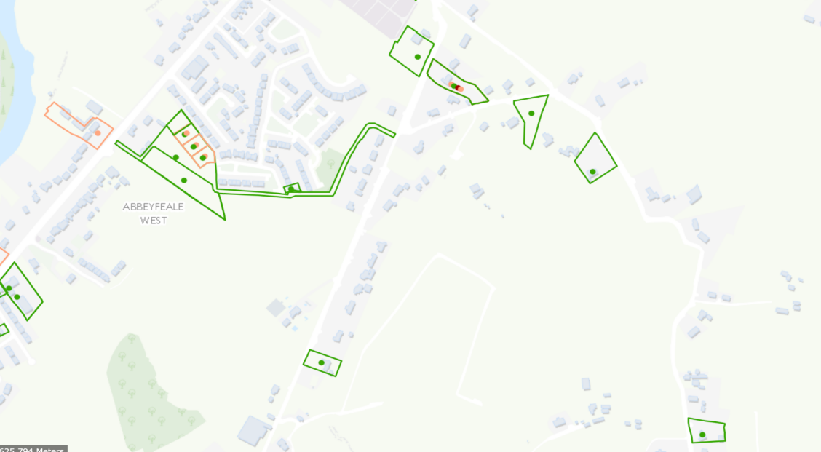
Current planning applications, in the vicinity of the proposed works.

