Document:
Appropriate Assessment Screening

Project:
Improvement works in Athea, Co. Limerick.

Prepared for:
Limerick City and County Council.

Prepared by:
Rory Dalton, Independent Ecologist

Table of Contents
Statement of Competence 3
1. Introduction 3
1.1 Appropriate Assessment Process 4
1.2 Methodology 5
2. Description of the Site and Proposed works 6
2.1 Description and Location of the Site 6
2.2 Proposed Works 6
3. Natura 2000 Sites and The Proposal 8
3.1 Natura 2000 Sites within the 15km Zone of Influence 8
3.2 Natura 2000 Sites and their Designations 8
3.3 Natura 2000 Sites excluded from further assessment 10
4. Natura 2000 Sites and Potential Impacts 11
4.1 Sources, Pathways and Receptors 11
4.2 Lower River Shannon SAC 13
4.2.1 Pressures and Threats 13
4.2.2 Assessment of Potential Impacts 14
4.3 The River Shannon and River Fergus estuaries SPA 16
4.3.1 Assessment of Potential Impacts
4.4 Stack’s to Mullaghareirk Mountains, West Limerick Hills and Mount Eagle SPA 16
4.4.1 Assessment of Potential Impacts 17
4.5 Cumulative Impacts 18
5. Conclusion 18
6. Bibliography 19
7. Maps 20

Statement of Competence
Rory is an independent ecological consultant with a decade of experience across a range of disciplines including aquatic ecology, habitats, mammals, and birds. He also carries out a range of species-specific and research-based studies. He graduated from University College Cork with a BSc. Hons in Environmental and Earth Science, after which he spent three years working with a leading ecological consultancy in Limerick. He then set up his own company and has been running it since. Sectors he works in include, conservation, solar farms, wind farms, roads and bridges, grid connections, housing, greenways, instream civil works, drinking water etc. The projects he is involved with range in size from small bridge surveys to the largest wind energy project in the country and the largest water quality project in Europe. He carries out work for a number of State Bodies, Semi-State Bodies, Engineering Consultants, Ecology Consultants, Environmental Consultants and Laboratories.

- Introduction

Rory Dalton was appointed by Limerick City and County Council to prepare a document for the appropriate assessment for Improvement works to be undertaken in Athea, Co. Limerick. The proposed project (detailed in section 2 below) consists of the replacement of existing footpaths in Athea village, Co. Limerick. It is proposed to replace seven individual sections of footpath to a total length of 1020 meters.

1.1 Appropriate Assessment Process

An Appropriate Assessment is undertaken to establish if any proposed plan or project is likely to have a significant effect or impact on any site that has been designated under: the E.U. Habitats Directive (92/43/EEC) i.e. SAC; or the E.U. Birds Directive (79/409/EEC as amended 2009/147/EC) i.e. SPA. Collectively, SAC’s and SPA’s are known as Natura 2000 sites. The need to undertake one or more stages of this process has arisen from Articles 6(3) and 6(4) of the aforementioned Habitats Directive; where the former Article is primarily concerned with the protection of sites from likely significant effects and the latter allows derogation from such protection in very specific circumstances involving imperative reasons of overriding public interest.
Article 6(3) of the Habitats Directive requires that:
“Any plan or project not directly connected with or necessary to the management of the site but likely to have a significant effect thereon, either individually or in combination with other plans or projects, shall be subject to appropriate assessment of its implications for the site in view of the site's conservation objectives. In the light of the conclusions of the assessment of the implications for the site and subject to the provisions of paragraph 4, the competent national authorities shall agree to the plan or project only after having ascertained that it will not adversely affect the integrity of the site concerned and, if appropriate, after having obtained the opinion of the general public.”
And Article 6(4) of the Habitats Directive requires that:
“If, in spite of a negative assessment of the implications for the site and in the absence of alternative solutions, a plan or project must nevertheless be carried out for imperative reasons of overriding public interest, including those of a social or economic nature, the Member State shall take all compensatory measures necessary to ensure that the overall coherence of Natura 2000 is protected. It shall inform the Commission of the compensatory measures adopted.”
In Stage 1, a screening process is undertaken to identify whether significant impacts on a Natura 2000 site are likely to arise from the project or plan in question. If significant impacts are likely to occur or if it is unclear whether significant impacts are likely to occur, then the process moves on to Stage 2 where an AA considers potential mitigation measures for adverse impacts. If it is considered that mitigation measures will not be able to satisfactorily reduce potential adverse impact on a Natura 2000 site then an assessment of alternative solutions is considered in Stage 3. This is then followed by Stage 4 in the event that adverse impacts remain and the proposed activity or development is deemed to be of Imperative Reasons of Overriding Public Interest (IROPI), allowing an assessment of compensatory measures to be considered. The outcome of a Stage 2 and higher assessment is presented in a report known as a Natura Impact Statement (NIS). While an AA NIS is provided by the advocate of the plan or project in question, the AA NIS itself is undertaken by the competent authority.

1.2 Methodology

Documents associated with the proposed project and relevant ecology databases were consulted as part of this assessment, with a site walkover also undertaken. Furthermore, the following guidelines were used in the completion of this assessment;
- Assessment of Plans and Projects Significantly Affecting Natura 2000 Sites – European Commission Methodical Guidance on the provisions of Article 6(3) and 6(4) of the ‘Habitats’ Directive 92/43/EEC (European Commission 2001)
- Integrated Biodiversity Impact Assessment – Streamlining AA, SEA and EIA Processes: Practitioner’s Manual (EPA 2013)
- Appropriate Assessment of Plans and Projects in Ireland – Guidance for Planning Authorities (DoEHLG 2009)

The Screening Stage of Appropriate Assessment is used to identify whether the Plan, either alone or in combination with other plans or projects, is likely to have a significant effect on a Natura 2000 site. This report follows European Commission (2001) guidance which recommends that screening should follow a four step process as outlined below:
- : Determine whether the plan is directly connected with or necessary to the management of the site.
- : Describe the plan and other plans and projects that, ‘in combination’, have the potential to have significant effects on a European site.
- : Identify the potential effects on the European site.
- : Assess the significance of any effects on the European site.

In stage 2 the potential impacts to conservation interests of the Natura site are looked at in depth and mitigations are put forward to avert these impacts. Each impact is assessed with reference to the conservation interest to which it applies in a case-specific manner. Mitigations are then tailored to each specific situation

- Description of the Site and Proposed works
2.1 Description and Location of the Site

Athea village is situated on the R523 Listowel to Ardagh regional road and the R524 Glin to Abbeyfeale regional road. The River Galey (locally called the Gale) flows through the village and is within the Shannon River Basin District. It rises in Rooskagh West, to the east of Athea and flows in a westerly direction through Athea before joining the River Feale further downstream to become the Cashen River. The upper reaches of the catchment are steep in nature and forestry is a significant pressure having been planted upon bog and deep peat, destroying the sponge effect of the peat within the catchment and subjecting the river to severe ecological pressures associated with low water. The River Gale is crossed by a masonry triple arch bridge (Athea Bridge) and a pedestrian bridge.
The proposed works exist within the footprint of the town on both the R523 and the R524. The section of footpath to be replaced on the R523 begins at the junction of the R532 and L1328 and extends east for 186 meters. This portion of the site is bordered by a mix of private properties and commercial businesses. The majority of the proposed works exist on the R524, with 181 meters of footpath to be replaced north of the junction with the R523 and 671 meters to be replaced south of the R523 junction. The northern section of the works begins at the junction of the R524 and R523 adjacent to Con Colbert Community Hall and extends northbound on the R524 for 181 meters. The southern section of the site of the proposed works comprises of a 671 meter section on the R524. It begins at the Junction with the R523 where the R524 heads southbound through a predominantly residential area.

2.2 Construction Methodology
Limerick City and County Council have outlined that the works involve the replacement of existing footpaths within the footprint of Athea Village on both the R523 and the R524 roads.
- Existing footpath to be dug up using small excavator, and rubble to be removed from the site to the council compound or to a licensed waste disposal site.
- Some sections of the existing footpath are narrow, and may need to be widened. Where kerb replacement is required, this will be carried out prior to the pouring of footpath concrete in order to attain the heights for the concrete. Kerbing will either be precast kerbs placed as standard, or a shuttered kerb which is filled with a relatively dry mix and let to set over night or over a number of days. This shutter will be struck out prior to the pouring of the footpaths and will ensure that the cell to be poured is sealed in terms of concrete leaking out onto the road.
- This works area will move along on a rolling basis as the old footpath is being excavated and the new footpath is being laid. The excavation work will be carried out by a small team in short sections (30 to 80m) to avoid excessive disturbance to members of the public using the footpath. The works area will be marked out with cones and an alternative footpath provided adjacent to the footpath being worked on.
- Devices (PVC Screed, expansion joint filler foam etc) to facilitate expansion/contraction will be placed at regular intervals in line with the levels of the footpath.
- Concrete pours will consist of one load of concrete (circa 8m³) being poured at a time and allowed to set before the next load arrives. This will equate to approximately 20-40m of footpath and the small team will work on levelling, screeding, floating and finishing the concrete. Pours will only be carried out during dry weather to ensure the quality of the finished surface and also to eliminate risk to the aquatic environment. In the unlikely event of unexpected rain, any uncured concrete will be covered in plastic sheeting; 50m length of which will be kept onsite at all times.
- On sloped areas, baffles of potato sacking/ hemp fibre will be placed at 90 degrees to the kerb will be placed every 10m to ensure that sediment which may become mobilised in a shower is minimised, similarly any entrances to the stormwater drainage system adjacent to the works will be covered with potato sack/hemp fibre.
- The rolling works area will be finished, brushed and cleaned, along with the road adjacent, as the works moves along to ensure overall tidiness of the village and to ensure the footprint of the works remains small.
- The Council will inspect the site intermittently to ensure that the site is in good condition and that the method outlined above is followed

The methodology above will be applied to the following sections:
- 186 meters of pathway will be replaced on the R523 in the east of the village beginning at the junction of the R532 and L1328.
- The northernmost section of the development will replace the currently existing footpath on the R524 beginning at Con Colbert Community Hall and extending north for 181 meters.
- The southernmost section consists of 671 meters of footpath in total and is to be undertaken on the R524 southbound from Athea Village. The first section, beginning at the junction between the R523 and the R524, will involve the replacement of footpaths on both sides of the road for approximately 180 meters.
- The remainder of this section is 311 meters in length and exists on the south eastern side of the road. and is bounded predominately by residential properties.

Figure 1 – Proposed site for development in Athea village, Co. Limerick.

- Natura 2000 Sites and Proposal

3.1 Natura 2000 Sites within the 15km Zone of Influence
Natura Site | Distance between study site and Natura 2000 site | Hydrological/ecological connection?
Lower River Shannon SAC (002165) | 5 mtrs | yes
River Shannon and River Fergus estuaries SPA (004077) | 12 Km | no
Stack's to Mullaghareirk Mountains, West Limerick Hills and Mount Eagle SPA (004161) | 5 mtrs | yes
Moanveanlagh Bog SAC (002351) | 7Km | No

3.2 Natura 2000 Sites and their Designations
Natura Site | Designated Features
Lower River Shannon SAC (002165) | [1110] Sandbanks  [1130] Estuaries  [1140] Tidal Mudflats and Sandflats  [1150] Coastal Lagoons*  [1160] Large Shallow Inlets and Bays  [1170] Reefs  [1220] Perennial Vegetation of Stony Banks  [1230] Vegetated Sea Cliffs  [1310] Salicornia Mudflats  [1330] Atlantic Salt Meadows  [1410] Mediterranean Salt Meadows  [6410] Molinia Meadows  [3260] Floating River Vegetation  [91E0] Alluvial Forests*  [1029] Freshwater Pearl Mussel (Margaritifera margaritifera)  [1095] Sea Lamprey (Petromyzon marinus)  [1099] River Lamprey (Lampetra fluviatilis)  [1096] Brook Lamprey (Lampetra planeri)  [1106] Atlantic Salmon (Salmo salar)  [1349] Bottle-nosed Dolphin (Tursiops truncatus)  [1355] Otter (Lutra lutra)
Stack's to Mullaghareirk Mountains, West Limerick Hills and Mount Eagle SPA (004161) | (A082) Hen Harrier (Circus cyaneus)
River Shannon and River Fergus estuaries SPA (004077) | [A017] Cormorant (Phalacrocorax carbo)  [A038] Whooper Swan (Cygnus cygnus)  [A046] Light-bellied Brent Goose (Branta bernicla hrota)  [A048] Shelduck (Tadorna tadorna)  [A050] Wigeon (Anas penelope)  [A052] Teal (Anas crecca)  [A054] Pintail (Anas acuta)  [A056] Shoveler (Anas clypeata)  [A062] Scaup (Aythya marila)  [A137] Ringed Plover (Charadrius hiaticula)  [A140] Golden Plover (Pluvialis apricaria)  [A141] Grey Plover (Pluvialis squatarola)  [A142] Lapwing (Vanellus vanellus)  [A143] Knot (Calidris canutus)  [A149] Dunlin (Calidris alpina)  [A156] Black-tailed Godwit (Limosa limosa)  [A157] Bar-tailed Godwit (Limosa lapponica)  [A160] Curlew (Numenius arquata)  [A162] Redshank (Tringa totanus)  [A164] Greenshank (Tringa nebularia)  [A179 ] Black-headed Gull (Chroicocephalus ridibundus)  [A999] Wetland and Waterbirds
Moanveanlagh Bog SAC (002351) | 7110 Active raised bogs  7120 Degraded raised bogs still capable of natural regeneration 7150 Depressions on peat substrates of the Rhynchosporion.

3.3 Natura 2000 Sites excluded from further assessment

Natura Site | Rationale for exclusion from further assessment
Moanveanlagh Bog SAC (002351) | The site of the proposed works exists 7km from this SAC. The conservation interests of this SAC are active raised bogs, degraded raised bogs and depressions on peat substrates of the Rhynchosporion. There is no hydrological connection to this site and the proposed works have no potential to cause negative impacts to this SAC.
River Shannon and River Fergus estuaries SPA (004077) | The site of the proposed works is ~12km from this site “as the crow flies”, however, the River Gale flows out to sea south of Ballybunion town. This SPA ends at Beal, which is approximately 12km north of where the Gale reaches the sea. This weak hydrological connection and and distance combine to ensure there are no potential impacts to the conservation objects of this SPA. This SPA is therefore not included for further assessment.

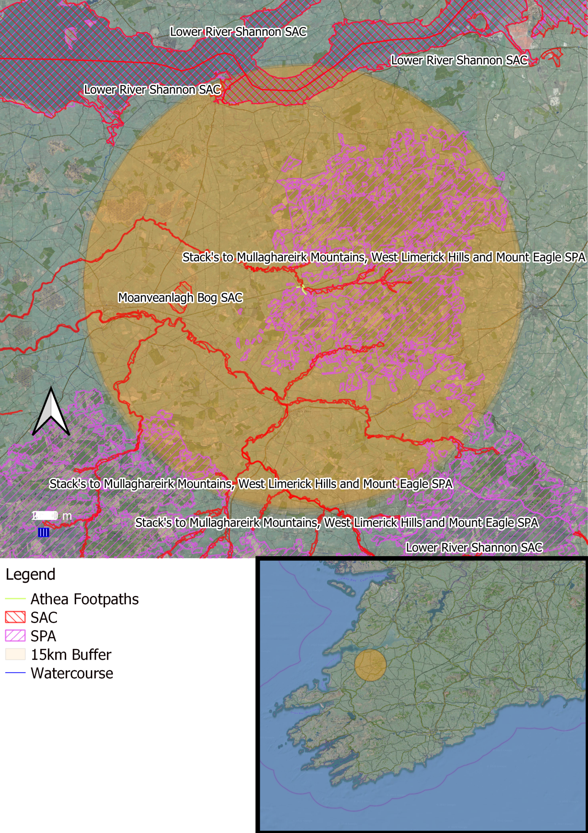

- Natura 2000 Sites and Potential Impacts

4.1 Sources, Pathways and Receptors

Source | Pathway | Receptor
Construction Phase
Construction works can cause the input of cementitious material and silt / fine sediment to a watercourse | There are two main elements to this. Initially, the old footpath must be dug up which will generate sediment onsite. Then the concrete footpaths will be laid which will mean there will be cementitious material onsite. These elements are explored separately below, however there is a lot of similarity and crossover.  Initially, the old footpath must be dug up which will generate sediment onsite. The works area will move along on a rolling basis as the old footpath is being excavated and the new footpath is being laid. The excavation work will be carried out by a small team and the rolling works area will be 30 to 80m in length. This effectively reduces the size of the site from the 1100m of footpath presented in Figure 1 above down to a rolling site of 30-80m in length. This is the single most important aspect of the methodology in terms of protecting the aquatic environment. As well as this, the footpath to be dug up is inside an existing kerb, and much of this kerb will remain in place during the works as long is it is in good condition and there is sufficient footpath width; this kerb will contain the works area and keep out water flowing down the road along the kerb. Excavated rubble is to be removed from the rolling site as it is being dug rather than laying within the works area. Baffles of hemp fibre will be placed at 90 degrees to the kerb out onto the road; these will be placed every 10m to ensure that sediment which may become mobilised in a rain shower is captured and minimised, similarly any entrances to the stormwater drainage system adjacent to the works will be covered with hemp fibre. Finally, the rolling works area will be finished, brushed and cleaned, along with the road adjacent, as the works moves along to ensure overall tidiness of the village and to ensure the footprint of the works remains small. All of these measures in combination will comfortably ensure that minimal sediment is incident on the watercourse.  The concrete footpaths will be laid which will mean there will be cementitious material onsite. The works area will move along on a rolling basis as the old footpath is being excavated and the new footpath is being laid. The excavation work will be carried out by a small team and the rolling works area will be 30 to 80m in length. This effectively reduces the size of the site from the 1100m of footpath presented in Figure 1 above down to a rolling site of 30-80m in length. This is the single most important aspect of the methodology in terms of protecting the aquatic environment. The original kerb will remain intact or will be replaced prior to pouring concrete; this will ensure that the cell to be poured is sealed in terms of concrete leaking out onto the road. Concrete pours will consist of one load of concrete (circa 8m3) being poured at a time and allowed to set before the next load arrives. This will equate to approximately 20-40m of footpath and the small team will work on levelling, screeding, floating and finishing the concrete. Pours will only be carried out during dry weather to ensure the quality of the finished surface and also to eliminate risk to the aquatic environment. In the unlikely event of unexpected rain, any uncured concrete will be covered in plastic sheeting; 50m length of plastic sheeting will be kept onsite at all times. Baffles of hemp fibre will be placed at 90 degrees to the kerb out onto the road; these will be placed every 10m to ensure that sediment which may become mobilised in a rain shower is captured and minimised, similarly any entrances to the stormwater drainage system adjacent to the works will be covered with hemp fibre. Finally, the rolling works area will be finished, brushed and cleaned, along with the road adjacent, as the works moves along to ensure overall tidiness of the village and to ensure the footprint of the works remains small. All of these measures in combination will comfortably ensure that cementitious material is contained within the footprint of the works.  Additionally, the Council will inspect the site intermittently to ensure that the site is in good condition and that the method outlined in the Construction Methodology (as desplayed in Section 2.2 above) is followed. | Aquatic species
Physical disturbance can can arise from noise associated with construction; mainly by machinery and to a lesser degree power tools and hammering | Due to the scale of the works noise disturbance from machinery and power tools during the works is not likely to be elevated much above the baseline noise of the village and surrounding farmland. | Otter, Hen Harrier
Destruction of habitat | The footpath will be placed on existing hardstand. The majority of this is existing footpath, and where it is to be widened, it will extend onto existing tarmac road. As such no habitats within, connected to or important for protected areas will be impacted. | Habitats and the species which depend upon them
Operational Phase
Disruption to the hydrology of a catchment can arise from creating new hard-stands | The footpath will be placed on existing hardstand. The majority of this is existing footpath, and where it is to be widened, it will extend onto existing tarmac road. As such no new hardstand will be created, and no pathway resulting in disruption to the hydrology of the catchment exists | Aquatic and riparian species and habitats
Physical disturbance can can arise from noise associated with habitation | The operational phase will essentially be the same as the current operation of the footpaths, and so no pathway for impacts is generated. | Otter, Hen Harrier

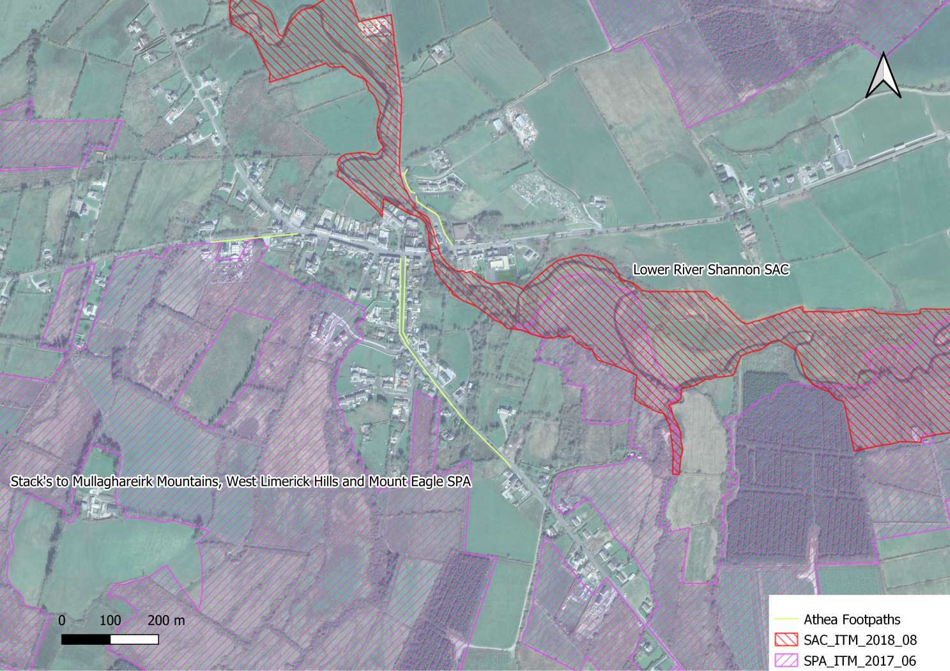

4.2 Lower River Shannon SAC

This very large site stretches along the Shannon valley from Killaloe in Co. Clare to Loop Head/ Kerry Head, a distance of some 120 km. The site thus encompasses the Shannon, Feale, Mulkear and Fergus estuaries, the freshwater lower reaches of the River Shannon (between Killaloe and Limerick), the freshwater stretches of much of the Feale and Mulkear catchments and the marine area between Loop Head and Kerry Head. The vast majority of the surface area is estuarine, however, the site also encompasses extensive river corridors, and so as a whole the site is varied in nature.
This site is of great ecological importance. It is designated for 11 marine/estuarine habitats, two terrestrial habitats, one freshwater habitat, 5 freshwater species, one marine mammal, and one semi-aquatic mammal. It includes the largest estuarine habitat in the country.

4.2.1 Pressures and Threats
Pressures and threats within this SAC are summarised in the following table
Level | Threat and Pressure Code | Inside or outside SAC | Threat and Pressure
Low | C01.01.02 | Inside | Removal of beach materials
Low | F01 | Inside | Marine and Freshwater Aquaculture
Low | F03.01 | Inside | Hunting
Low | E03 Inside | Inside | Discharges
Medium | J02.01.01 | Inside | Polderisation [drainage of wetlands]
Low | J02.12.01 | Inside | Abandonment of management of water bodies
Low | G01.01 | Inside | nautical sports
Low | J02.10 | Inside | management of aquatic and bank vegetation for drainage purposes
Medium | A04 | Inside | grazing
Low | B | Inside | Sylviculture, forestry
Medium | H04 | Outside | Air pollution, air‐borne pollutants
Low | D01.01 | Inside | paths, tracks, cycling tracks
Medium | E03 outside | Outside | Discharges
Medium | J02.01.02 | Outside | reclamation of land from sea, estuary or marsh
Low | I01 | Inside | invasive non‐native species
Medium | E01 | Outside | Urbanised areas, human habitation
Medium | A08 | Outside | Fertilisation
Medium | K02.03 | Outside | eutrophication (natural)
Medium | A08 | Inside | Fertilisation
Low | C01.03.01 | Inside | cutting of peat

4.2.2 Assessment of Potential Impacts

Conservation Interest | Assessment of Potential Impacts
Sandbanks which are slightly covered by sea water all the time [1110]  Estuaries [1130]  Mudflats and sandflats not covered by seawater at low tide [1140]  Coastal lagoons [1150]  Large shallow inlets and bays [1160]  Reefs [1170]  Perennial vegetation of stony banks [1220]  Vegetated sea cliffs of the Atlantic and Baltic coasts [1230]  Salicornia and other annuals colonising mud and sand [1310]  Atlantic salt meadows [1330]  Mediterranean salt meadows [1410] | These habitats are coastal, exist at least 30km downstream from Athea (excluding meandering), and will not be impacted by the proposed development
Floating River  Vegetation [3260] | Patches of this habitat are present in the Gale River. Potential impacts include direct habitat destruction usually by machine, severe siltation, and the introduction of invasive aquatic plants. This project does not have the capacity to generate these Potential Impacts
Molinia meadows on calcareous, peaty or clayey-silt-laden soils [6410] | This habitat has been recorded on the eastern bank of the Shannon, just north of Castleconnell, Co. Limerick. Full distribution of this habitat in this SAC is currently unknown and it almost certainly occurs elsewhere (NPWS, 2012). Potential impacts include direct habitat destruction or hydrological modification (both usually by machine), and the introduction of invasive plants. This habitat is not present within or near the works site, this project does not have the capacity to generate these Potential Impacts, and so no likely significant effects are envisaged
Alluvial forests with Alnus glutinosa and Fraxinus excelsior [91E0] | Areas of this habitat exist all over the SAC, and they range in nature from small fragmented pockets, to intact riparian corridors. This habitat is important not only in it’s own right, and for the terrestrial life that depends on it, but also for the health of watercourses by providing shade to cool the water and prevent excessive algal growth (both of which increase oxygen levels and benefit the system as a whole), by removing nutrients, by creating buffer zones for animals and diffuse organic pollution, and by providing organic matter in the form of leaves [rather than compounds in solution] which float to a naturally depositing area to be broken down and sequestered naturally. Examples of this habitat of varying quality exist along the Shannon, but anything larger than groves of this habitat are unfortunately largely absent from the upper Gale Catchment, the last extensive area of woodland (mixture of alluvial and oak woodland) having been sadly cleared from a glen ~4km upstream of Athea village in the 1990s. The nearest section of woodland corresponding to this habitat is upstream of the bridge in Athea Village.  Due to the nature of the works involved, and the fact this habitat does not exist within the footprint of the works or immediately adjacent to the works, there is no potential for direct habitat destruction, introduction of invasive species, drainage of the watercourse or water table upon which the habitat depends. This insures this habitat will not be negatively affected by the proposed works.
Freshwater Pearl Mussel [1029] | The Gale River is not represented under the “Margaritifera Habitat Classification”or the “Margaritifera SAC Catchment”, nor are its headwaters represented in the “Margaritifera First Order Rivers”, all of which are layers on the EPA Map Portal. The upper Gale is however shown in the “Margaritifera Sensitive Areas” mapping as a catchment with “previous record of Margaritifera, current status unknown”; this is the lowest in importance of 3 categories within the “Margaritifera Sensitive Areas” database. The freshwater pearl mussel conservation objectives for the Lower River Shannon SAC relates specifically to the Cloon River population in Co. Clare which is located within a different river catchment approximately 20km across the Lower Shannon Estuary transitional waterbody from the proposed gravel removal works. The River Gale previously held records of freshwater pearl mussel, however an assessment of pearl mussel populations in the River Gale undertaken in 2009 by the NPWS did not record the species within the catchment. That said, some of the sites within that study were downstream of Moyvane bridge; from Moyvane bridge to the sea was destroyed by an arterial drainage scheme executed by the OPW in which the riverbed was dropped 5m, and the pearl mussel population population downstream of Moyvane bridge would have been removed also. It is possible that there are mussels in the river upstream of Moyvane bridge in the Upper Gale and in some suitable tributaries, notably the Knocknagornagh River. Pearl Mussels require relatively stable riverbed habitat to take hold and thrive. The section in the vicinity of Athea Bridge exhibits the signs of significant amounts of mobile sediment, indeed, there is a plan to remove some of this mobile sediment as part of a flood management scheme. The riverbed in the vicinity of Athea Village is too unstable to hold a population of FPM.  Additionally, as discussed in section 4.1 above, the method employed to carry out the works, particularly limiting the size of the works area to a rolling works area of 30m to 80m in length as well as working inside of kerbing, ensures that little or no sediment or cementitious material will enter the watercourse, and certainly not enough to coat the riverbed or impact any unlikely FPM population downstream of Athea.
Sea Lamprey [1095]  Brook Lamprey [1096]  River Lamprey [1099] | Barriers to migration are a significant threat/pressure on river and sea lamprey NPWS 2019b. The bridge apron at Moyvane poses a serious obstacle to both of these species; it consists of a drop of ~4m over a length of ~35m in order to lower the riverbed level within the OPW dredged area without causing erosion issues (ie an upstream migrating waterfall). There is a denali fish pass here, however this design is generally considered unsuitable for lamprey spp. There is another passage issue downstream from here atShrone Bridge, though not as dramatic. And so a population of sea lamprey and river lamprey at Athea is considered unlikely. There are however brook lamprey present right up to the upper reaches where the instream energetics are not suitable for the accumulation of larval beds.  As discussed in section 4.1 above, the method employed to carry out the works, particularly limiting the size of the works area to a rolling works area of 30m to 80m in length as well as working inside of kerbing, ensures that little or no sediment or cementitious material will enter the watercourse, and so no likely significant impacts are envisaged for these species.
Salmon [1106] | This species is present throughout the Gale River. The best spawning grounds in the system are from Athea Village to Glenagower and up along the Knocknagornagh River. There is decent quality spawning habitat downstream of Athea, however nutrients from higher intensity farming and sediment from drainage ditch maintenance increasingly become a problem as you go downstream and the valley opens out.  As discussed in section 4.1 above, the method employed to carry out the works, particularly limiting the size of the works area to a rolling works area of 30m to 80m in length as well as working inside of kerbing, ensures that little or no sediment or cementitious material will enter the watercourse, and so no likely significant impacts are envisaged for these species.
Common Bottlenose Dolphin [1349] | This species exists in the middle and outer Shannon Estuary and no sources or pathways for impacts to this species exist.
Lutra lutra (Otter) [1355] | There is no suitable holt habitat within the footprint of the works. Disturbance will not be elevated much above the usual noises of the village. No likely significant impacts are envisaged.

4.4 Stack's to Mullaghareirk Mountains, West Limerick Hills and Mount Eagle SPA

The Stack’s to Mullaghareirk Mountains, West Limerick Hills and Mount Eagle SPA is a very large site centred on the borders between the counties of Cork, Kerry and Limerick. The site is skirted by the towns of Newcastle West, Ballydesmond, Castleisland, Tralee and Abbeyfeale. The mountain peaks included in the site are not notably high or indeed pronounced, the highest being at Knockfeha (451 m). Other mountains included are Mount Eagle, Knockanefune, Garraunbaun, Taur, Rock Hill, Knockacummer, Mullaghamuish, Knight’s Mt, Ballincollig Hill, Beennageeha Mt, Sugar Hill, Knockanimpuba and Knockathea, amongst others. Many rivers rise within the site, notably the Blackwater, Owentaraglin, Owenkeal, Glenlara, Feale, Clydagh, Allaghaun, Allow, Oolagh, Gale and Smerlagh.
The site consists of a variety of upland habitats, though almost half is afforested. The coniferous forests include first and second rotation plantations, with both pre-thicket and post-thicket stands present. Substantial areas of clear-fell are also present at any one time. The principal tree species present are Sitka Spruce (Picea sitchensis) and Lodgepole Pine (Pinus contorta). A substantial part (28%) of the site is unplanted blanket bog and heath, with both wet and dry heath present. The vegetation of these habitats is characterised by such species as Ling Heather (Calluna vulgaris), Bilberry (Vaccinium myrtillus), Common Cottongrass (Eriophorum angustifolium), Hare’s-tail Cottongrass (Eriophorum vaginatum), Deergrass (Scirpus cespitosus) and Purple Moor-grass (Molinia caerulea). The remainder of the site is mostly rough grassland that is used for hill farming. This varies in composition and includes some wet areas with rushes (Juncus spp.) and some areas subject to scrub encroachment.
The site is a Special Protection Area (SPA) under the E.U. Birds Directive, of special conservation interest for Hen Harrier. This SPA is a stronghold for Hen Harrier and supports the largest concentration of the species in the country. A survey in 2005 recorded 45 pairs, which represents over 20% of the all-Ireland total. A similar number of pairs had been recorded in the 1998-2000 period. The mix of forestry and open areas provides optimum habitat conditions for this rare bird, which is listed on Annex I of the E.U. Birds Directive. The early stages of new and second-rotation conifer plantations are the most frequently used nesting sites, though some pairs may still nest in tall heather of unplanted bogs and heath. Hen Harriers will forage up to c. 5 km from the nest site, utilising open bog and moorland, young conifer plantations and hill farmland that is not too rank. Birds will often forage in openings and gaps within forests. In Ireland, small birds and small mammals appear to be the most frequently taken prey.
Short-eared Owl, a very rare species in Ireland, has been known to breed within the site. Nesting certainly occurred in the late 1970s and birds have been recorded intermittently since. The owls are considered to favour this site due to the presence of Bank Voles, a favoured prey item. Merlin also breed within the site but the size of the population is not known. Red Grouse is found on some of the unplanted areas of bog and heath – this is a species that has declined in Ireland and is now Red-listed.

The Stack’s to Mullaghareirk Mountains, West Limerick Hills and Mount Eagle SPA is of ornithological importance because it provides excellent nesting and foraging habitat for breeding Hen Harrier and is one the top sites in the country for the species. The presence of three species, Hen Harrier, Merlin and Short-eared Owl, which are listed on Annex I of the E.U. Birds Directive is of note.

4.4.1 Assessment of Potential Impacts

Conservation Interest | Assessment of Potential Impacts
(A082) Hen Harrier (Circus cyaneus) | The site of the proposed works exists 20 mtrs from this SPA at the closest point.  An Irish National Hen Harrier Survey undertaken by Ruddock et al (2012) found that the majority of breeding pairs, 43.8%, of hen harriers nested primarily in second rotation plantation forest habitats, while 24.4% nested in heather habitats. Studies undertaken of the foraging activity of hen harriers continued to indicate that hen harriers favor open moorland while hunting, avoiding intensive agricultural areas. Their diets, consisting of birds and mammals, are regularly composed of ground nesting birds such as the meadow pipit and skylark.  The proposed works will occur in a built-up area, amid private dwellings and businesses which does not provide suitable habitat for Hen Harrier. Neither suitable nesting sites or suitable foraging for the hen harriers exists within the footprint of the works.  As the Stack's to Mullaghareirk Mountains, West Limerick Hills and Mount Eagle SPA is 20mtrs from the site of the proposed works, there is a pathway for noise disturbance from machinery and power tools during the development. However this disturbance will be minor in nature and of short duration and will be typical of regular road works and not elevated much above the usual noises of the town and surrounding rural areas. During the operational phase of the works no additional disturbance will be generated hence, no significant pathway for disturbance exists.  No negative impacts are envisaged for these habitats.

4.5 Cumulative Impacts
Given the absence of pathways for the sources identified in Section 4.1 above, combined with the nature and scale of the works, it can be said with reasonable confidence that there will be no cumulative impact to any of the conservation interests on the Lower River Shannon SAC , the River Shannon and River Fergus Estuaries SPA or the Stack's to Mullaghareirk Mountains, West Limerick Hills and Mount Eagle SPA arising from this proposal.

5. Conclusion
In conclusion the construction of footpaths in Athea, as outlined in the construction methodology will not cause adverse impacts on the conservation objectives of any Natura 2000 Site .

6. Bibliography

Department of Environment, Heritage & Local Government (DoEHLG). 2009. Appropriate Assessment of Plans and Projects in Ireland – Guidance for Planning Authorities. DoEHLG, Dublin
Environment Agency's 'River Habitat Survey in Britain and Ireland Field Survey Guidance Manual 2003'
European Commission. 2001. Assessment of Plans and Projects Significantly Affecting Natura 2000 Sites – European Commission Methodical Guidance on the provisions of Article 6(3) and 6(4) of the ‘Habitats’ Directive 92/43/EEC. European Commission DG Environment, Oxford UK.
European Commission (2018). Managing Natura 2000 sites. The provisions of Article 6 of the Habitats Directive 92/43/EEC. Brussels, 21.11.2018 C(2018) 7621 final.
Environmental Protection Agency (EPA). 2013. Integrated Biodiversity Impact Assessment – Streamlining AA, SEA and EIA Processes: Practitioner’s Manual. EPA STRIVE Programme 2007–2013; Report Series No. 106. EPA, Wexford.
EPA(2020) EPA map viewer. Last accessed on 28.04.2022 at https://gis.epa.ie/EPAMaps
NPWS (2012) Conservation Objectives: Lower River Shannon SAC 002165. Version 1.0. National Parks and Wildlife Service, Department of Arts, Heritage and the Gaeltacht.
NPWS (2015) Conservation objectives for Stack's to Mullaghareirk Mountains, West Limerick Hills and Mount Eagle SPA. Department of Housing, Local Government and Heritage.
NPWS (2019) The Status of EU Protected Habitats and Species in Ireland. Volume 2: Habitat Assessments
NPWS (2019b) The Status of EU Protected Habitats and Species in Ireland. Volume 3: Species Assessments
NPWS (2012) Conservation objectives for the River Shannon and River Fergus Estuaries SPA. Version 1.0. National Parks and Wildlife Service, Department of Arts, Heritage and the Gaeltacht.
NPWS (2015) Conservation objectives for the Moanveanlagh Bog SAC. Version 1.0. National Parks and Wildlife Service, Department of Arts, Heritage and the Gaeltacht.
Ruddock, M. & Dunlop, B.J., O’Toole, L., Mee, A., Nagle, T. (2012) Republic of Ireland National Hen Harrier Survey 2010. Irish Wildlife Manual, No. 59. National Parks and Wildlife Service, Department of Arts, Heritage and the Gaeltacht, Dublin, Ireland.

6. Bibliography
7. Map

https://www.npws.ie/sites/default/files/protected-sites/natura2000/NF002165.pdf

