MULCAIR VALLEY ENVIORNMENTAL RESEARCH AND DEVELOPMENT PARK
SUBJECT: Submission to LIMERICK LOCAL ECONOMIC AND COMMUNITY DEVELOPMENT PLAN 2023/2028
EMAIL LECP@limerick.ie
From
- David Thompson: B Agric Sc; MA, farmer, secretary of the MulcairEIP, past president ASA, past chairman Limerick IFA
- John Dillon:farmer,former president Irish Farmers Association,chairman of the MulcairEIP.
- Joe Dillon:BSc, CEODillon Bros Buildersand chairman of EnvironmentalPark Concept.

Project concept background
Project 1
Mulcair EIP led by local farmers developed and promoted the concept of supporting and pilot testing environmental initiatives in the Mulcair catchment areato help improve water quality and training to farmers on adopting more environmentally friendly farming practices in the catchment.
An innovative programme was developed and submitted to the dept of ag for funding. The project was approved and currently 65 farmers are participating in a programme to drive environmentally friendly,economically feasible farming practices in the catchment. These farmers have undertaken and implemented a significant number of mitigation measures which should indicate an improvement in water quality in the Mulcair catchment and making farmers more aware of the steps required to help the environment without impacting economic viability. Also, a project involving the lesser horseshoe bat is underway which should provide interesting results on our ability to retain our wonderful wildlife.
Joe Dillon, Director of the company Mulcair Renewables LTD, has developed and launched a project to process waste from food processing, farm slurry and other wastes to generate biomethane for sale as fuel for transportation and c02 for industry.The biogas project is located adjacent to the Dillon home farm and is at the build out stage with the main structures already in place.It should be operational by mid-2024.
The next phase of the project is a concept to build an environmental park on a 4-acre site where the current biodigester is located. The concept includes identifying complimentary environmental projects which may locate on the park and working with universities and government agencies to research and develop environmental projects which could be developed and incubated and establish their business at the park
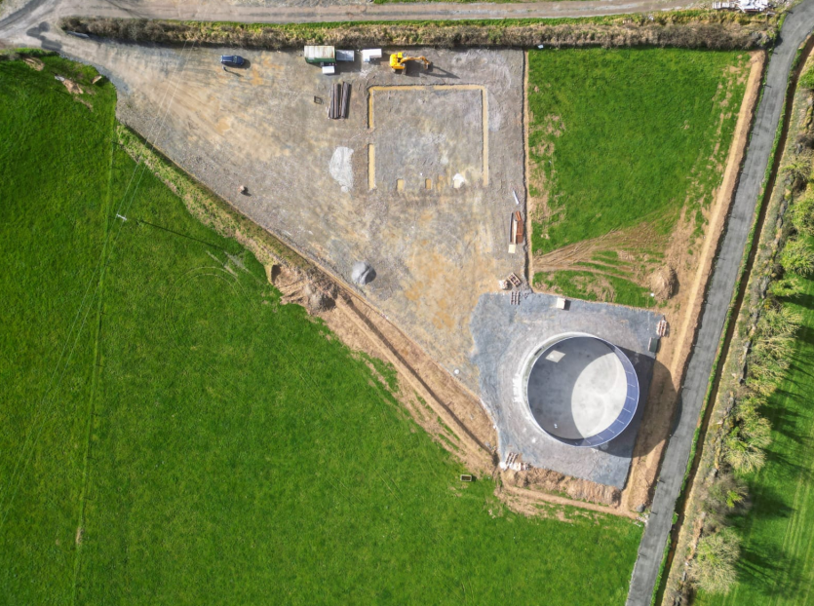
Mulcair valley environmental research & development park phase1.
Under construction biogas project.

The Mulcair catchment
The Mulcaircatchment has a number of existing wind energy projects and planned solar projects for the area, when combined with the Mulcair EIP, should provide a critical mass of environmental businesses which make the area an environmental hub for the development and testing and attraction of environmental business opportunities.
The initial environmental park concept will consist of 4 acres .one acre will be taken up by the biogas project and the remaining space will be developed if support is available, this will provide incubator space for environmental startups, factory space for environmental projects in the engineering and bio space areas.
Included in the concept plan is a link up with local universities and potentially with an international university with many years of experience in environmental research and entrepreneurship who will become an integral part of the project.
Planning and building out the Mulcair valley environmental park.
Support and active partnership will be required from the state to develop and build out the environmental hub and to bring the project to fruition, including:
- Financial and technical support to carry out a detailed feasibility on the concept.
- Assistance on identifying other components which might be added to the park and where limerick county council could be the lead partner, providing environmental leadership. In supporting this environmental initiative which if successful could be applied nationally and provide a model for environmental initiatives using a public private development approach.
Next steps project 1
1. Feasibility study funding to develop a business plan for the Mulcair valley environmental research and development park. Concept.
2. Determine the most appropriate build /development model for the park, potential demand, and the needs of potential clients both state and private. The most appropriate layout for the park, the protocols required, and investment required to build out the project.
3. Meetings discussions with potential partners including local universities, international universities, agencies and identifying best practice for such a project will include identifying if similar models exist overseas.
4. A detailed operating plan for the park.
Conclusion: Project 1
The park will be Irelands first environmental business park providing leadership and support to companies wanting to develop an environmental business including research,pilot testing and development support to potential clients.

Project 2: Tourism project
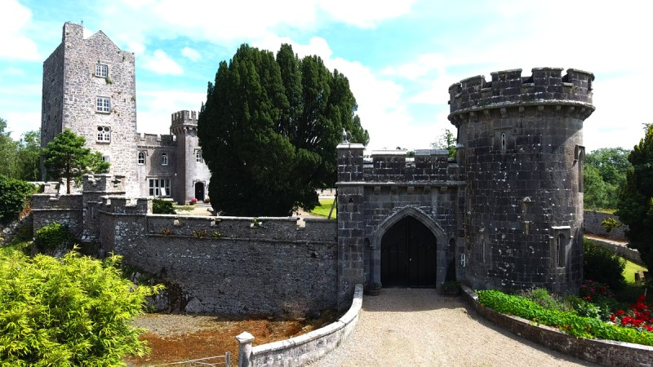
Castlegarde as it is today.
Tourism development project
Castlegarde castle located on the banks of the Mulcair river in the centre of a wooded demesne and Ireland’s oldest continuallyinhabited haunted family home castle which was built in the 12th century. It has attracted lots of interest as a tourist destination. The Thompson family, who occupy the castle,have spent their life savings preventing this unique historic gem from becoming a ruin. Also has pilot tested a number of initiatives to encourage tourists to visit the castle. All visitors have expressed keen interest in returning for further visits to Castlegarde. The website is castlegardecastle.ie.
The owners Hazel and David Thompson are still actively pursuing their vision to make Castlegarde a premier visitor destination and have already added a number of additional activities to the complex and plan on adding new attractions and facilities to the castle in the future which they believe could be a significant tourist attraction in Ireland’s golden vale on par with Knappogue and Dungaire castles in Co. Clare.
What is required to deliver this vision for future generations?
Support and financial help is needed to develop Castlegarde as a major historical tourist attraction while at the same time keeping it as a family home.
- Identify the target market and carry out research on how to successfully attract visitors from this market.
- Identify and target tour operators to our unique heritage experience.
- Develop further cultural attractions.
- Continue the necessary restoration work on the castle and outhouses.
Castlegarde has the potential to be a key tourist attraction in east limerick creating employment and spin off for the local economy.

