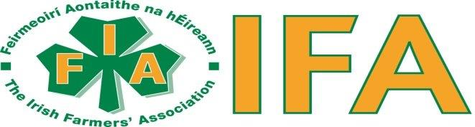

IFA Office, Croom Enterprise Centre, Croom, Co. Limerick
Tel: (061) 314196 E-mail: limerick@ifa.ie IFA Website: www.ifa.ie

Summary

The following submission sets out the scale, depth and fundamental impact that agriculture, farming and farmers make to the rural county Limerick and to the wider urban hinterland. We submit that this role needs to be included as a critical part of a comprehensive Local Economic and Community Plan for Limerick City and County 2023-2028.

Key Points

Points 1 to 7 below set out the scale of farming and agriculture in County Limerick

- 5.000 farm families
- 7% of the national herd is farmed in Limerick.
- Agricultural output of at least €560 million at farm gate prices
- Wider economic multiplier impact of €1.2 billion
- At least, 7000 off farm jobs are supported.

Hyperlinks are included to supporting documents.

Introduction

The Irish Farmers Association (IFA) represents over 72,000 farmers nationally and has almost 3000 members in Limerick. IFA represents all farming sectors, from large to small, dairy, cattle, sheep pigs, full and part time.

We have read with interest the draft Local Economic and Community Plan (LECP) 2023 – 2028 (table of contents below) and would like to make the following observations.

We feel that the impact of agriculture, farming, farmers, and their role in local, economic and community has been largely not mentioned. There is no doubt they exist in other streams, but if they are not mentioned in the chapters of the LECP, one could be under the impression that agriculture and farming does not exist in Limerick. We appreciate farming and agriculture is hiding in plain sight and we want to submit some facts and figures to back up our assertion.

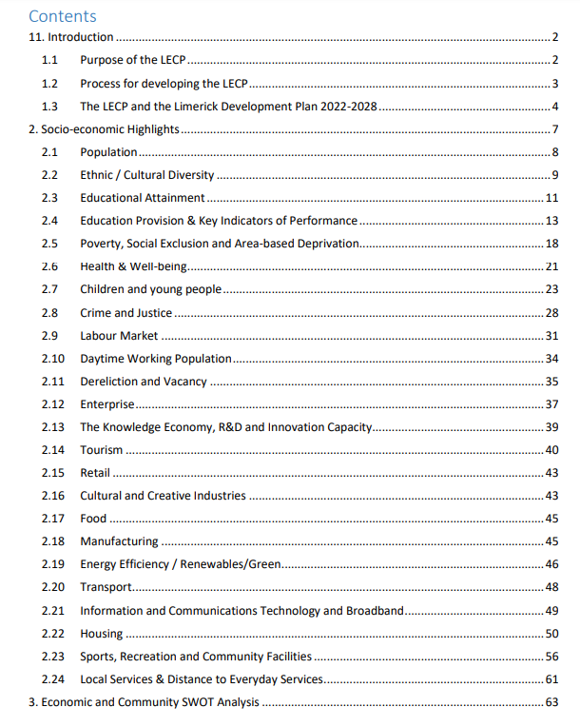
A word count in the draft document of the word “farming” occurs once, “agriculture” once, “farmers” three times.

Facts and figures for Agriculture, Farming and Farmers in County Limerick

- According to the Department of Agriculture’s “CAP Beneficiaries Publication” https://publicapps.agriculture.gov.ie/capben-ui/ there were in 2020, 4,959 individual recipients of area based “Direct Payments” in County Limerick. All of these are individual farm units or farmers. The payments received from the EU under this category was €49 million. In total farmers received a total of €73 million under all CAP measures in 2020.

- According to the CSO the following Livestock numbers were the foundation of agriculture output in Co. Limerick in June 2021 https://www.cso.ie/en/releasesandpublications/ep/p-clsjf/cropsandlivestocksurveyjunefinalresults2021/

- Total Bovine Livestock in Limerick were 456k (6% of National Total) of which 125k (8% of National Total were dairy cows.

- In 2013 IFA nationally produced a series of fact sheets for each county. While the figures and values are somewhat out of date, they largely give an idea of the scale of farming and agriculture in Co Limerick. https://www.ifa.ie/wp-content/uploads/2020/06/Limerick.pdf

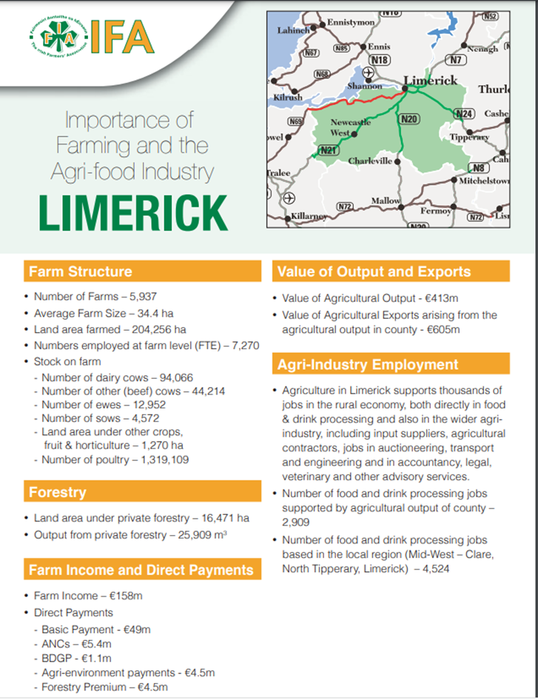

- If we assume based on the % of total livestock numbers in 3 above that Limerick accounts for 6% to 8% of the total. The value of agricultural output at farmgate prices in 2020 per the Department of Agriculture is approximately €8 billion.
( https://assets.gov.ie/88632/eff46189-8124-4072-9526-c49f995833b9.pdf ) Assuming Limerick at 7% of national output this implies agricultural output for Limerick could be as high as €560 million in 2020.
- The economic impact of agricultural output does not just end with a farmer getting paid. It is well known that farmers recycle and re-invest their earnings locally. It therefore has a significant multiplier effect. In the attached report commissioned by the Department of agriculture in 2020, the economic spending multiplier rages from 2.0 for dairy output and 2.5 for beef output. Applying this multiplier at an estimated 2.2 would equate to a total economic impact of €1.2 billion

( https://assets.gov.ie/118138/afc83651-331b-4edc-bec2-1e870ee10d4d.pdf )

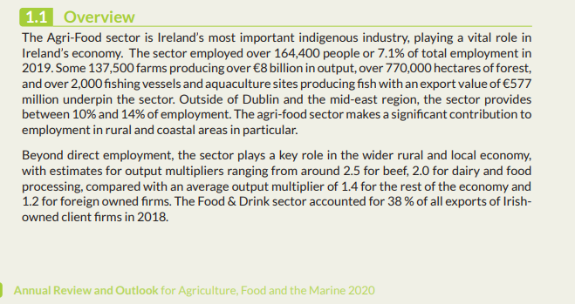

- Finally, in November 2022, KPMG in conjunction with the Irish Farmers Journal prepared a report on the economic impact of agriculture on 5 typical country towns across Ireland.
The report’s authors reviewed agricultural economic activity within a 30km radius and estimated a value for economic activity. Of particular interest to us is Charleville, just over the border in County Cork. It places a value of €1.7 billion on economic activity with in 30km. Half of that area is in County Limerick, but that output does not include other areas in Limerick outside the circle. By contrast the economic output of Ballyhaunis is €708 million, almost €1 billion less than the Charleville circle.. The major difference between the two areas is the concentration on dairy farming in Limerick. For a copy of the report follow this link
( https://assets.kpmg.com/content/dam/kpmg/ie/pdf/2022/11/ie-2022-irish-farmers-journal-kpmg-agribusiness-report.pdf )
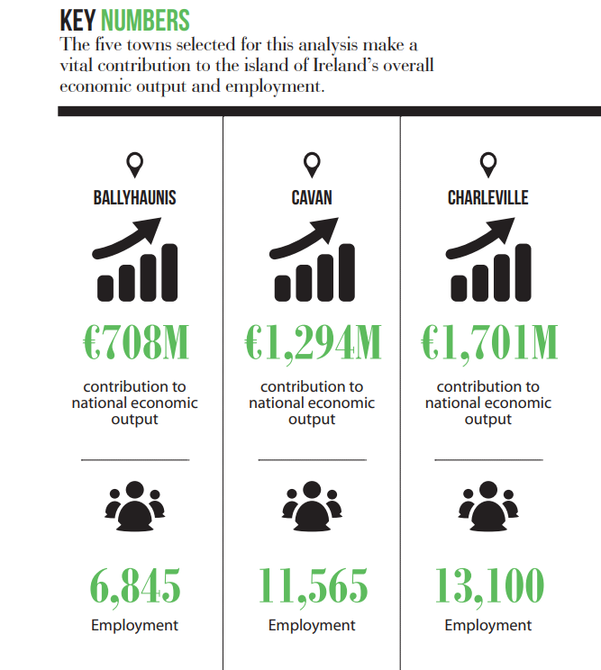

Other Considerations

Farming like every industry is becoming more digital with an increasing number of management tools which require high quality broadband access even in remote locations for sensors, cameras and links to machines. It is therefor essential that the role out of fibre broadband is accelerated throughout the county.

Planning needs to support a transition at farm level to support green and renewable technologies at farm level for micro generation where suitable. The electricity grid needs to support these initiatives especially the provision of 3-phase transformers.

Farmers are being encouraged to diversify, therefore programmes like Leader need to continue with increased funding of entrepreneurial development of farm-based businesses in food and tourism. A renewed and vibrant Leader programme could have a significant impact.

