Horizon 2020 SCC-2018
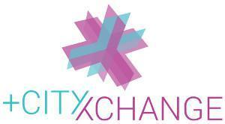
This project has received funding from the European Union’s Horizon 2020 research and innovation programme under grant agreement No 824260.

OPEN CALL:
INNOVATIVE CITIZEN SOLUTIONS FOR
POSITIVE ENERGY TRANSITION AND
LIMERICK’S GEORGIAN LANEWAYS
Date: 07 January 2020
Status: Draft
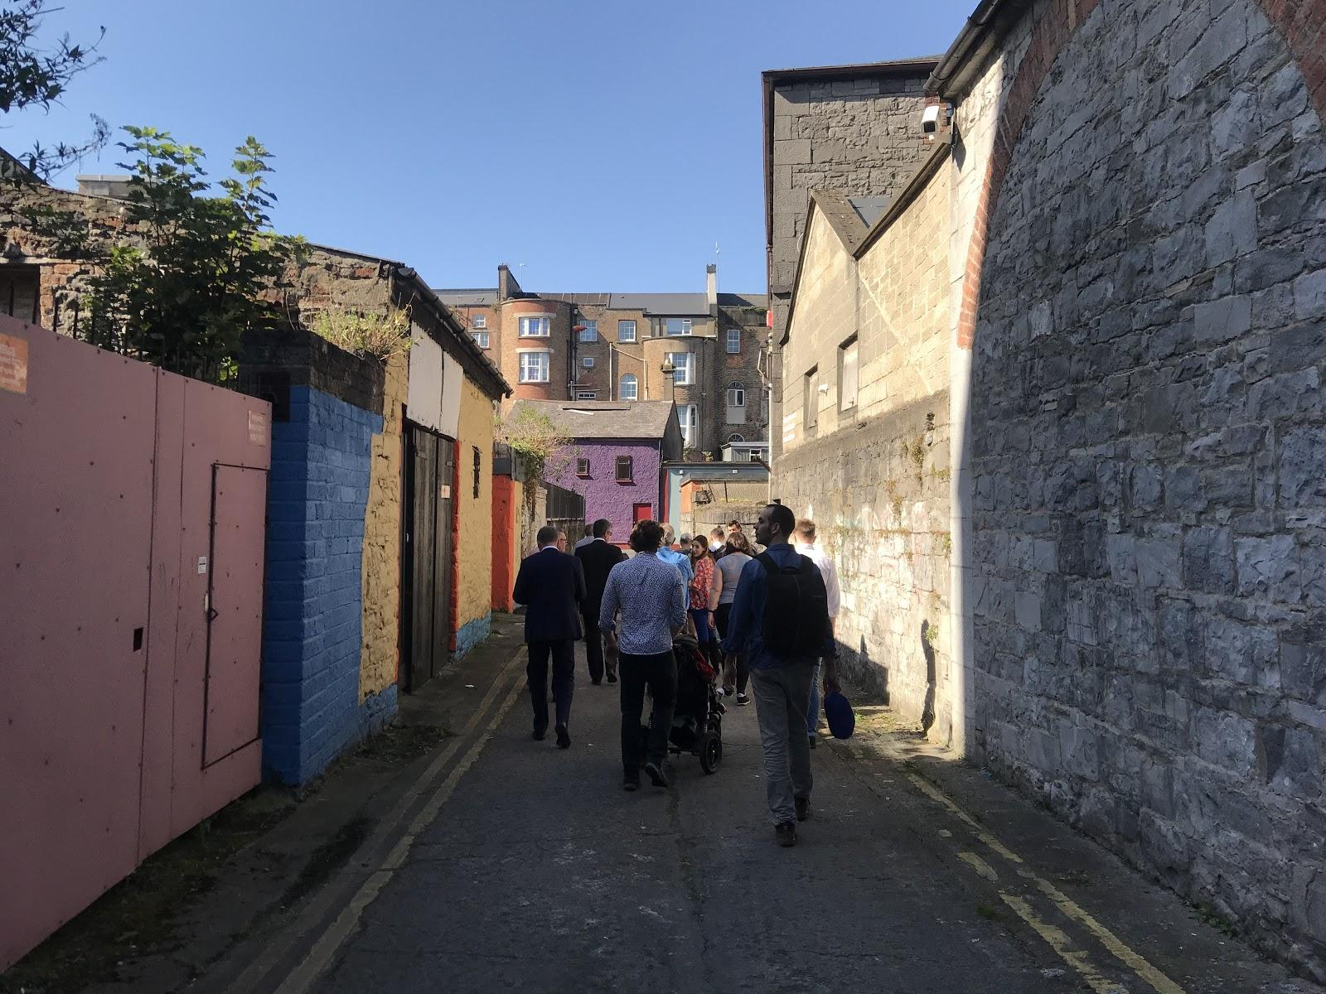
© image by Kevin Kearney of UL/SAUL AGL, 2019

TABLE OF CONTENTS

CITIZEN SOLUTIONS FOR LANEWAYS OF GEORGIAN LIMERICK
Introduction
Requirements
Assessment process and selection criteria
Timeline
Application Form
Submissions

INNOVATIVE CITIZEN SOLUTIONS FOR POSITIVE ENERGY TRANSITION AND LANEWAYS OF GEORGIAN LIMERICK

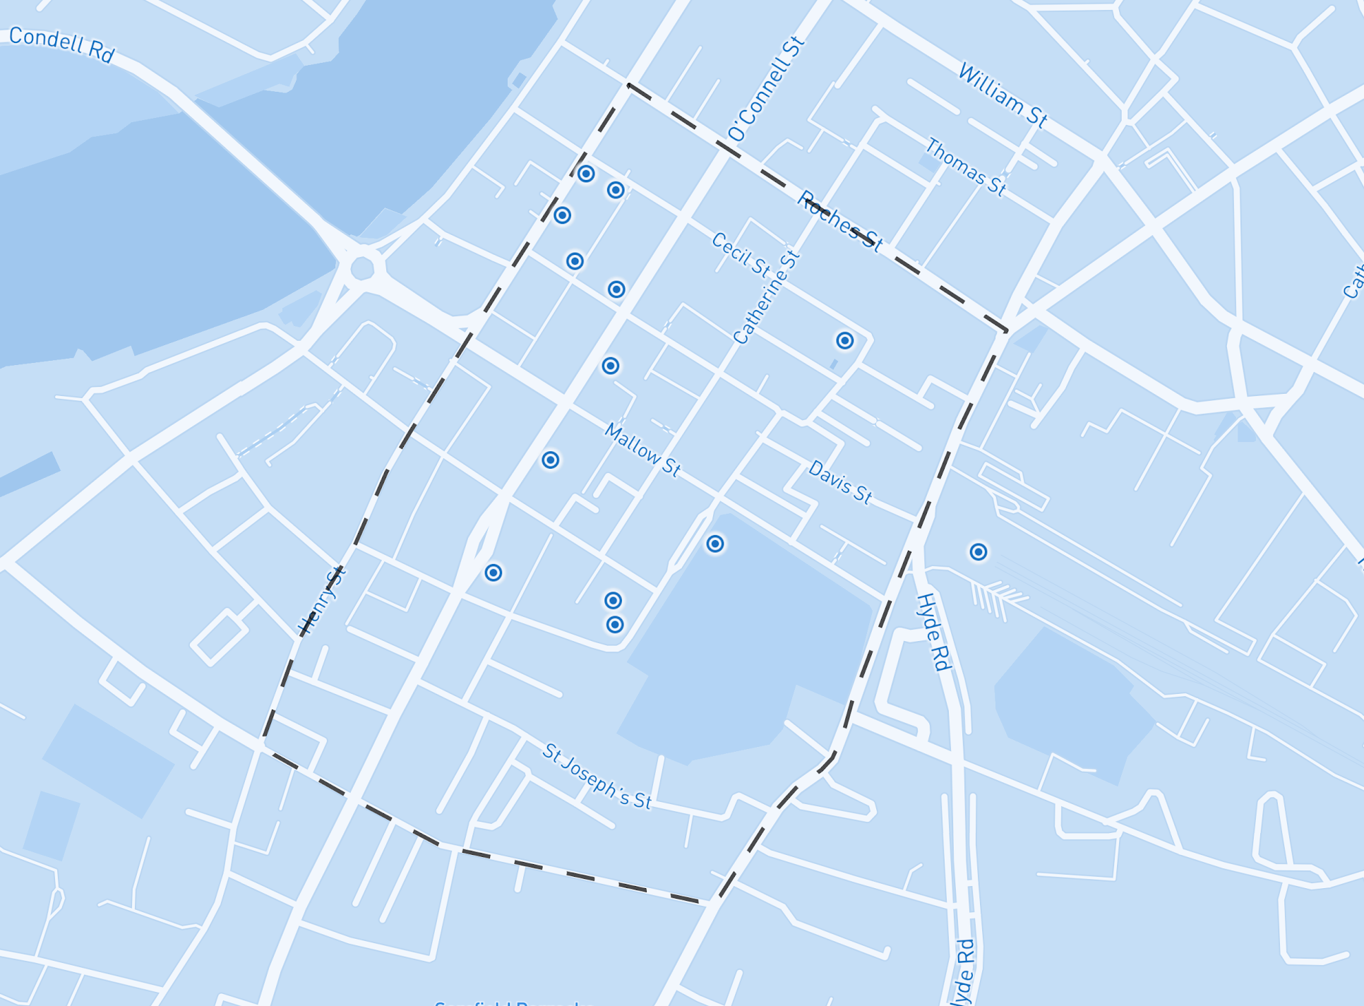
Fig 1.: Innovation Playground in Georgian Limerick (© Mapbox, © OpenStreetMap)

Introduction

Limerick’s Georgian Neighbourhood is developing flexibly and through the use of prototyping and community participation, in close cooperation with stakeholders: citizens, companies, city administration and researchers.

Supported by the European Horizon 2020 programme and as part of the +CityxChange Project (https://www.limerick.ie/cityxchange/about), Limerick is employing smart city development by co-creation in a public-private-people partnership bringing benefits to all stakeholders. One of the elements of this smart city development is accelerating through agile piloting - ie, ‘Urban Prototyping’.

The Urban Prototyping programme accelerates Smart City innovation by procuring new urban products and service prototypes to be co-created with citizens and wider creative networks. Solutions are tested in real life settings during a period of up to 12 months. The programme supports pilot projects and offers tools to innovate, co-create and experiment with new programmes, initiatives & changes to regulation, products and services etc. together with citizens, makers, creatives, startups and other stakeholders.

From 2019 to 2021, there will be three open calls for urban prototypes, focused on enabling the formation of a Positive Energy District (https://cityxchange.eu/knowledge-base/ped/) in the Georgian Neighbourhood of Limerick City.

These calls are supported by the Limerick CityEngage Weeks (https://www.limerick.ie/council/services/business-and-economy/business-supports/living-limerick-city-engage), during which citizens engage in developing a vision for living in the historic core of Limerick City Centre. Through workshops, mapping days and events in these CityEngage weeks, stakeholders explore ways to make the transition to a positive energy neighbourhood.

The first CityEngage week was held September 23rd to 28th, 2019 and focused on the ‘Georgian Laneways’ and ‘Citizen Sensing’. During that week the +CityxChange team supported and assisted citizens in gathering information about what is valued, and to share their ideas, hopes and aspirations for the Laneways. In April and September 2020, there are further CityEngage Weeks planned in Limerick.

This Open Call will identify and support the first Urban Prototypes to be tested in the Georgian Neighbourhood and focused on developing solutions for Laneways and Citizen Sensing supports. The open call is looking for teams involving local community groups, supported by designers and makers to design, create and test solutions to common issues in the Georgian Neighbourhood area.

The call will support two types of prototypes that help the transition of the Limerick Georgian Neighborhood to a Positive Energy District:,
- urban design/tactical urbanism solutions which respond to common issues with the laneways and
- digital innovation solutions at their heart.
Any artistic/design discipline is welcome for the tactical urbanism solutions, and the call may be suitable for architects, software and hardware professionals, product designers, urban designers,landscape architects, and hackers. Makers (a term for diy crafters, hackers and enthusiasts, especially when related to technology and open-source hardware) may include a designer and communities themselves and can also be supported by maker groups e.g. mens sheds, shared community workshops, craftivists etc.

For digital innovation solutions the call is open to any discipline but technical capacity to implement the solution should be proved by the application team. Digital innovation solutions could be about environmental sensing, data visualization, energy generation energy storage and any other themes covered in the +CityxChange project. Open source hardware and software approaches will be positively evaluated.

To facilitate this call, we are going to run an Information Session and Matchmaking Event , on Wednesday, 12th of February at 18:30 at the Citizen Observatory at the Fab Lab Limerick on Rutland Street.

A people-focused approach and location in the Georgian Neighbourhood is extremely important for the project. We welcome applications from groups who wish to work together on this project, designers must work with community groups, communities of interest, businesses or residents in the Georgian Neighbourhood.

For further information on this project: https://www.youtube.com/watch?v=6FlGKpeigrs

Requirements

- Proposals should meet the description of “Energy-related Innovation”, and use the ideas of Urban Prototyping and Citizen Sensing to address any of the following themes aligned with the concepts of the +CityxChange project:

- Introduction of more renewable energy sources in the Georgian Neighbourhood
- Sustainable energy management including increased use of energy storage
- Improvement of air quality
- Increased community participation in the energy transition to ‘positive energy’ status
- Increased e-mobility (electric vehicles)
- Improved quality of the built environment
- Shared public space - ways to encourage equity in shared use of public space
- Space for electric transport in the city
- Promotion of electric mobility options

more information at: https://www.limerick.ie/cityxchange/about

- Teams should comprise:

Please note a strong design and community element is required in each proposal - applications should be made with or made by community members/groups connected or interested in working in the Limerick Georgian Neighbourhood;

Projects need to be fabricated and implemented by the team as part of the proposal. Technical capacity to implement each proposal should be proved by the application team in their application.

- Funding of between €500 and €5000 is available to successful proposals.
Applications require a breakdown of budget in each case, under the headings described in the application form, and should include in-kind contributions and all expenses.

Please note: The +CityxChange Innovation Lab at Fab Lab Limerick in Rutland Street offers access to its network of communities of interest, makers and hackers. Access to equipment can also be negotiated.

- Applications should include the timeline for developing and installing projects. We suggest on site between the 10th of April and September 25th, 2020.

- That the project is deployed within the Georgian Neighbourhood (Figure 1., page 1)

- Online content, documentation and sharing of project outcomes will be required, including publication at the “CityEngage Week” in April 2020 and other publications related to the +CityxChange project.

- All the information provided as part of this call can and will be released in the public domain and other the Freedom of Information Act. Any intellectual or commercially sensitive information that cannot be disclosed in the public domain will need to be clearly marked in the proposal.

- That the project must meet data protection requirements, safety standards, permissions and consents for installation in a public space.

- Normal EU procurement and exchequer criteria in respect of grant aid shall apply

Assessment process and selection criteria

Assessment board will comprise a selection of project partners from Limerick City and County Council, the University of Limerick and the +Limerick project team.

In addition to the requirements described above, the following criteria will be used to evaluate proposals received.

- Cost (20%)
- Quality (80%) of which:
  - Proposal (Linked to projects and Innovative Elements) (40%)
  - Team (25%)
  - Execution Planning (15%)

Timeline

Open call for proposals | 13th January, 2020
Information Session (Open Night) | 12th February, 2020 at 18:30
Deadline for queries | 21st February, 2020
Response to queries (online FAQs published) | 28th February, 2020
Deadline for submissions | 2nd March, 2020 at 17.30
Successful proposals announced | 6th March, 2020
Projects in place (suggested) | Between the 10th of April and the 25th of September, 2020

Submissions
If you have any queries, please email cityxchange@limerick.ie
Submissions only digitally to MyPoint.Limerick.ie, before Monday, the 2nd March, 2020 at 17.30.

https://mypoint.limerick.ie/en/content/open-call-innovative-citizen-solutions-positive-energy-transition-and-limericks-georgian-laneways

